***MEANDERING BRUSH ……***

***Artworks & Verses by nehab***

***Neha Bisht***

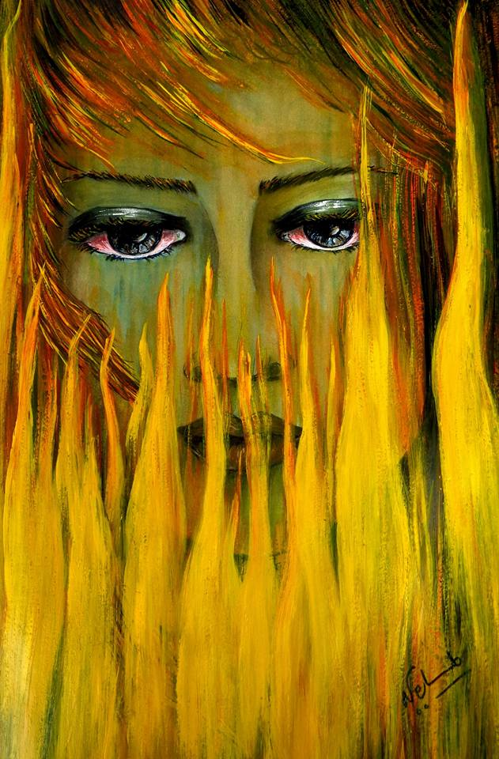

***Art is a Journey of the soul lived in experiences, painted in colours, sung in melodies, written in verses …….***

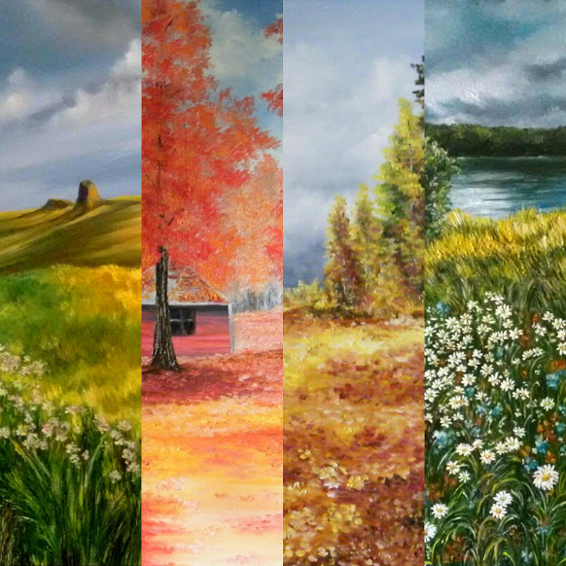

*For Swaritt….*

*The little pebble that rolled with the meandering river….*

***ARTWORKS& VERSES by NEHAB***

Neha Bisht

***SUNDRENCHED OAK***

*(watercolour/ year 2014)*

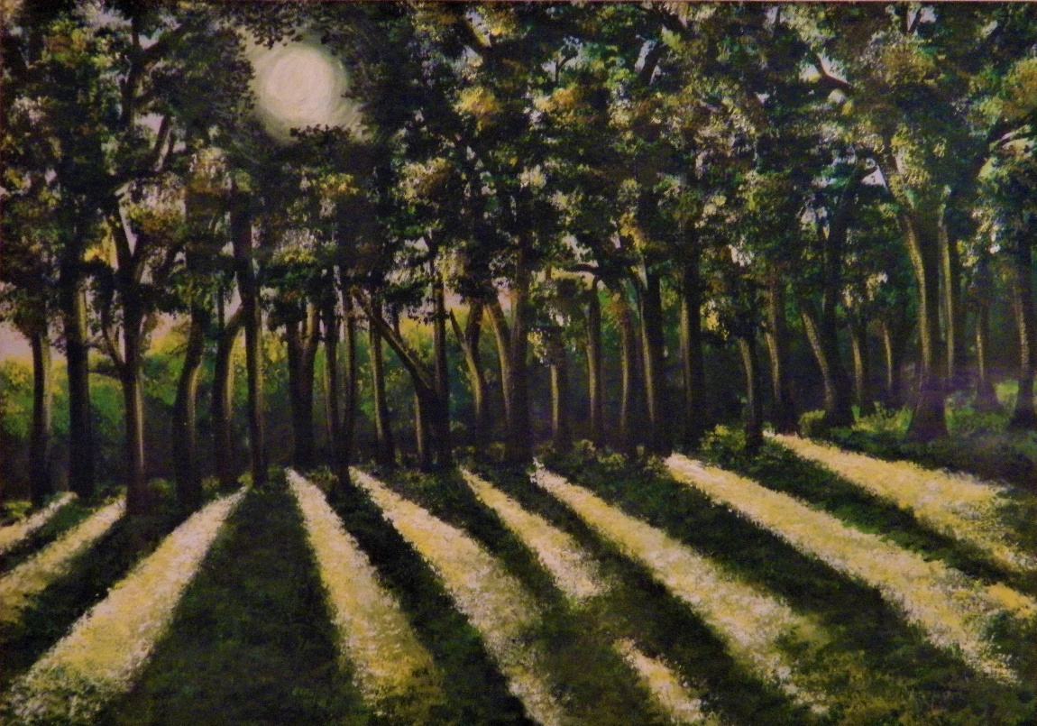

*Lansdowne, Uttaranchal*

***My dog stopped here and so did I …..***

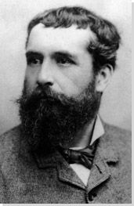***“People discuss my art and pretend to understand.As if it were necessary to understand, when it's simply necessary to love”.***

***Claude Monet***

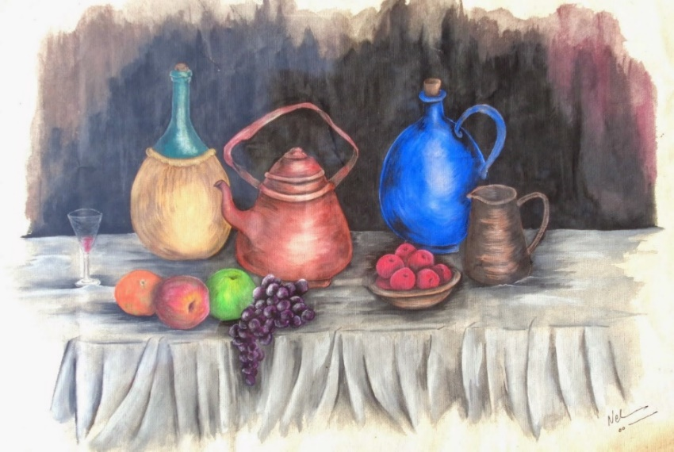

*Wine & Fruit (watercolour/ year 2011)*

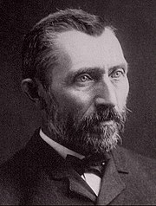***“I put my heart and my soul into my work, and have lost my mind in the process”.***

***Vincent Van Gogh***

**TABLE OF CONTENTS ……**

Introduction - Painting The Soul

The Story Unfolds….

Soul Healing….

Meandering Brush – The Art Catalogue

Elements of the Universe

Spirit of the Universe

Moods of the Universe

Autumn Flames

Winter Hues

Small paintings & vignettes

Two Stories - Yours& Mine

Feminine Energy- Mood & Emotion

Artworks ByNehab/ Neha Bisht – contact information

***“Paintings have a life of their own that derives from the painter's soul.”***

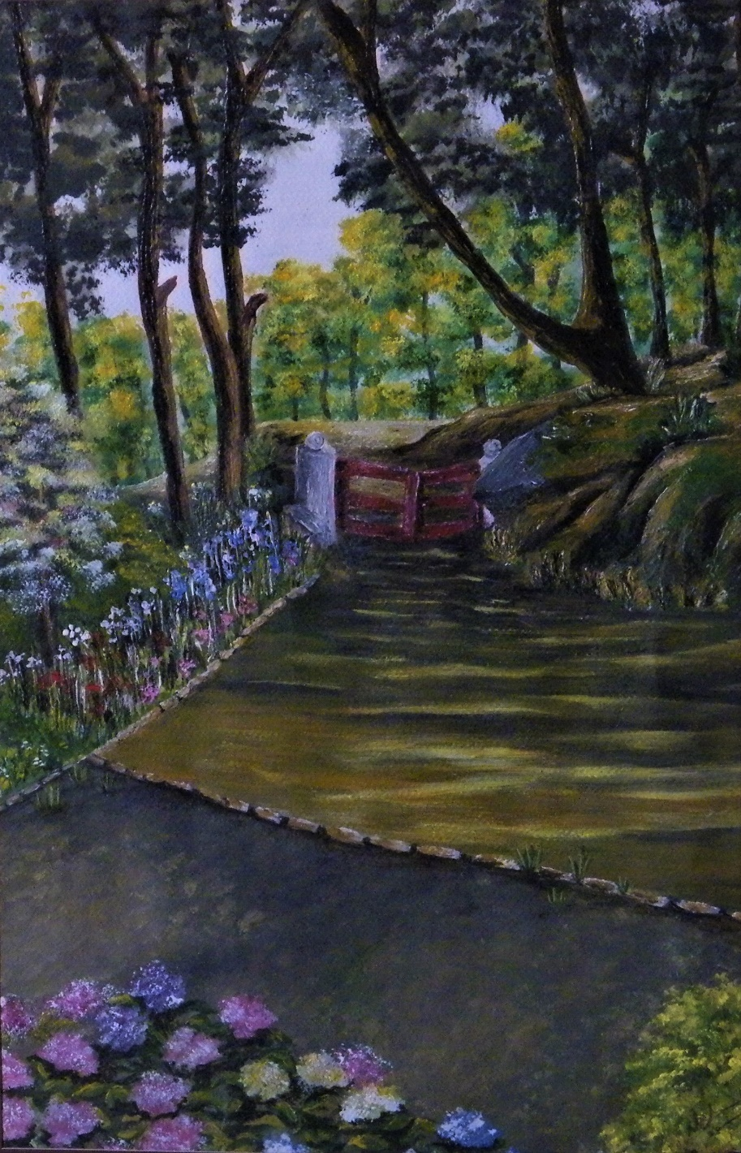***Vincent Van Gogh***

“A Summer Homecoming”

*(watercolour/ year 2014)*

***View from the veranda of my bungalow in Lansdowne.***

***My home of 7 years.***

***PAINTING THE SOUL ……***

***ABOUT MY ART …***

***As above, so below. As within, so without.***

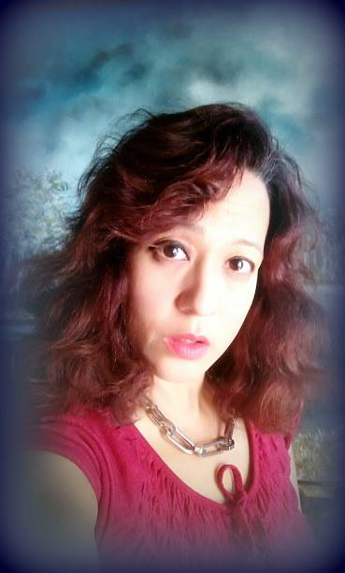

***“I do not literally paint that table, but the emotion it produces upon me”.***

***Henri Matisse***

***“I dream of painting and then I paint my dream”.***

*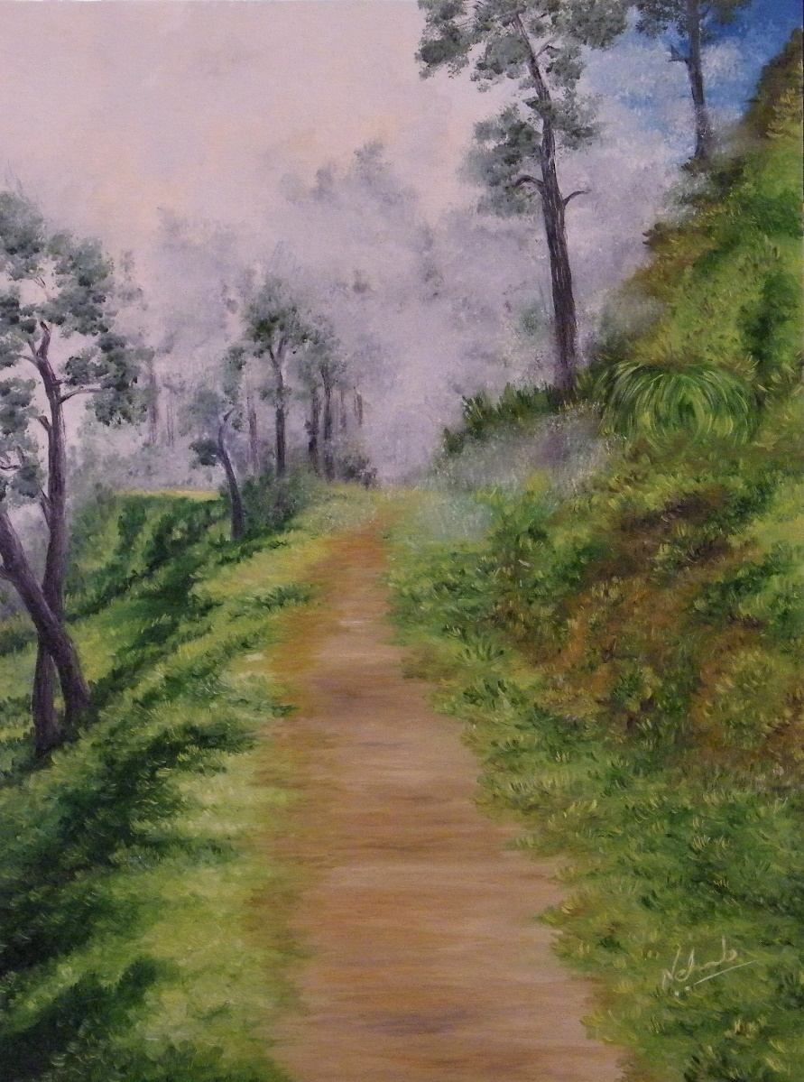****Vincent Van Gogh***

***“Into the Fog”***

*Oil on Canvas/ year 2014*

*Lansdowne, Uttarakhand.*

***A trekking path I often wandered on …..***

***THE STORY UNFOLDS….***

***MYPAINTINGS OF THE SOULare a Celebration of the Divine Force present in the five elements, Fire, Water, Wind, Earth, Aether, and embodied in Colours and in Nature.***

***My Soul Paintings are my worship of the Divine and bring to you and to your environment the Healing, the Serenity and the Wellness of nature.***

***My Soul Landscapes are Chariots that transport you to a world of Beauty, Purity, Devotion and Oneness with the Divine Universe.***

***To understand Universe & Self, one needs to feel the Universe & Self throbbing inside. My Soul Paintings are a bridge that connects you to the Divine Universe and to your own soul.***

***AS ABOVE SO BELOW,***

***AS WITHIN SO WITHOUT.***

***I CREATE AS I FEEL IT FLOW INSIDE…..***

**PAINTING THE SOUL……**

For me, everything, animate or inanimate, possesses an aura, a vibe. I like to call it the soul energy. When I see an object, it is the soul energy that connects to me and evokes feeling inside me. It is this “soul”that I paint. Never the object alone.

I portray the soul energy of colours and elements in my art.

Creating the Soul is a concept that has breathed deep in me, ever since I picked up the brush and consciously started my art journey.

I remember seeing great masterpieces by great artists like Monet, Van Gogh, Pissario, Gauguin, Picasso, Renoire, Fyodor Vasilyev, Boldini, Savrasov, Repin, Shishkin, Cezanne, and many, many more … And I remember being transported into the painting. I remember being stirred deep by the painting.

I remember listening to great music and being moved beyond words. I remember seeing great photo-art and being stirred deeply.

It led to my understanding that all art styles are good. Be it classicism, romanticism, realism, impressionism, expressionism, fauvism, cubism, contemporary, modern art, any genre or style. All art styles are great and are afusion of each other, portraying a movement of collective thought in a society.

However, what makes an artwork a piece of art is the presence of a soul, an embodiment of energy pulsating through it.

As I journeyed down the beautiful road of colours and elements, I discovered my very own personal artistic expression. My art style and expressionlay in painting the soul that speaks to my soul!

All colours embody an energy. It is the soul of that colour.

Red is the embodiment of passionate emotional intensity, be it in love, anger or ambition. Blue on the other hand, embodies peace and sometimes melancholy.Green is a nurturing energy that embodies fertility and prosperity.Yellow embodies happiness, wisdom, balance.

As many colours, so many energies.Similarly all elements also embody a soul. Seasons too embody a soul energy.

Everything in this Universe can be understood as soul energy. From a house, to an inanimate rock to a fluttering butterfly or a squirming maggot, everything embodies a soul energy. This whole Universe is nothing but soul energy.

I like to bring colours and elements of nature together to express a soul atmosphere or energy in my artwork.

The fury of dark raging waves and tranquillity of calm lakes is unparalleled. The passion in red autumn forests and wisdom of yellow golden birch trees is incomparable.

I create landscapesthat embody mood and emotional atmosphere. They are “Soul Landscapes”.I am a lover of Impressionism and Lyrical landscapes.

Decades ago, in 19th century Europe, Claude Monet, Renoire, Vincent Van Gogh and many other artists moved away from realistic and depictive art to Impressionistic style of using colours and light. They used colour tones, light and shadow and wind to create an emotional atmosphere, mood and movement in their landscapes. Kinetic energy is a key element of Impressionism.

During the same period, in 19th century Russia, a movement called “Lyrical or Mood Landscapes” by “[Peredvizhniki](https://wiki2.org/en/Peredvizhniki)” artists gained momentum. Alexi Savrasov, Isaac Levitan, Fyodor Vasilyevare some of the great exponents of this movement in Russia. The essence of this movement was to see beyond the landscape, towards the soul of Russia. And take artto the public and remove the domination of bureaucracy and elite. The folk life, villages, foliage, sunlight and wind was used to create a breathing and live mood and aura. These “Mood Landscapes” or “lyrical landscapes” of Soviet Union are like a song.

I have greatly admired these two movements – Impressionism and Lyrical landscapes of 19th century Europe and Russia. They embodied beauty, expression, emotion and dialogue – the four key elements of art.

These art movements are milestones in the world of art. They broke away from the traditional concept of simple realistic or romanticised depiction. Instead, colours and elements were used and played around with,to express thought and emotion. Art became more free and expressive and an embodiment of soul.

We have much to thank these movements for. They became the forerunners of many new thoughts leading to cubism and modern art genres of 20th century. .

Impressionism and Lyrical Landscapes is a major influence in my art style.I learned art not in a classroom but from studying great art by great EuropeanMasters and from life. I am indebted to the invaluable art guidance I received from SergeiSonera (Artist/Fine Art Teacher, Estonia), and YuriiChernenko (Art connoisseur, Ukraine).

I do a blend of brush and knife work. I work with primarily only two or three colours to bring out the core colour aura. Layering and texturing are my favourite techniques.

My Paintings of the soul are a personal dialogue of mood and feelings between the art and the viewer and between the art and the artist.

I see the divine energy in nature and it is the divine energy that I paint as I see it and feel it.

**Mark Rothko, a famous German artist once said,**

***“A painting is not the portrayal of an experience. It is the experience”.***

**I bring to you an experience to be experienced….**

***SOUL HEALING***

*Just like the physical body needs nourishment and healing, so also the soul needs nourishing and healing.*

*This nourishment and healing of both soul and the physical body comes from healing energy of nature and natural elements.*

*Colours, sound and the elements of nature are the core instruments of Soul Healing.*

*The energy of colours and elements in the environment embalms the soul, nourishes and heals it.*

*All the 7 chakras embody a colour energy. Very often the colours we seek are the very energies that our persona has an imbalance of. Hence, the soul seeks that energy and attracts us more towards that colour. It can be understood as the magnetic attraction between polarities.*

*Love is the most potent healing energy. All is born of love and ends in love. That is the divine order.*

*To heal and nourish the soul, one should bring into their environment, those colours and elements that the soul needs, in order to balance and empower itself. It is important to act from a space of compassion and love.*

*This healing is a process that is unique to each individual. And it starts by listening to what your soul is saying. If your soul wants red, give it red. If your soul wants snow, give it snow. Bring it into your environment through art. Surround yourself with beauty and love.*

*I create nature. My soul landscapes embody a distinct colour energy. My art is born of love and its myriad emotions that flow in me.*

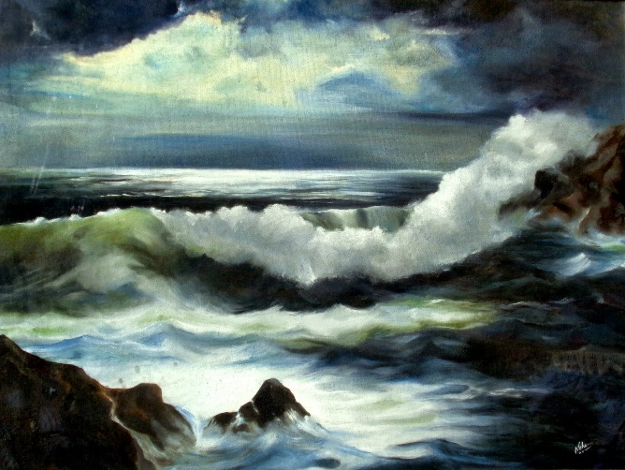

***My thought is born in the trance of meditation. My soul heals as I create it. I offer that healing to you…..***

*Midnight Surf /oil on canvas 1995*

***“I dreamt of living in a beautiful cottage in a beautiful valley with open meadows and a tiny stream flowing by. Mansion would be nice too!***

***I dreamt of flower fields with chamomiles and daffodils swaying in the breeze. I dreamt of all the beautiful seasons visiting my garden. I dreamt of golden birches and red maple. I dreamt of a brook gushing by. Vibrant spring, green summer, monsoon mist, golden autumn and white winter. A cosy town a little way down.***

***I dreamt of freedom.***

***And I desired the adventure of exploring.***

***Not always were all dreams possible. And not always all desires in the realm of practicality.***

***And so I took a blank canvas and painted dreams on it.”****…. Neha Bisht*

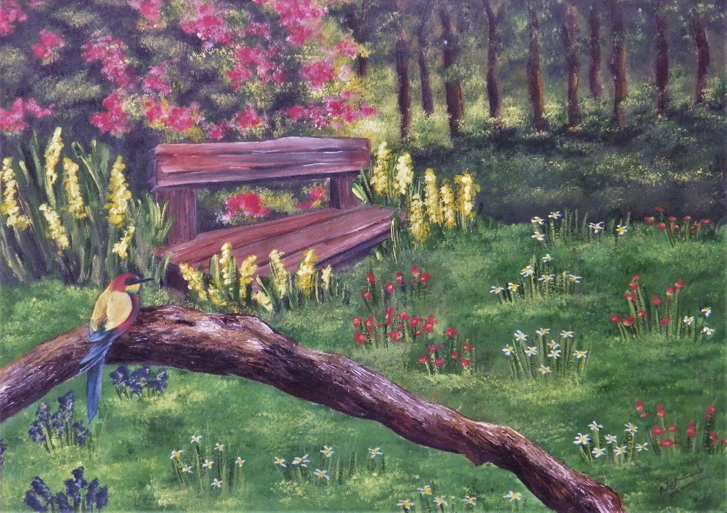

A Woodland Bench

Lansdowne, Uttaranchal

(watercolour/ year 2010)

***“No one is an artist unless he carries his picture in his head before painting it, and is sure of his method and composition”.***

***Claude Monet***

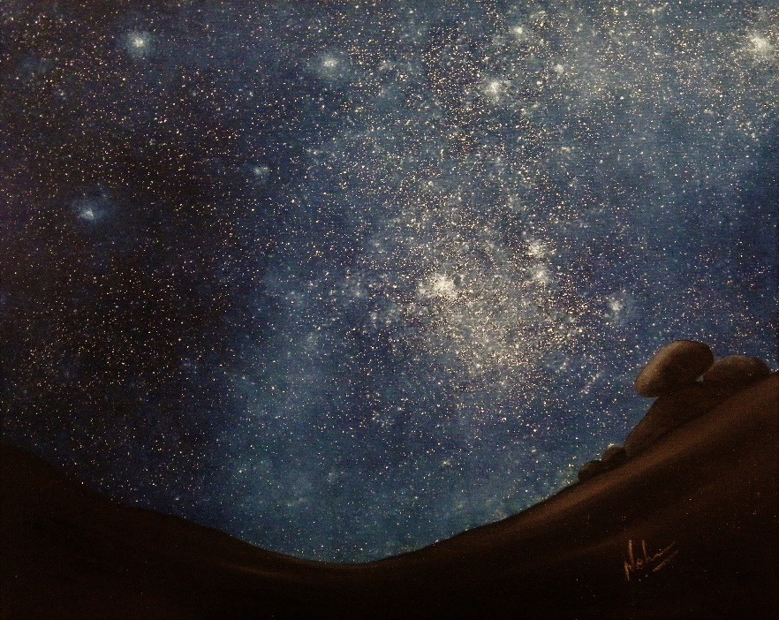

***Romancing The Night***

*(Oil on Canvas/ year 2012)*

*Life is a journey…..*

*Life is a journey of emotions. It is not a journey of assets bought and sold. It is not a journey of social status and material achievements.  It is a journey of experiences where every awareness is a milestone and every awakening takes you closer to the Divine.*

*Every painting is a fragment of that journey.*

*Every painting is a story of a story….*

**THE ART CATALOGUE…**

**&**

**The art of buying art…**

**….**Buying art is a very personal, a very thoughtful and mindful action.

When you buy art and bring it home, what you are effectively doing is bringing an energy home. That energy will occupy a space in your house. Hence the art must speak to you.

The energy embodied in the art must interact with your thoughts. And should bring healing and good “*vastu*” (aura) of the elements of Universe into your room.

The painting on your wall is a doorway that connects you to your experiences. It is a window that brings in the winds of healing and hope and joy. It is a dream where your soul finds refuge.

Art on your wall is not just a lifeless picture. It is alive and throbbing part of your home energy.

In my art catalogue (Timeline 2013 to 2019), I bring to you the healing energy of seasons, colours, forests and nature and the strength of the soul.

I believe that God, Angels, Saints, Divinity, all reside in nature. I bring to you the beauty of the Divine Symphony of the Universe.

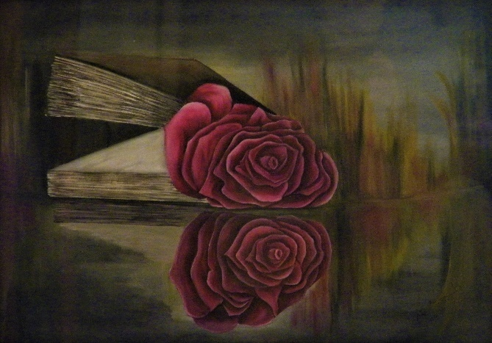

***“The principles of true art is not to portray, but to evoke”***

***-Jerzy Kosinski***

***Polish-American novelist***

*Reflections (watercolour/ year 2011)*

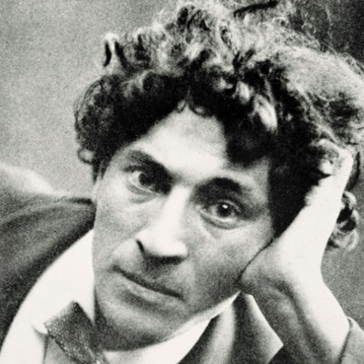***“If I create from the heart, nearly everything works: if from the head, almost nothing.”***

***Marc Chagall***

There is something very intense and magnetic in the interaction of natural elements with each other. The clouds, forests, waves, - they are the words of God. Their interaction is like a dialogue between Gods. You can only sit silently and listen to them with your eyes and your mind.…..

***ELEMENTS OF UNIVERSE……***

*The breeze, the waves,*

*Skies and stars,*

*Floating Clouds, fog and snow.*

*Raindrops on scorching earth.*

*Water, Earth, Aether, Wind and Fire –*

*They talk to each other in silence and in storms.*

*They embrace one another.*

*And lash out in furious battles,*

*Like a dialogue between Gods.*

*Ancient world worshipped them as Gods.*

*Modern world fears them as the wrath of Gods.*

*I worship them as blessings from above.*

*They are the Elements of the Universe.*

*Gods that hold the Sceptre.*

***THE EDGE***

*The Edge awaits the decision.  
The retreat or the fall?   
The fall or the flight?  
A Moment of Decision.  
Trepidation or Transition.  
Threshold of Transformation.  
Plunge or Ascension.   
Churning of thoughts.  
A moment of Deafening Silence. ...  
Everything lies beyond the Edge.  
Beyond fog & beyond clouds.  
Beyond light and beyond abyss.  
All moments, events & occurrences, lead to the edge.  
All hues turn to shades of grey.  
A new world awaits.  
Destiny awaits to unfold.  
But Truth lies beyond the Edge.  
Destiny lies beyond the truth.  
The Edge awaits the Decision.  
The retreat or the fall?   
The fall or the flight?*

***THE EDGE …….***

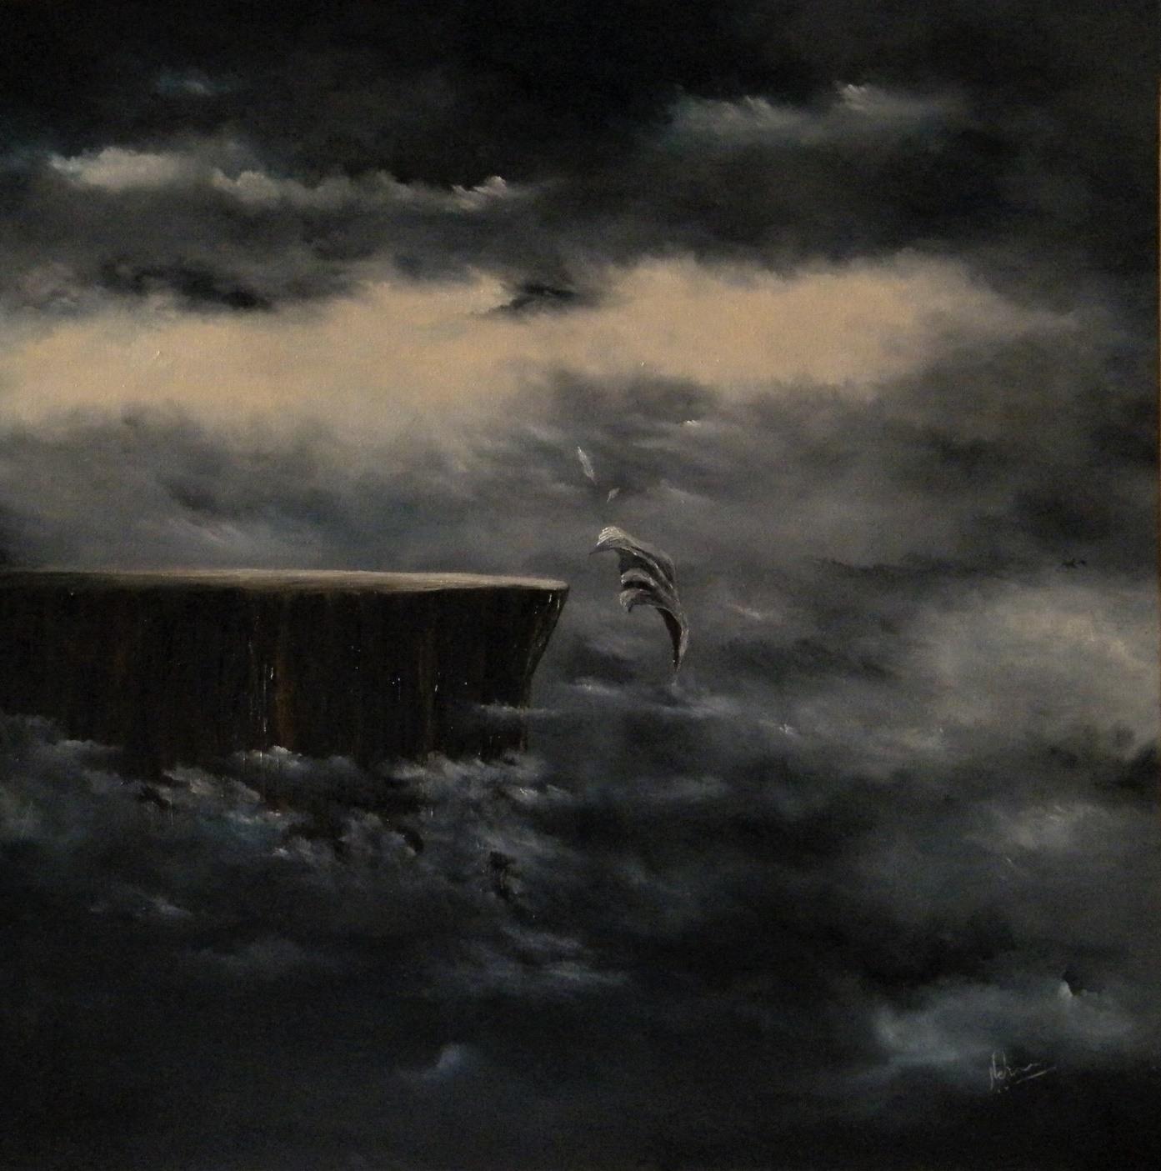

*Oil on Canvas / year 2018*

*Large / 36 inches x 40 inches*

*Energy of Transformation, Awakening, Ascension, Endings and Beginnings. It is embodied in the soul of Shiva….*

***MOONLIT BALLAD***

*While you and I sleep,*

*Universe breathes.   
Elements waltz to an unheard symphon.*

*While you sleep.*

*While I sleep.*

*The wind,*

*The waves,*

*The cliffs and tides*

*Tell the story of many hearts.*

*When the moon shines,*

*The waves rise.*

*The cliffs wait with bated breath*

*The winds murmur*

*And*

*The Moonlit Ballad unfolds.*

*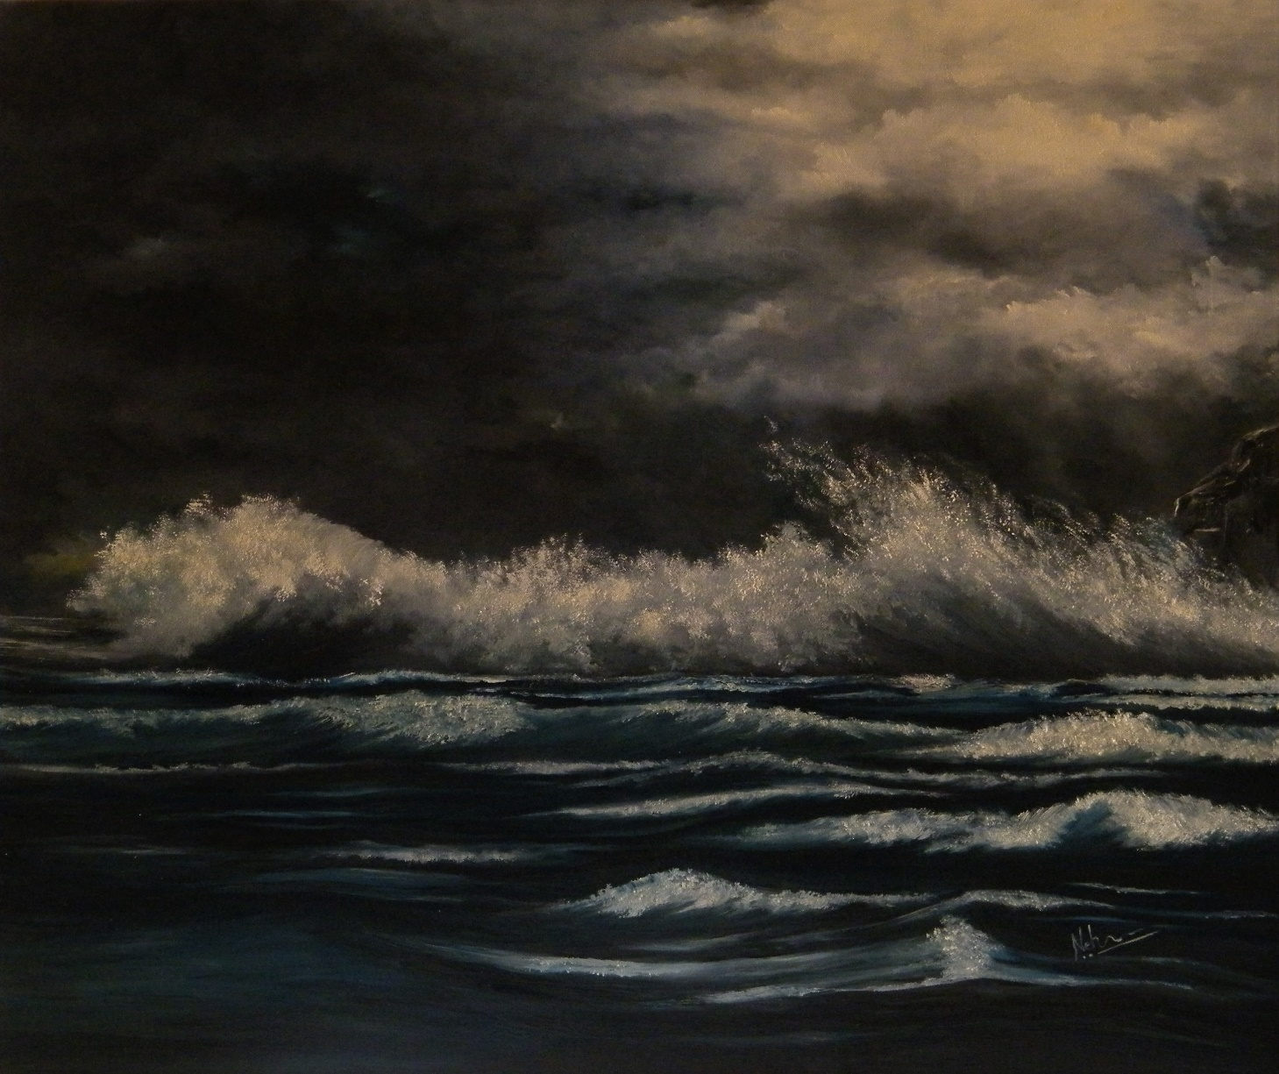****MOONLIT BALLAD …….***

*Oil on Canvas/ year 2018*

*Large / 36 inches x 36 inches*

*Moon is like the magical magnet that draws out emotions……*

***A CLEANSING*** *Neon lights gleamed bright.  
Created a blind spot in the mind.  
Blackness around grew darker.  
Melting colours and images.  
A boiling cauldron of deceptive illusions bubbled.  
Sounds whirred in a monotonous drone.   
Empty sounds of empty promises.  
Heart wanted to run.  
Yearned for a green, green forest.  
Cleansing of a golden sunlight.   
To heal the broken wings of dreams.  
Dreams that fell mid-flight.  
Yearned for green green grass by the blue pond.  
To rest a while before starting the journey again.  
Searched for the forest everywhere.  
Only to find the green sanctuary,*

*Deep inside the silence of the soul.*

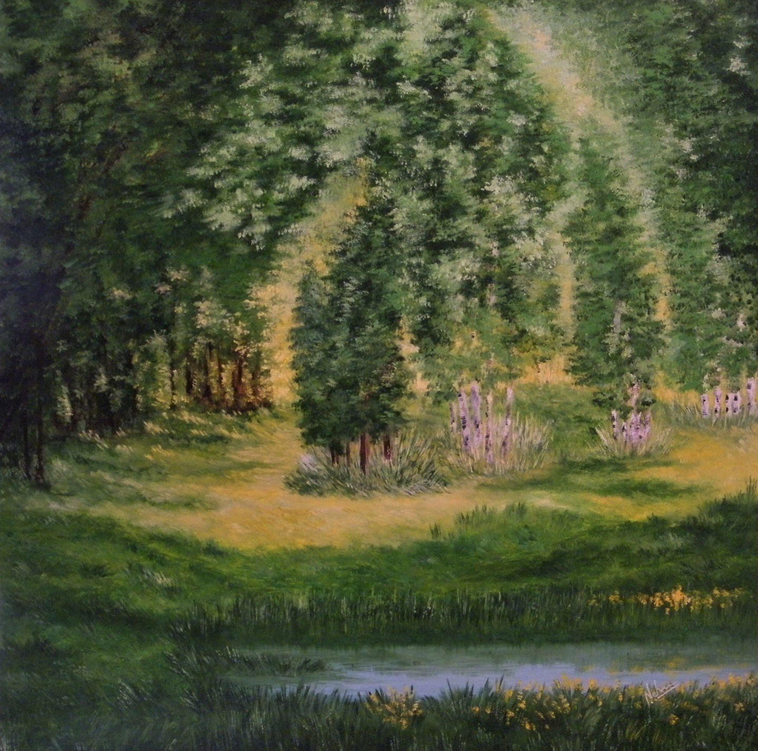***A CLEANSING...***

*Oil on Canvas/ year 2018*

*Large / 36 inches x 36 inches*

*Forests heal with their colours and abundance. Green is Heart Chakra.*

***FLAMES***

*In the autumn that burned my heart,*

*Scalded my soul,*

*The flames rose high.*

*Rained hot tears.*

*Every hue smouldered like embers.*

*Leaves, like letters, lay scattered.*

*Hissed when tears fell.*

*Wings burned.*

*My soul lay bare,*

*In the autumn that burned my heart….*

*In the summer of romance,*

*I was lost in soothing hues.*

*But it was,*

*In the autumn that burned my heart,*

*I found myself…*

***FLAMES……***

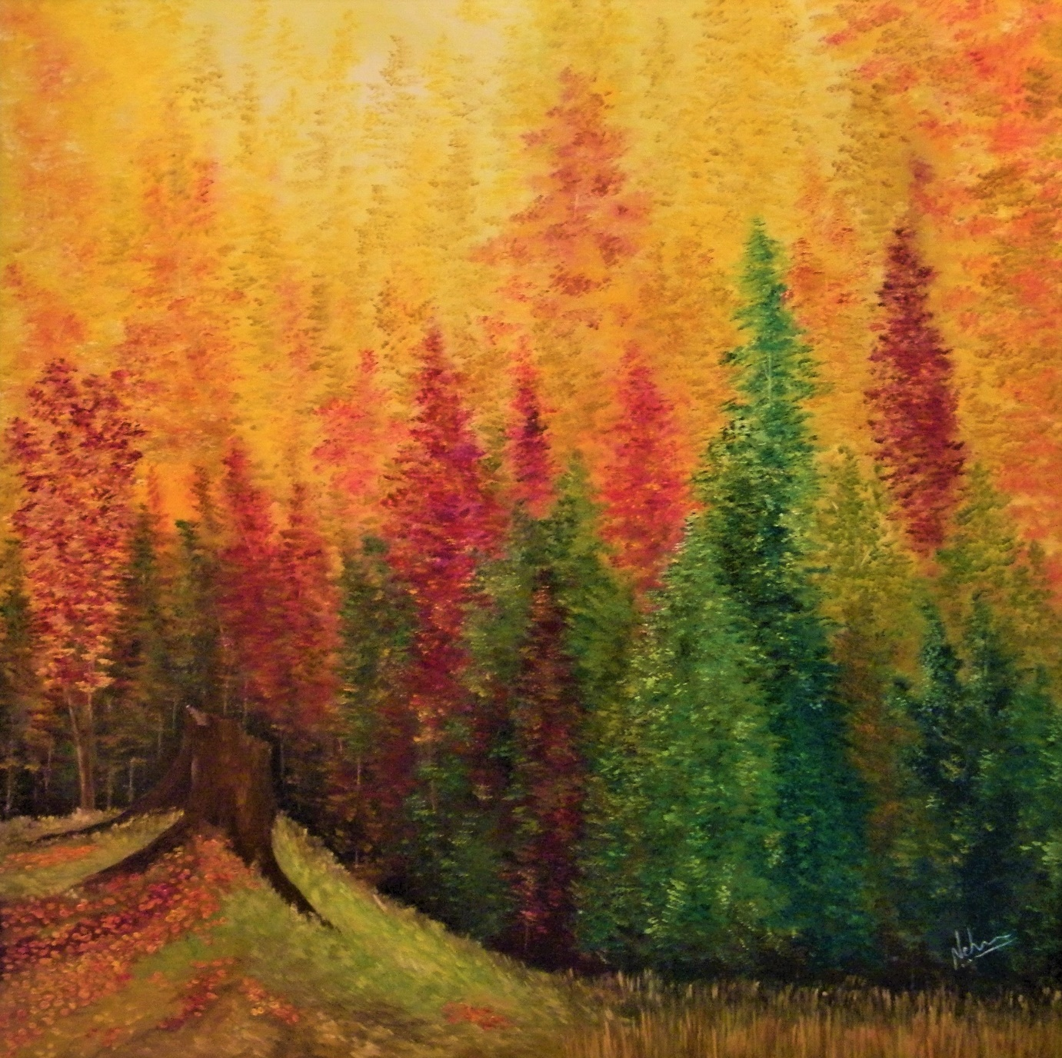

*Oil on Canvas/ year 2018*

*Large / 36 inches by 36 inches*

*The vibrant Fall Forests are full of nostalgia. They heal and reconnect and embody love.*

***MOONSHINE TRANCE***

*It fell on me like silver dust.  
Lit up my dreams like a beautiful curse.  
On its silvery rays, fairies and angels rode.  
I gave them my letters for heavenly abodes.  
A love, a smile, a dream and a dime.  
I sent my wishes, oh, such a crime!  
The spell was cast by the moonlit dance.  
Such was the hex of the moonshine trance.  
I didn’t see the devil lurking in the dark.  
So still and quiet, I was marked.  
He snatched my letters and took my dream.  
Holds them to ransom with a wicked gleam.  
The release is tough, ransom high.  
Price we pay makes the soul cry.  
Yet sweet is the illusion in the moonlit dance.  
Such is the hex of the moonshine trance.*

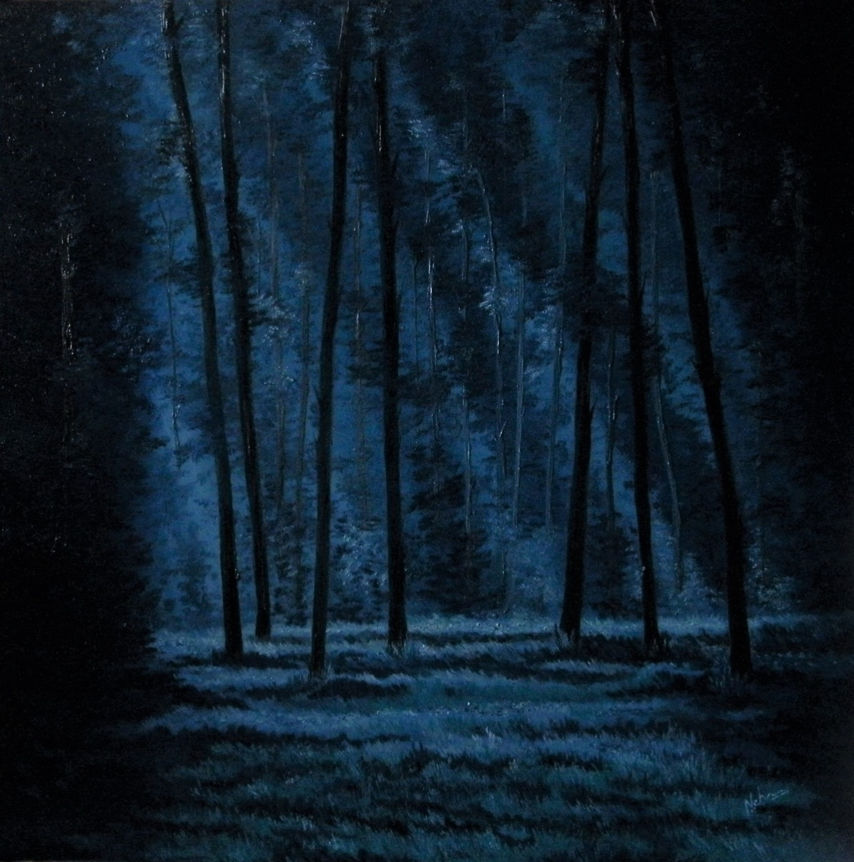***MOONSHINE TRANCE…..***

*Oil on Canvas/ year 2018*

*Large / 36 inches by 36 inches*

*Moonlight creates illusions, heightens emotions and makes the heart tell stories… somewhat true, somewhat fictional, yet full of love.*

***TURQUOISE SKIES***

*In whites and greys.  
With unpredictable skies.  
Winter came in hues of blues and turquoise skies.  
For long I resisted its calm and warmth.  
I was fearful of frozen lands, and forlorn.  
But it knocked on my door, rattled my windows.  
Softly and incessantly.  
Inevitable it was.  
I stepped into the cold.  
Sweet winter fell on me like a Viking axe.  
I accepted my winter.  
Strangely, it soothed & calmed.  
A turquoise sky glowed upon me.  
Beautiful & cold ...As cold as it could be.   
I saw them smile…  
Their eyes twinkled.  
A gust of cold wind blew through my hair.*

*Promise of a warm sun glowed somewhere.*

*.*

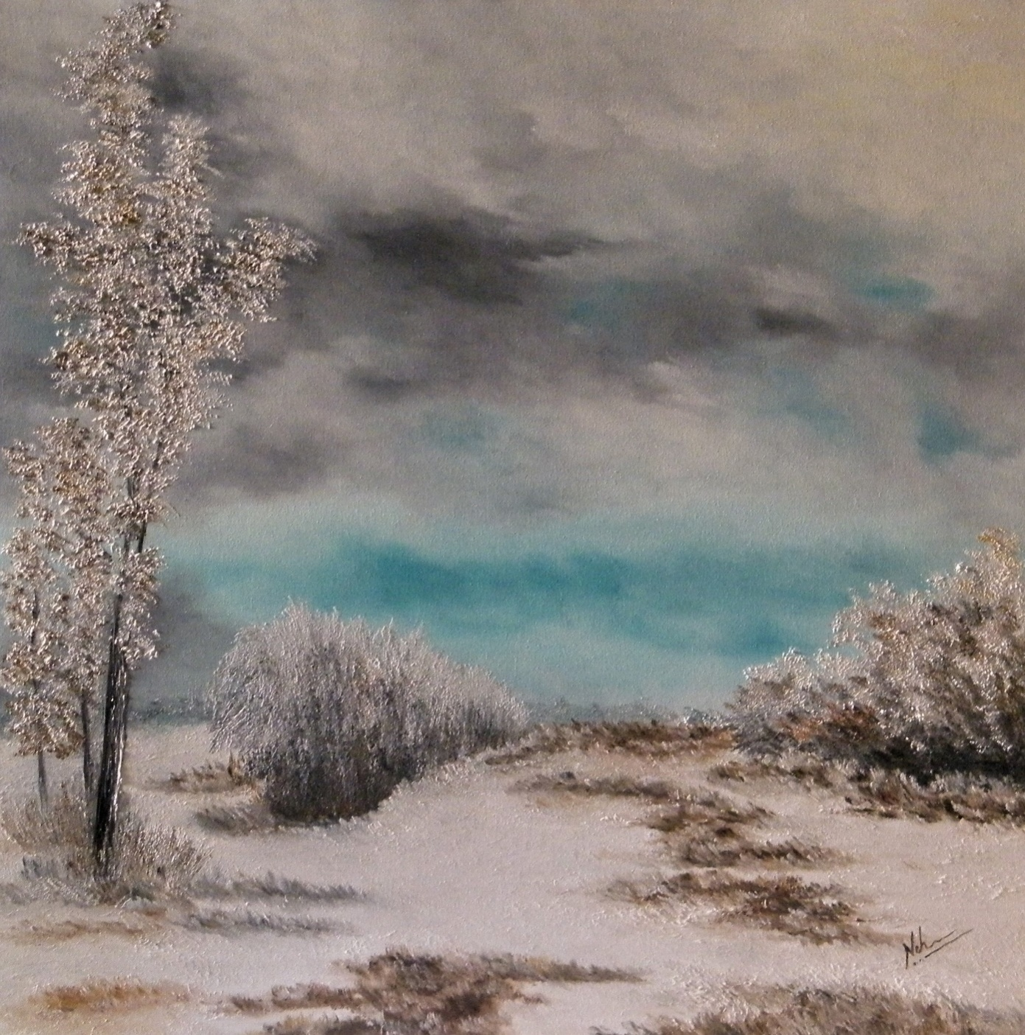 ***TURQUOISE SKIES ……***

*Oil on Canvas / year 2019*

*Large / 36 inches by 36 inches*

*Cold white winter and turquoise skies make the soul reflect and introspect. Turquoise, the colour and the element embody the 5th Chakra. Throat Chakra.*

***BREAKING LIGHT***

***Glimpse of a Smile***

*The skies had wept hard & long.*

*Drenched in pain, drowned in blood.*

*Many a dark nights had come and gone.*

*A storm had raged in and out.*

*So many days had in darkness been.*

*The fog, the moon had all played their roles.*

*It seemed impossible that sun would shine again.*

*It seemed impossible to smile again.*

*But, the crack in the clouds grew bigger.*

*At last, light broke through in a shower.*

*Soaked in tears, the land was bathed in light.*

*Magical and anew, it tenderly smiled.*

*But the story had not ceased yet.*

*Land was new, bathed in tears, soaked in light.*

*But Alas! The rains had washed the paths away.*

*No road in front.*

*Only the light & wind to guide.*

*A new direction had to be walked.*

*A new path, a new journey had to be charted.*

*Like a smile, a blessing, the light broke through.*

*In affirmation of cycles anew.*

***BREAKING LIGHT…..***

*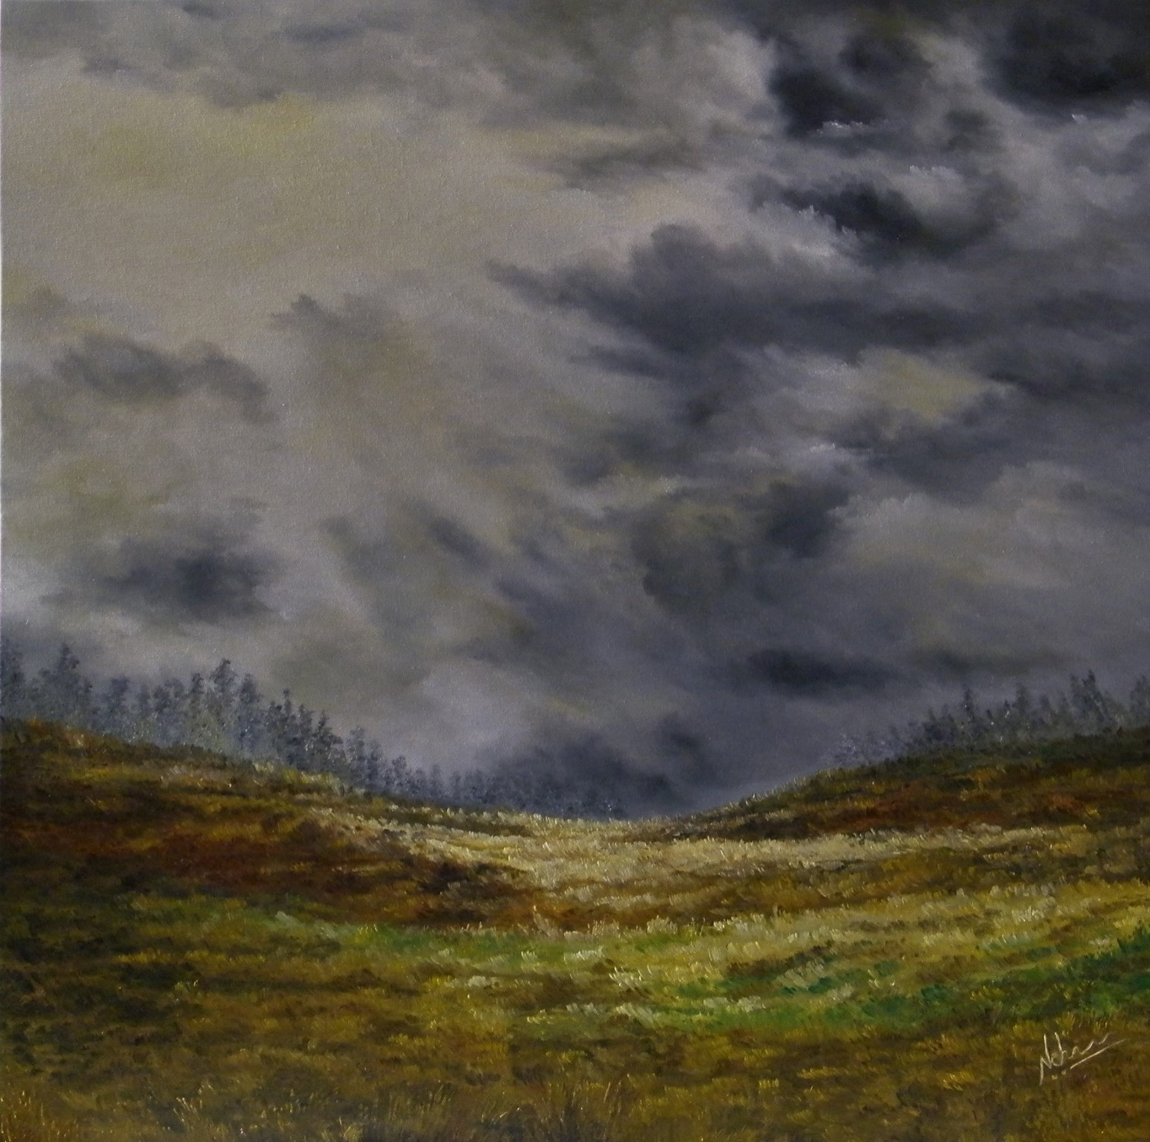****Glimpse of a Smile***

*Oil on Canvas / year 2019*

*Large / 36 inches by 36 inches*

*There is nothing more beautiful than smile through tears. And nothing more beautiful than light through clouds. And nothing more beautiful than sun after the rains….*

***FROZEN***

***….fallen angels***

*Lightly they fall like feathers white.*

*Blanket the earth in divine white.*

*Buried in snow, frozen and cold,*

*Lies a seed waiting for a breath of life.*

*Vibrant colours lie hidden,*

*Beneath shades of grey and white.*

*A life has been lived.*

*A life awaits rebirth.*

*The seed is buried deep.*

*The frozen soul throbs.*

*With strange tales of eternity, so fierce,*

*Snowflakes, the fallen angels, spread their wings.*

*It is not time yet…*

*A silent serenity hides the passion about to burst.*

*Buried in snow, frozen and cold.*

*Lies a seed waiting for a breath of life.*

*An Art Lover & Photographer once bestowed upon this painting, the greatest honour. He said "This painting creates a pleasant nostalgia for me. It is executed in tints of winter landscapes just like the paintings of an old Russian master, Nikolai Dubovskij." I couldn't have imagined a more honourable comparison.*

***FROZEN …..***

***…….fallen angels***

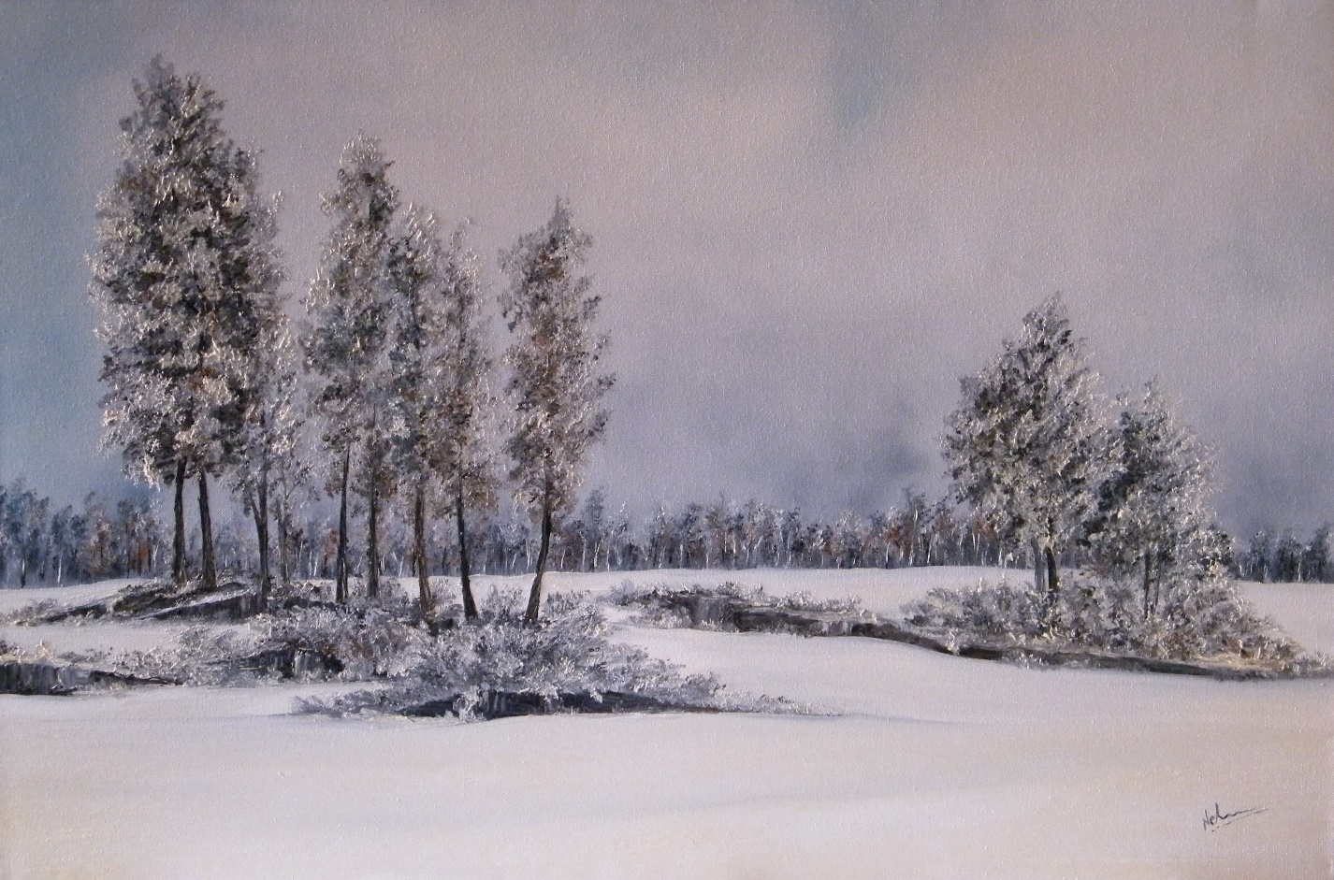

*Oil on Canvas/ year 2017*

*Large / 24 inches X 36 inches*

*Snowflakes are like angels. Each unique. Each beautiful. They are like fallen angels that fall on earth and lie frozen, protecting the seeds buried deep. When the warm sun glows, they melt and fly back to the skies, leaving behind the bounty of spring.*

***GATHERING***

*Last chapter unfolds.*

*All elements gather.*

*The wind,*

*The water,*

*The skies,*

*The earth,*

*Aether*

*The stillness in the air deceives.*

*Hides the intensity of the passion about to unleash.*

*Destiny unfolds as destined.*

***GATHERING ……***

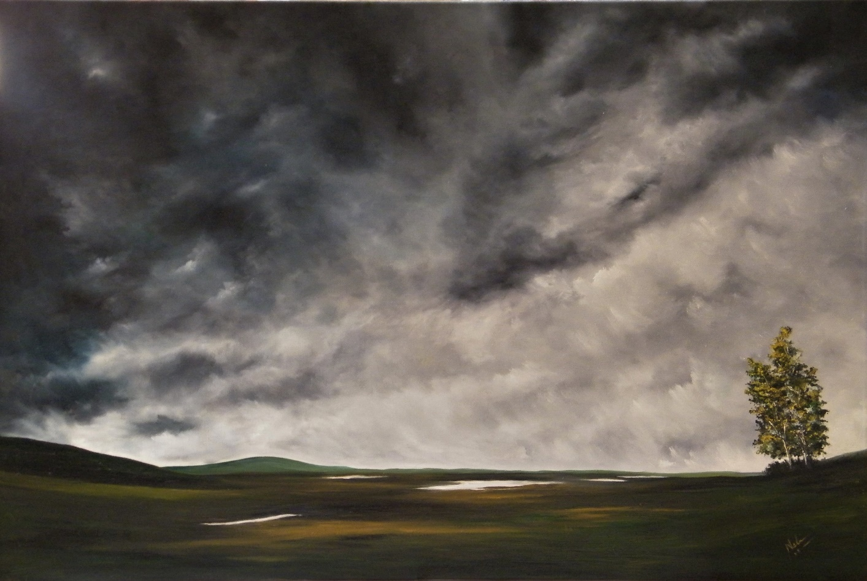

*Oil on Canvas / year 2017*

*Large 26 inches x 36 inches*

*Sounds of Silence in Nature are communication with the Divine…..*

***CRASHING***

*The ocean, rises and crashes, in gigantic waves.  
With an impatience.*

*The racing waves, head to the shore.  
To meet the silent rocks that patiently wait....  
Wait for the waves heading to the shore.  
They meet and kiss, in a passionate embrace.  
The waves crash and die.*

*The rock lets out a sigh.....  
The ocean, rises and crashes, in gigantic waves.  
With an impatience.*

*The racing waves head to the shore....*

*Again….*

*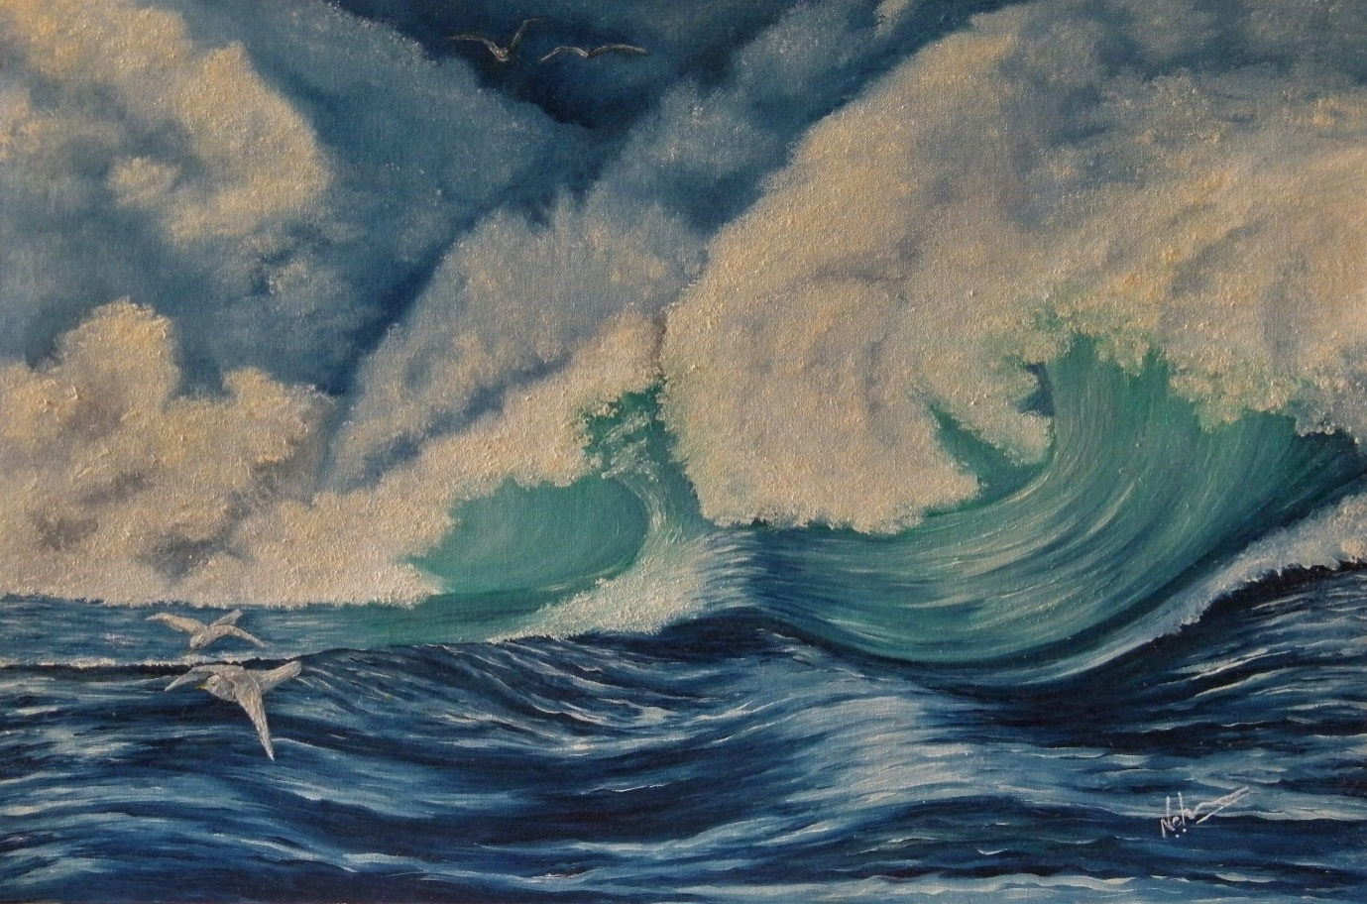****CRASHING ……***

*Oil on Canvas/ year 2013*

*Medium / 20 inches X 24 inches*

*Sea is power. It is passion. It is love….. It is emotion in every colour.*

***“There are always flowers for those who want to see them”.***

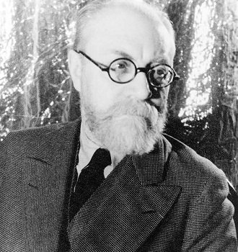

***Henri Matisse***

***Flowers that bloom despite all, regardless of all, embody in their core, the spirit that cannot be broken. Flowers embody soul. You see it with your eyes but feel it deep inside ……***

***THE SPIRIT OF THE UNIVERSE …..***

*In rain, in storm, in heat in cold,*

*It blooms and spreads its beauty and fragrance.*

*Dancing in the fields,*

*Dressing the deserts, shores, forests and mountains.*

*Like beautiful ornaments.*

*It stays frozen in a tiny seed, waiting for the right time.*

*Even in its death it spreads beauty.*

*In its womb carries the seed of a new life.*

*In barren lands, in fertile shores.*

*In crevices, between hard rocks.*

*A flower blooms,*

*Unfolding the secrets of the universe in its colourful petals.*

*Nothing can stop it.*

*Nothing can kill it.*

*Embodying emotion and knowledge,*

*Hope and love and cycle of life.*

*It is the Spirit of the Universe.*

*It is a Flower.*

***A LOVE STORY***

*He the eternal lover.*

*She his only love.*

*Fated to love.*

*Destined separation.*

*His hue surrounded her soul, in a shade so deep.*

*Her fragrance breathed in him, an essence so pure.*

*She, a tear in his eye,*

*A companion in his solitude.*

*He, the only rhythm pulsating in her soul.*

*It is a love story woven in a tear drop.*

*Told and untold.*

*Blessed by the heavens to be forever remembered.*

*He the eternal lover, she his only love.*

*Once Lord Krishna after his marriage to Rukmini, met Radha. As Radha bid goodbye to Lord Krishna, there was a tear in Lord Krishna's eyes. Radha smiled and said, “I am honoured that I am the only tear in your eyes”. Thereafter they never met. This was Radha and Krishna’s last earthly meeting, so they say …*

*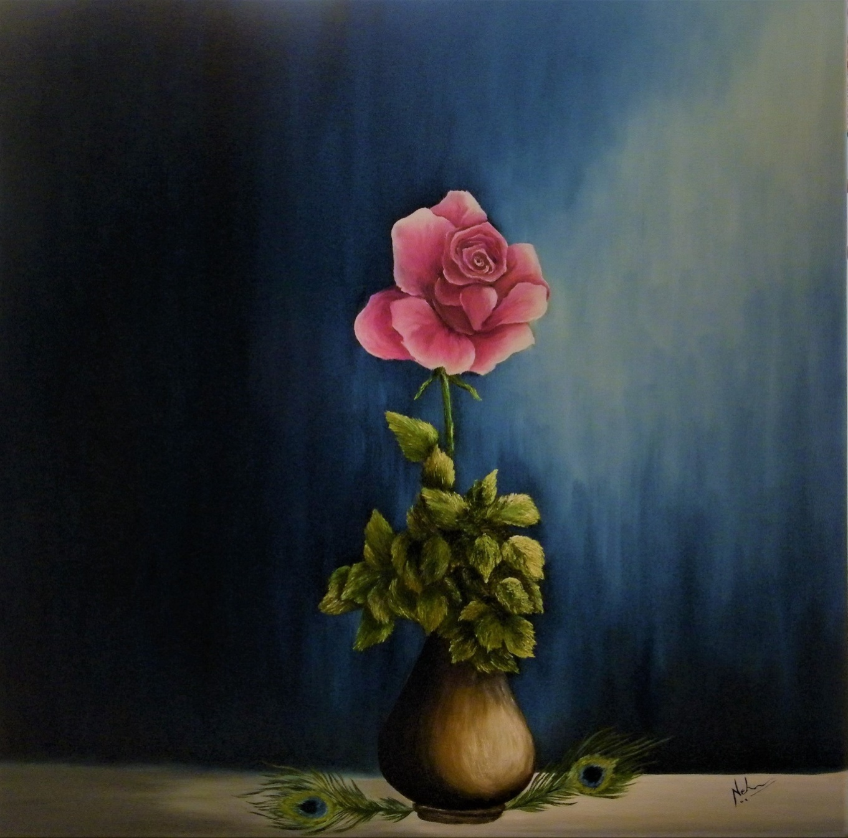****A LOVE STORY …..***

*Oil on Canvas / year 2018*

*Large/ 36 inches X 36 inches*

*Radha& Krishna - A love story of the soul, told in a tear and a throb……..*

***SPIRIT***

*It lies dormant.  
Waiting for the right moment & conditions.   
And then it rises through earth.  
Through crevices,*

*Between rocks.  
And blooms.  
Sways in the breeze,*

*Dreaming & seeking again.*

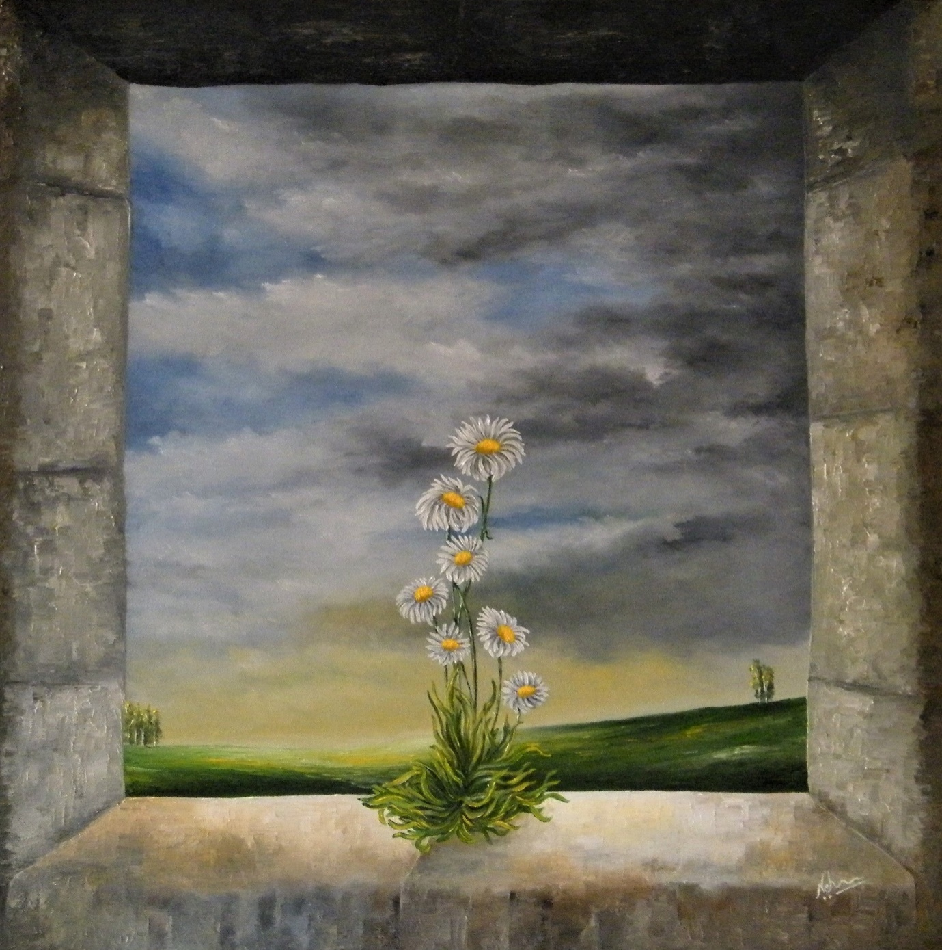***SPIRIT …..***

*Oil on Canvas / year 2018*

*Large / 36 x 36 inches*

***Spirit of resilience and hope resides in the most delicate and vulnerable of forms….***

***A SYMPHONY***

*Like dancing chamomiles, dreams dazzle.*

*Beyond cages of gold and iron.*

*Sunshine falls like rain of gold and clouds float laden with love.*

*You ask me questions and urge me to speak.  
What should I say?  
My stories are like words scribbled on mute walls.*

*In a language you don’t understand.  
When I close my eyes, I see a beautiful world.  
Where sunlight shines like diamond, in the morning mist.  
Where soft breeze caresses through my hair.  
Where tiny squirrels scamper by, and hedgehogs hide in bushes.  
Where snowbirds take playful flights.*

*Where grass is a soft carpet of green and gold.*

*Where chamomiles bloom in fields of dazzling white.  
I see and I breathe.*

*What should I say to make you see?*

***SYMPHONY …..***

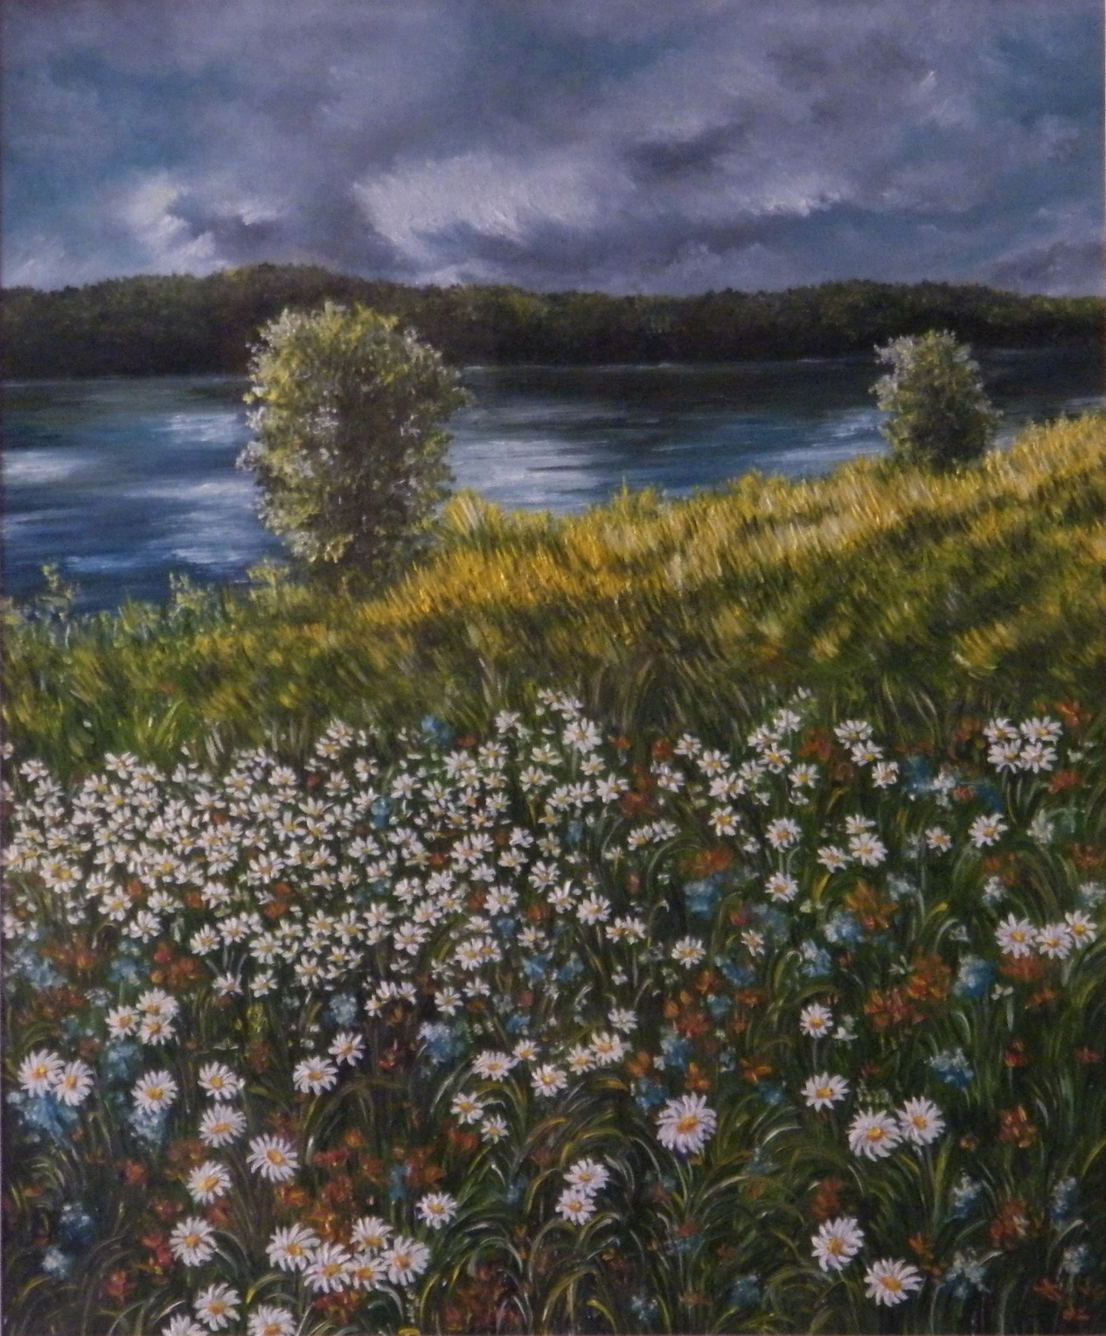

*Oil on canvas / year 2015*

*Medium / 18 inches x 20 1nches*

*(In private collection)*

***“Painting from nature is not copying the object; it is realizing one's sensations”.***

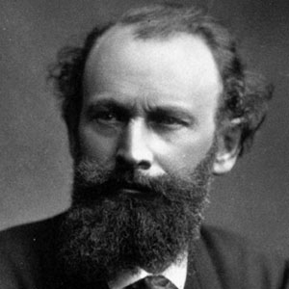

***Paul Cezanne***

***MOODS OF THE UNIVERSE…….***

*The myriad seasons come and go…*

*Like bliss and sorrow.*

*Love and pain.*

*Filled with passion and with melancholy.*

*Full of shades of every hue.*

*Moods of the Universe they surely are.*

*Spring a moment of cheer.*

*Languorous Summer.*

*Monsoon of unpredictability.*

*Autumn for the heart.*

*Winter for the soul.*

*Moods of the Universe they surely are….*

**THE FALL COLLECTION**

*A TRIBUTE TO AUTUMN*

***AUTUMN FLAMES***

***As nature breathes its last sigh,***

***Love and memories burn high.***

***All is set ablaze in hues of fire.***

***Everything is aflame with the last desire.***

***Tall birches turn a colour of gold.***

***Maple is soaked in a red so bold.***

***Brown leaves like yellow pages, rustle as I walk.***

***Crimson leaves like drops of blood, fall from the top....***

***As nature breathes its last sigh.....***

***Love and memories burn high......***

***TEARS OF FALL***

*Like teardrops of many hues.*

*Yellows, reds and flaming hues.*

*Teardrops of memories hang on the trees.*

*Float….*

*Carried by the winds.*

*Poignant stories of the heart that cannot be told,*

*Are written in the Tears of Fall.*

***TEARS OF FALL ….***

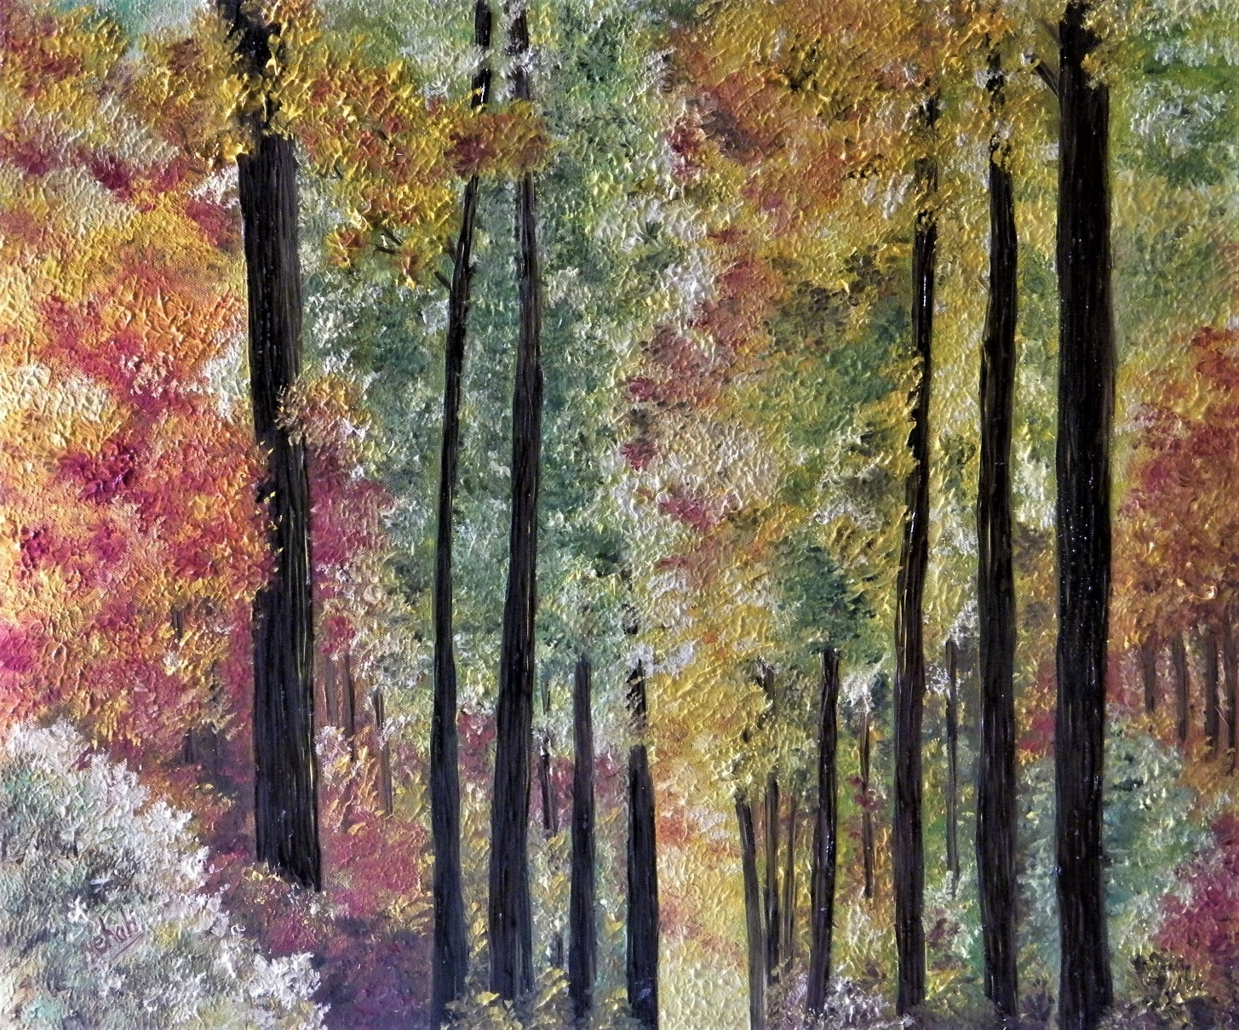

*Oil on Canvas / year 2015*

*Medium / 18 inches X 20 inches*

***STILL WATERS***

*Glassy and Silent.*

*Dark and unrevealing.*

*Still,*

*Absolutely still.*

*They mirror the world around.*

*The glassy reflections.*

*Deceptively calm,*

*Hide the turbulence deep within.*

*Still waters run deep,*

*So they say….*

***STILL WATERS ….***

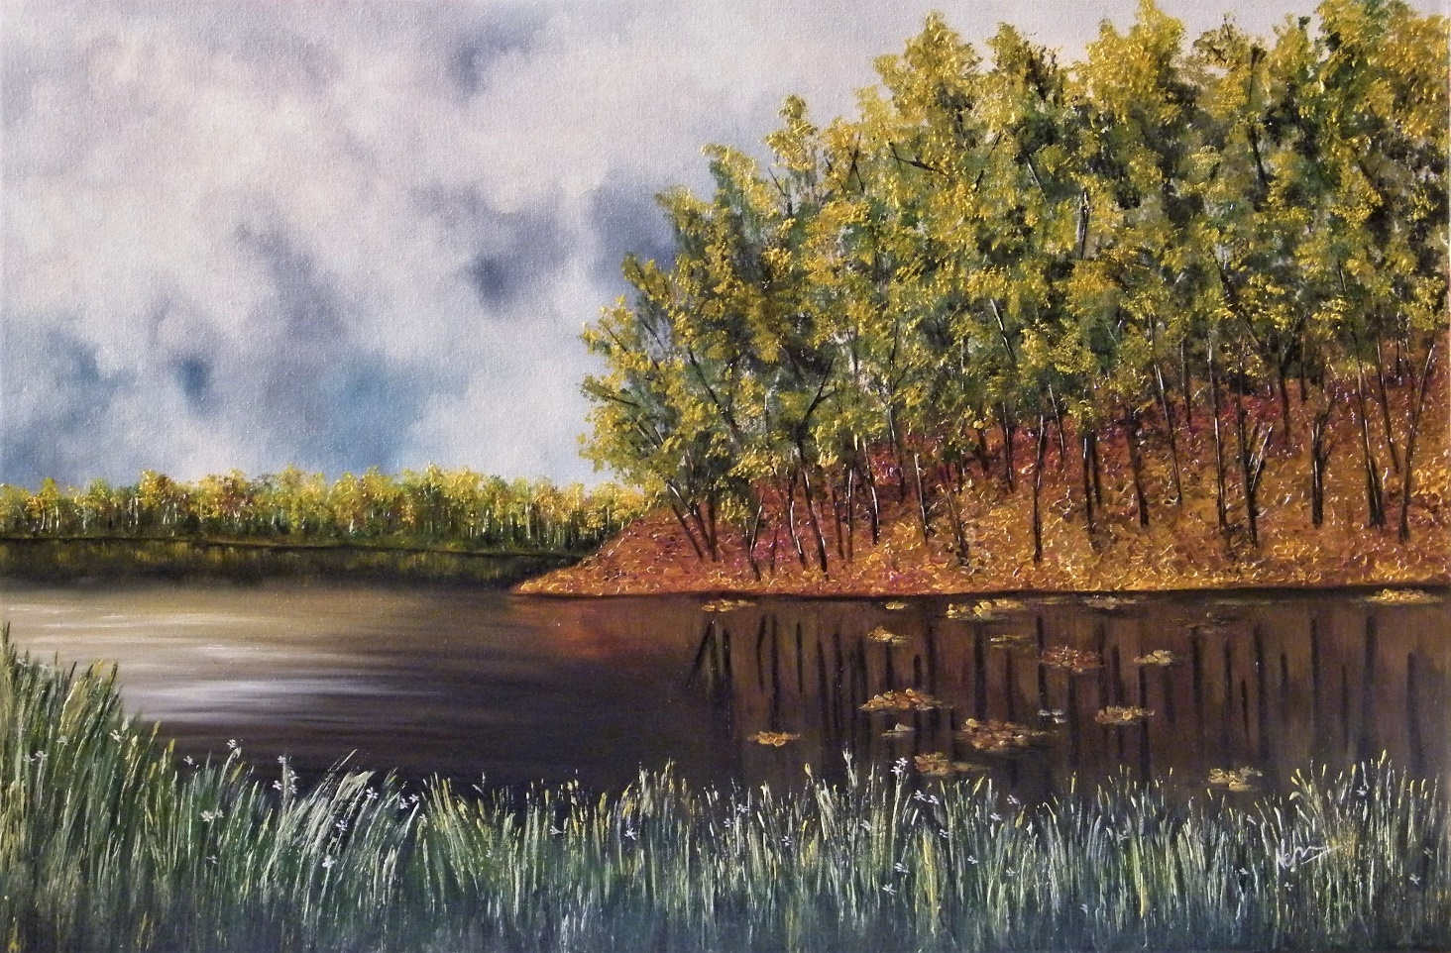

*Oil on Canvas / year 2016*

*Large/ 26 inches x 36 inches*

***GOLDEN RIM***

*Love it was.*

*Born in spring.*

*Like a golden bird in summer it did sing.*

*Monsoon drenched its tender feathers*

*Washed away the deceptions and tethers.*

*Truth stood naked.*

*Confused and cold.*

*But the dying embers strangely glowed.*

*A strange warmth breathed in the heart.*

*Heat of memories that wouldn’t leave.*

*Who knew what winter would bring.*

*Autumn gold was breathing still.*

*A song of love sang the lonely bard*

*A golden rim did surround the heart.*

*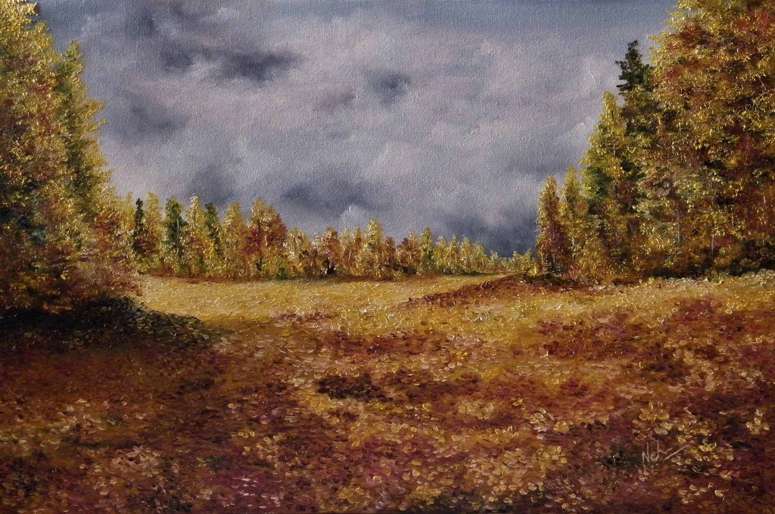****GOLDEN RIM …..***

*Oil on Canvas / year 2016*

*Large/ 26 inches x 36 inches*

***ILLUSIONS***

*It was all so bright.*

*The light dazzled the eyes.*

*Nothing was visible except the shine.*

*Shadows were cast all around.*

*Long and dark.*

*As sharp as the light.*

*Light and Shadow.*

*Both magnified.*

*Creating illusions.*

*But the eyes were blinded.*

*No doubts existed…..*

*The hapless heart did not understand…*

*That sometimes,*

*Perceived clarity and illumination,*

*Creates an illusion of perceived truth.*

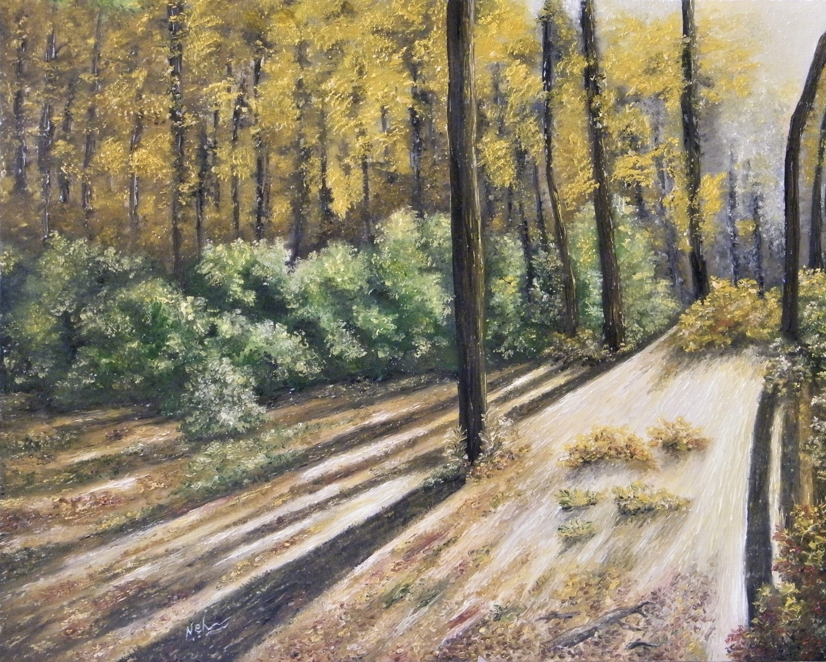***ILLUSIONS …***

*Oil on Canvas / year 2016*

*Large/ 26 inches x 36 inches*

***RUSTLE OF AUTUMN …***

*The cold October sun,*

*Creates a strange mood.*

*The sun looks so warm.*

*Yet it leaves me cold.*

*The rustle of dead autumn leaves makes me wonder…*

*If some life is left in them, still.*

*A seed hides beneath layers of gold and brown.*

*Perhaps it will sprout in spring.*

*Into a dazzling chamomile,*

*Like a spirited wildflower.*

*But it is cold now.*

*Winter knocks at the door.*

***RUSTLE OF AUTUMN…***

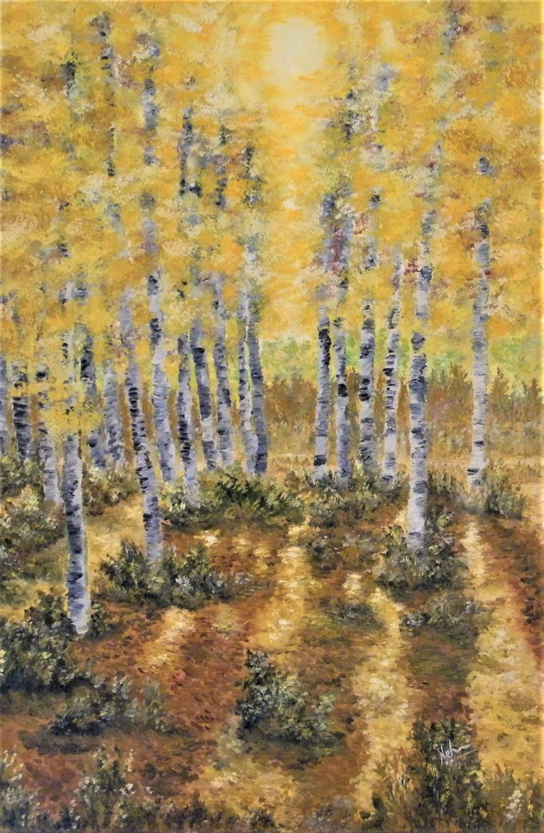

*Oil on Canvas / year 2017*

*Large/ 26 inches x 36 inches*

***HIDDEN ….***

*Hidden in the womb of a forest,*

*Lies a beautiful sanctuary.*

*Where hues of love colour the landscape.*

*And memories float like leaves on water.*

*Where peace and harmony resides like a symphony.*

*Where questions cease and answers unfold.*

*Where silence speaks and sound is silent.*

*To find that sanctuary is the journey.*

*A journey of courage through dark forests.*

*It is hidden deep in your soul.*

*Behind veils and dense fogs.*

*Behind darkness and lighted illusions.*

*To reach it, is a journey of many lifetimes…*

*It lies hidden*

*Deep within.*

***HIDDEN ….***

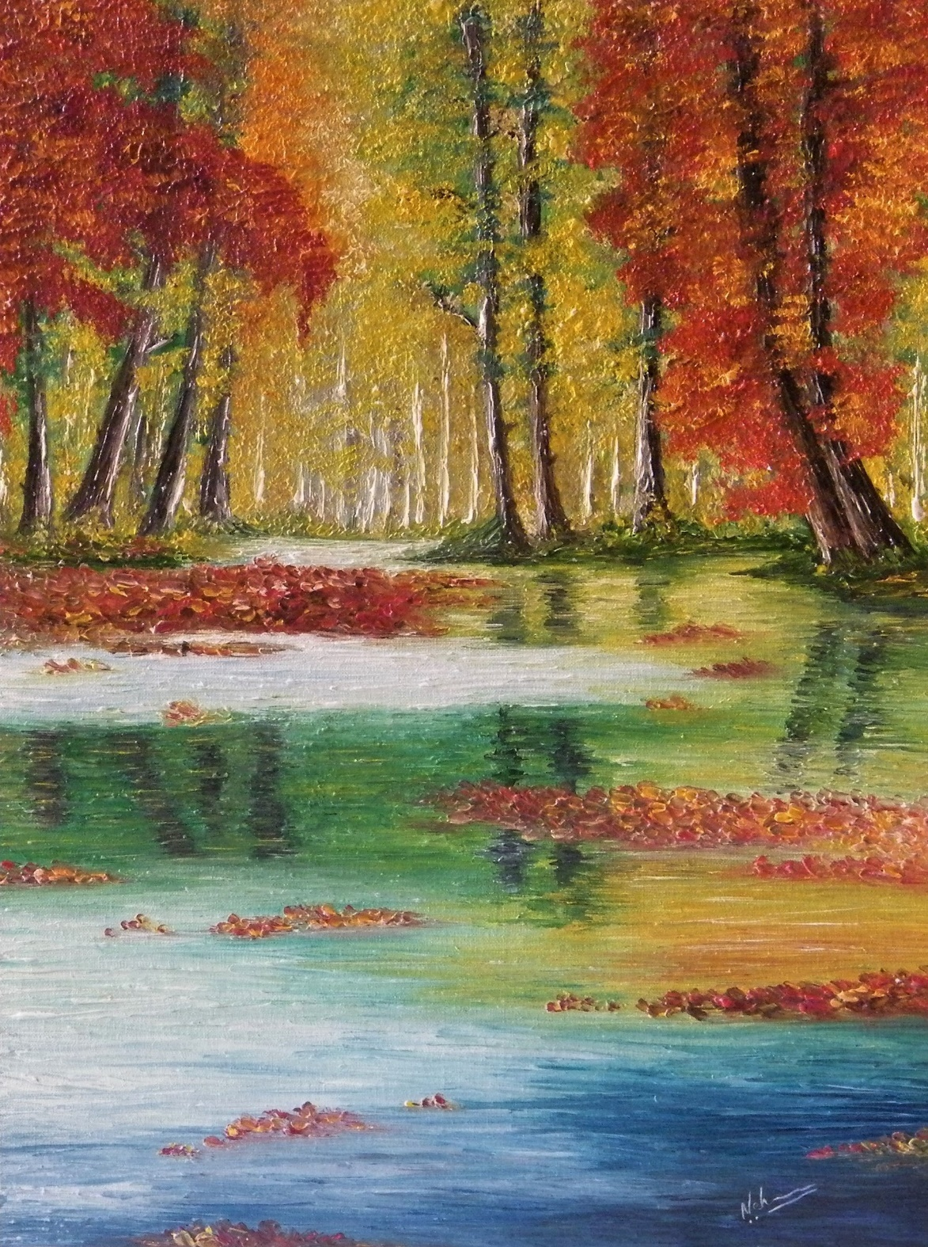

*Oil on Canvas / year 2015*

*Medium / 18 inches x 20 inches*

***AUTUMN SANCTUM***

*A time of year and age comes.*

*When the heart basks in the golden warmth.*

*In the golden rain of an autumn sanctum.*

*Memories come flooding.*

*Like letters on floating leaves.*

*The earth becomes a golden sheet*

*Of wealth accumulated through years gone by ….*

*A time of year and age comes….*

***AUTUMN SANCTUM….***

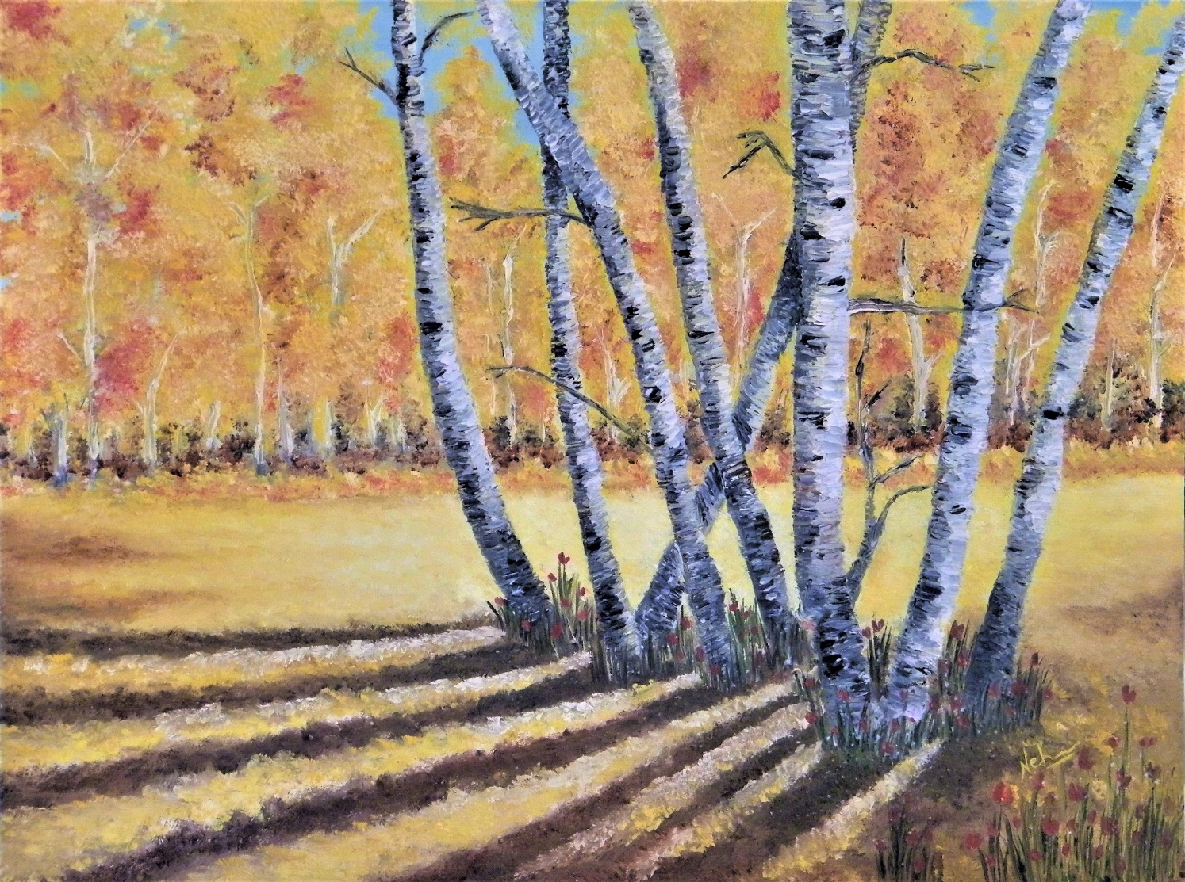

*Oil on Canvas / year 2015*

*Medium/ 18 inches x 20 inches*

***SOLITARY***

*Playfully blows the wind.*

*Through mountains and meadows.*

*Caressing the trees,*

*Tickling the grass.*

*Carrying a lover’s letter to his beloved.*

*Tofar off lands.*

*Playfully blows the wind.*

*The song of the wind only a solitary heart hears.*

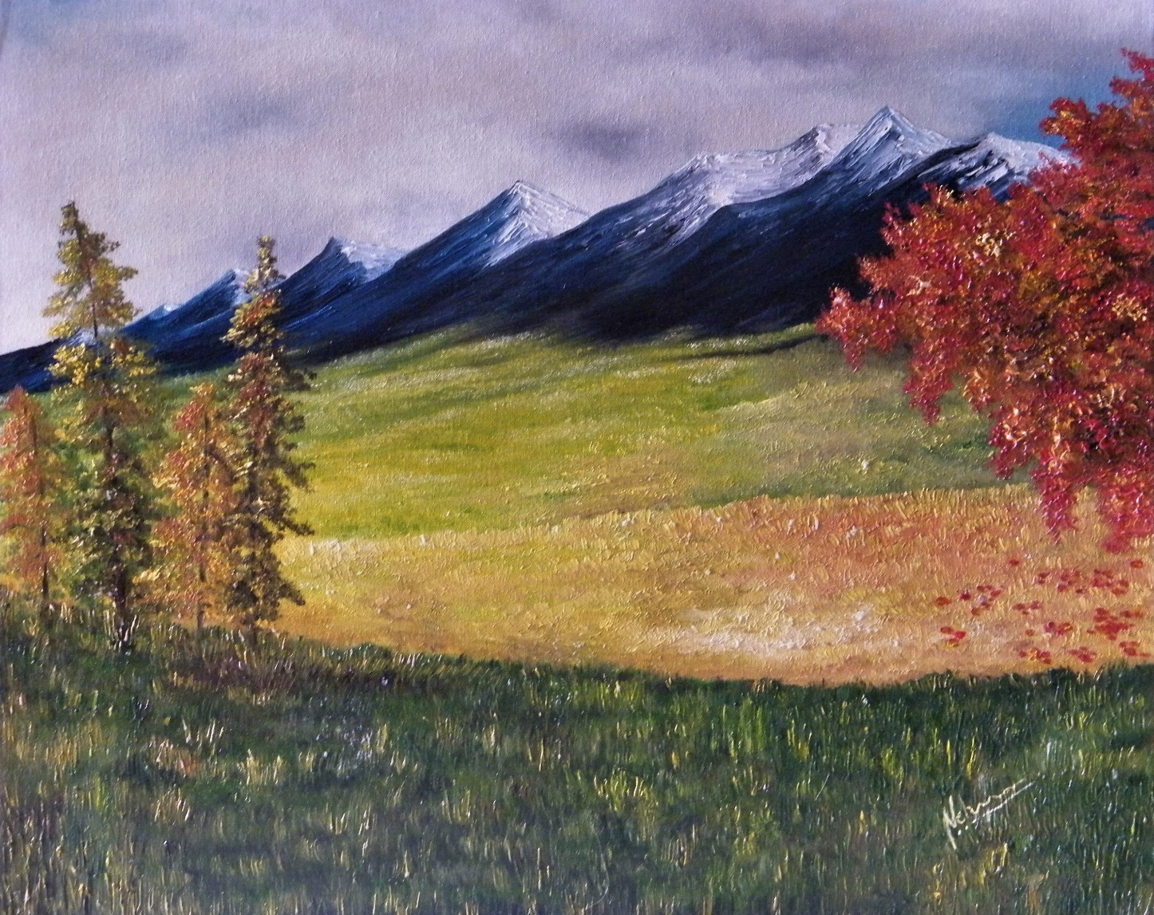***SOLITARY…..***

*Oil on Canvas / year 2015*

*Medium / 20 inches x 24 inches*

***FLY AWAY…***

*Heart flies away*

*On the wings of the wind.*

*To distant lands and shores.*

*Where the Golden Birch stands tall.*

*Perhaps awaiting my arrival.*

*Or meeting my soul in the scent of the breeze.*

*My heart flies away.*

*On the wings of the wind…..*

*My love aligns with the universe.*

*Floats like clouds,*

*Drops like kisses of raindrops.*

*Covers the earth in golden leaves.*

*My heart flies away*

*On the wings of the wind….*

*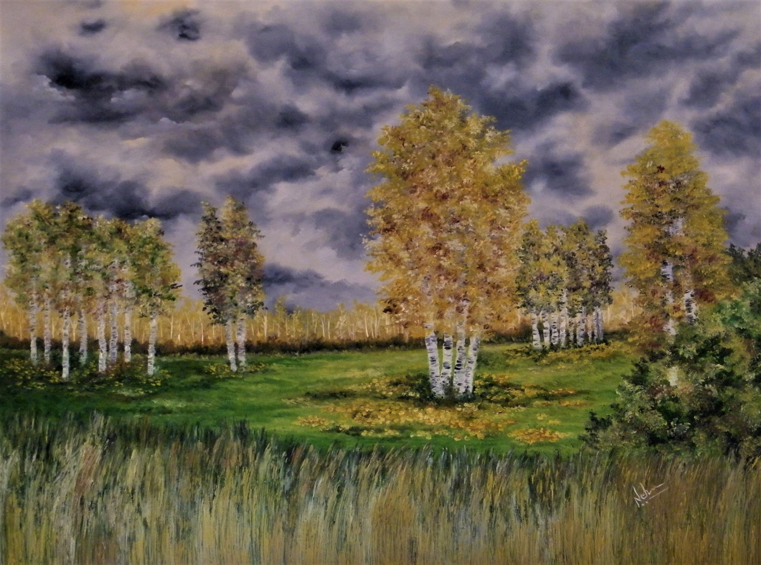****FLY AWAY…***

*Oil on Canvas / year 2017*

*Large/ 36 inches x 36 inches*

***BLUE MIRROR***

*In the languorous autumn afternoons,*

*Even the deep waters seem to sleep.*

*Deceptive reflections weave illusions so enticing.*

*Beneath the floating white clouds,*

*Hearing the lullaby of rustling yellow leaves,*

*Still waters dream intoxicatingly sweet dreams.*

*You, my love, were a midsummer night's dream!*

*A midsummer night's dream that forever floats in the air …*

*Clings to the soul like an indescribable scent.*

*The blue mirror hides in its depths,*

*Secrets that once lived.*

*Secrets that now lie silent in the deep blue depths.*

*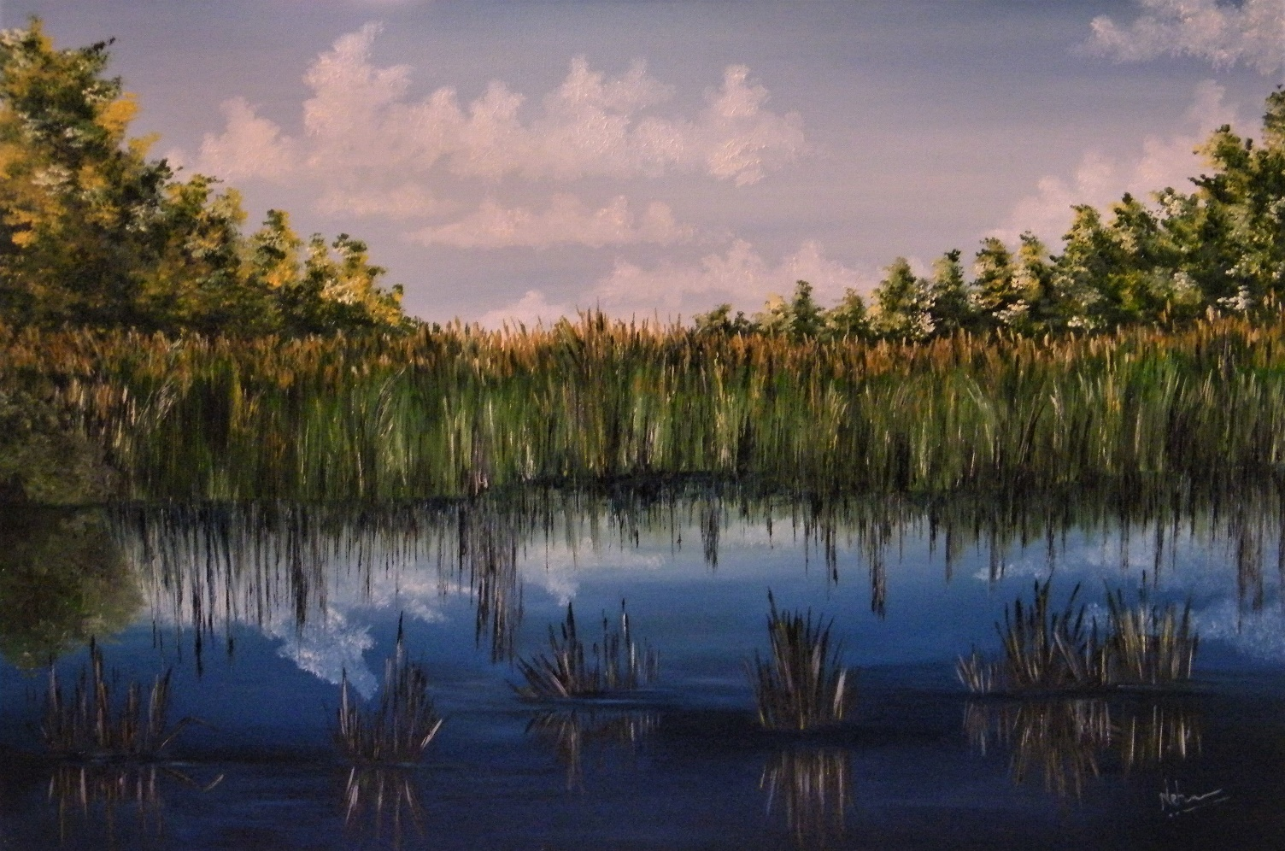****BLUE MIRROR …..***

*Oil on Canvas / year 2016*

*Large/ 26 inches x 36 inches*

***A TRYST IN TIME***

*All the Universe works on clockwork precision.*

*Erases nothing, conceals nothing.*

*Only cycles tick-tock.*

*Nothing is forgotten.*

*Nothing is forgiven.*

*Thoughts and deeds, once created,*

*Become energies that forever float in aether.*

*Everything is a dot in the timeline.*

*You and me,*

*It is a Tryst in Time…..*

***A TRYST IN TIME….***

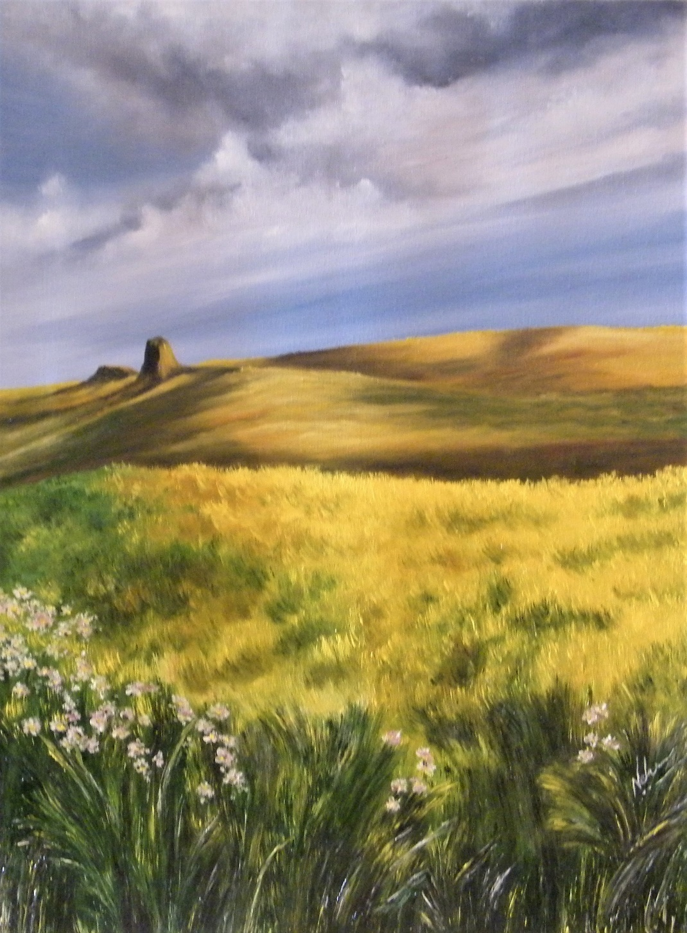

*Oil on Canvas/ year 2016*

*Medium / 16 inches x 20 inches*

***RISING MIST***

*As the sun shines,*

*Bringing warmth to the ground.*

*The dewy illusions of the night,*

*Turn into a haze of fog.*

*With the rising mist,*

*Dreams evaporate in wafts of misty clouds.*

*Truth unfolds.*

*Colours and elements catch the new rays.*

*A veil lifts…*

*A new day begins …..*

***RISING MIST…***

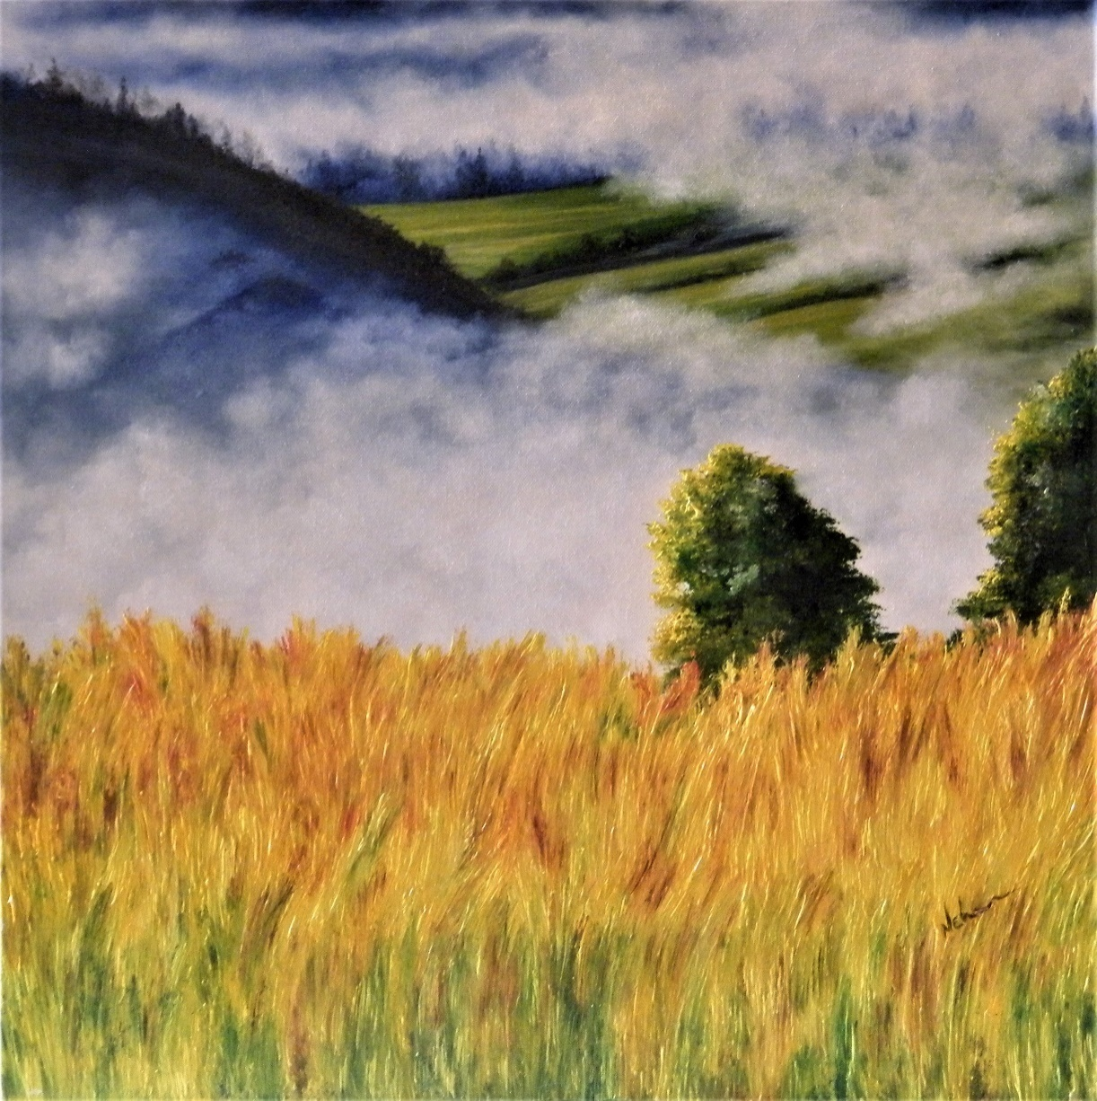

*Oil on Canvas / year 2016*

*Medium / 18 inches x 20 inches*

***AMBER DAWN***

*As earth catches fire,*

*With the light of dawn,*

*The autumn amber grass like ember glows.*

*Warm with love, wet with dewy tears.*

*And*

*Flashes in the mind,*

*Of  
All we remember,*

*All we yearn for,  
Like a sigh and a moan,*

*Despair and hope,*

*Entwine together,  
In an amber dawn.*

***AMBER DAWN….***

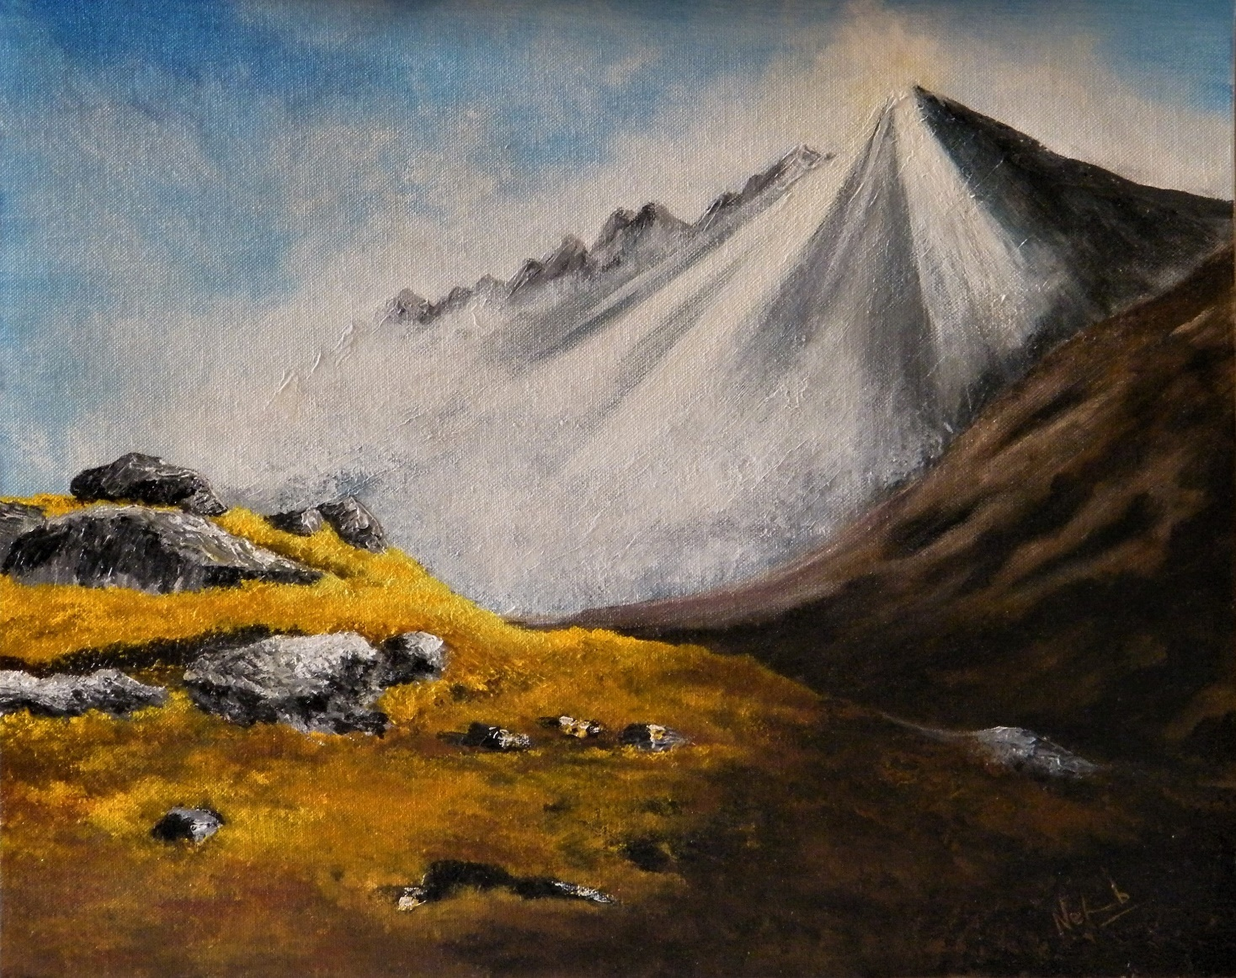

*Acrylic on Canvas / year 2015*

*Medium / 18 inches x 20 inches*

***RED FOREST***

*As the red Maple sheds its leaves.*

*The blood of autumn falls like drops.*

*In the Red Forest,*

*Etched in blood,*

*Hang from trees,*

*Float in the breeze,*

*A thousand stories of loves lived and lost.*

*The little tree window in a red forest,*

*Looks heavenwards,*

*Filled with love,*

*Lost or sought…..*

***RED FOREST …***

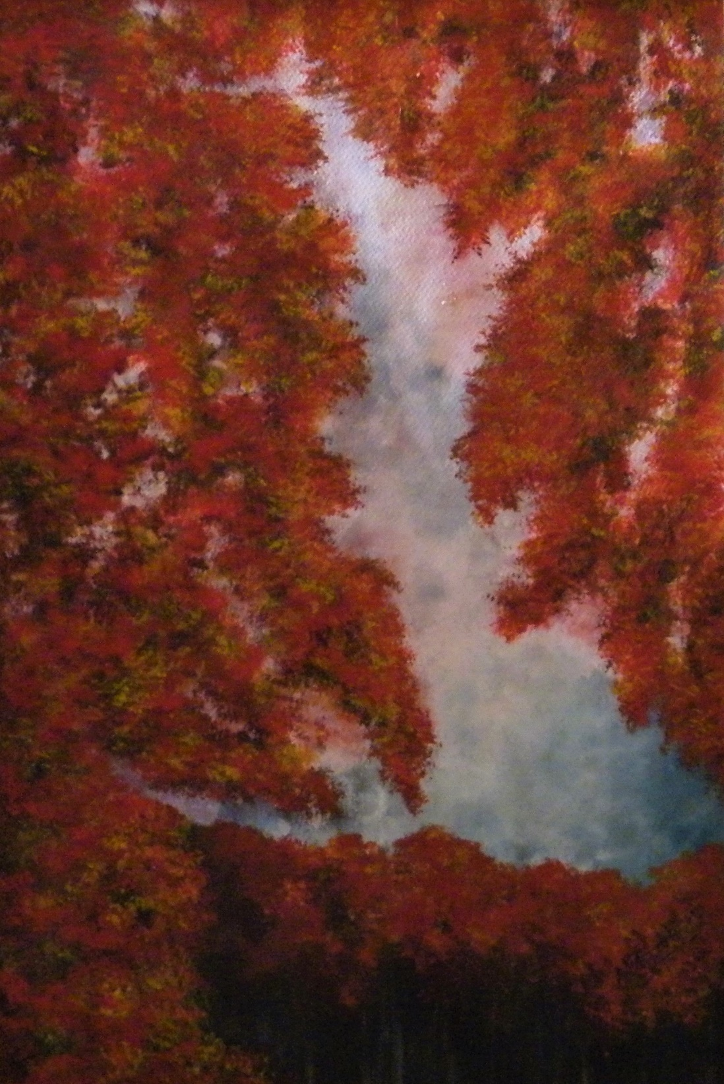

*Watercolour on Paper/ year 2013*

*Medium / 20 inches x 16 inches*

***BLUE DUSK***

*In the twilight zone,*

*Colours change.*

*A haze of blue falls, moods change.*

*Shapes in the mind are manifested in sight.*

*Joy is happier,*

*Sorrow sadder.*

*Somethings are brighter.*

*Some darker*

*It is real and unreal,*

*When caught in the veil of a Blue Dusk.*

***BLUE DUSK.......***

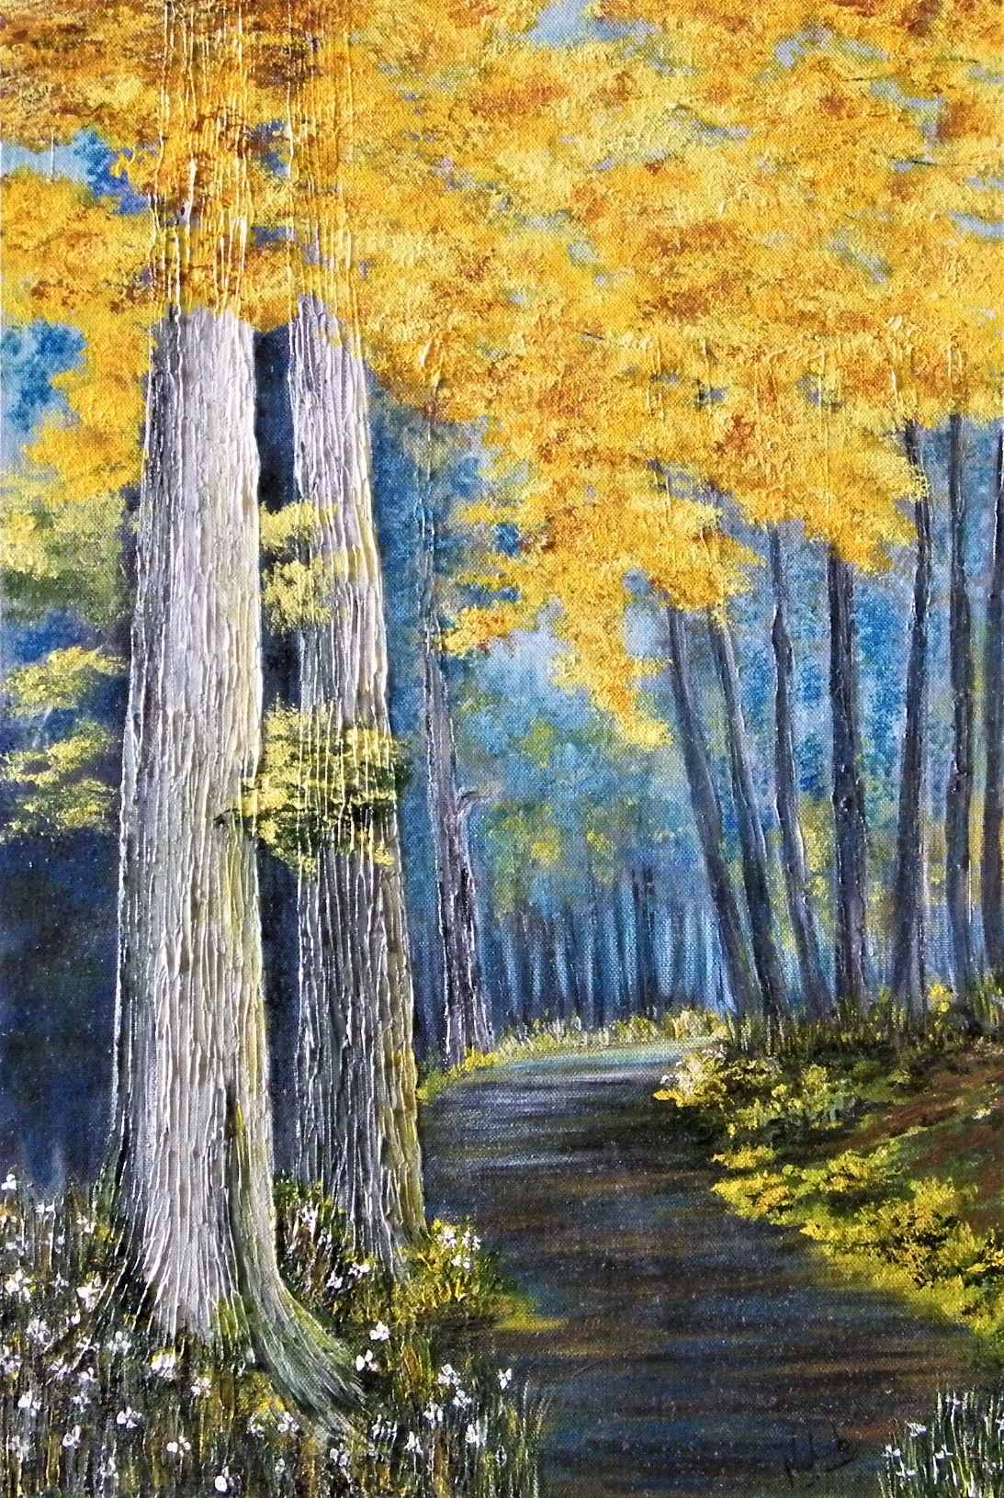

*Acrylic on Canvas / year 2015*

*Medium/ 20 inches x 24 inches*

***WOODLAND PATH***

*Wandering through woods,*

*Vibrant or dark,*

*You never ever know,*

*Where a woodland path might open.*

*The dark twisting path may lead to beautiful meadows.*

*Or the beautiful flower lined paths may open into swamps.*

*But a chance you’ve got to take,*

*And walk through woodland paths.*

*To find the pastures that are meant for you,*

*While wandering through woods,*

***WOODLAND PATH…..***

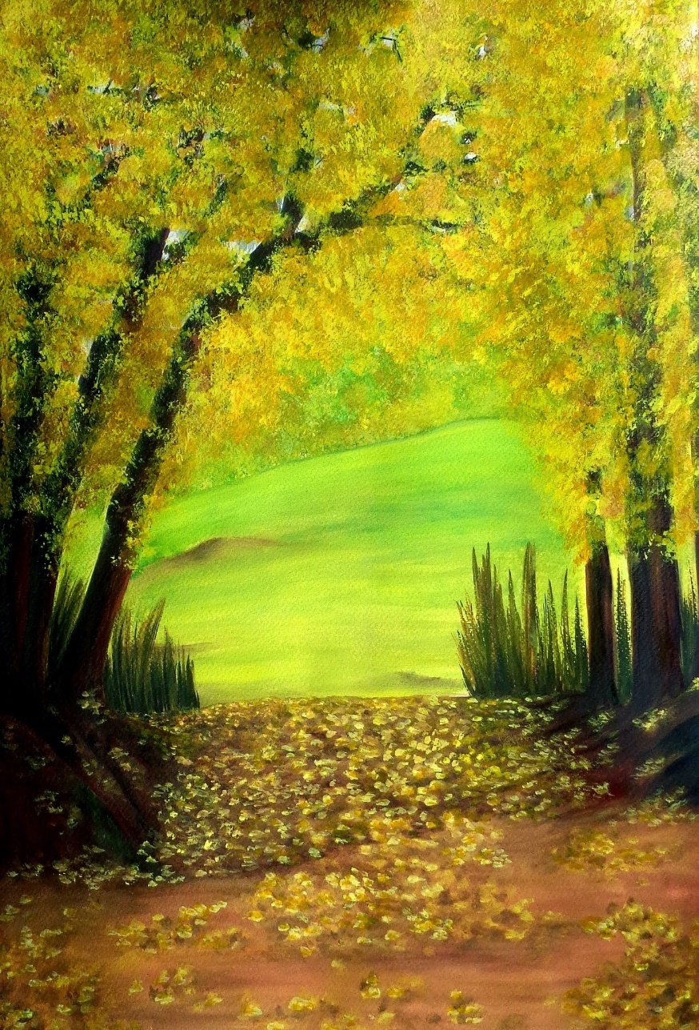

*Watercolour on paper/ year 2013*

*Medium / 24 inches x 18 inches*

***CRIMSON OFFERRING***

*Blood of autumn*

*Falls on earth.*

*Like a crimson offering*

*To the Universe.*

*An offering of love and passion.*

*A desire to annihilate self to meet the one.*

*A crimson offering,*

*At the doorway to freedom.*

*Blood of autumn*

*Falls on earth.*

***CRIMSON OFFERRING …..***

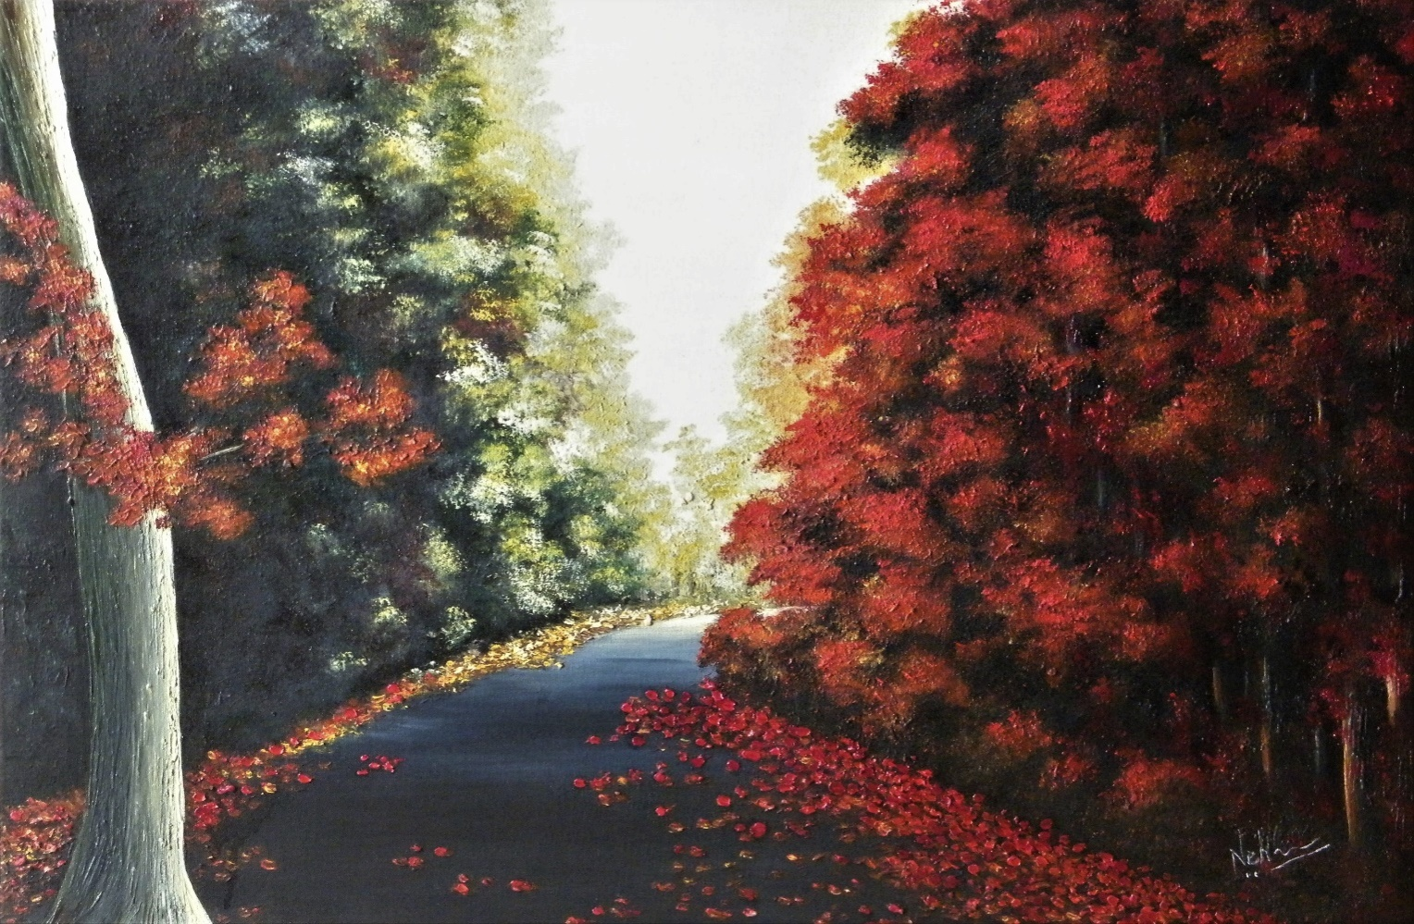

*Oil on Canvas / year 2015*

*Medium / 20 inches x 24 inches*

***TWIN WALTZ ….***

*Reflections of the heart,*

*Like the breeze,*

*Enterevery crevice, nook and cranny,*

*Uninvited and uncalled.*

*Like the snow that settles into every crack.*

*The onset of winter and the farewell of fall,*

*Are two worlds, and both beautiful.*

*A time of the year when two cycles co-exist.*

*A time of transformation,*

*When old and new breathe together.*

*When sorrow of a farewell embraces the joy of a welcome.*

*It is nature’s twin waltz.*

*Two seasons sing their own songs in perfect rhythm,*

*Creating a new melody.*

*When golden Fall*

*Flames upon white Winter.*

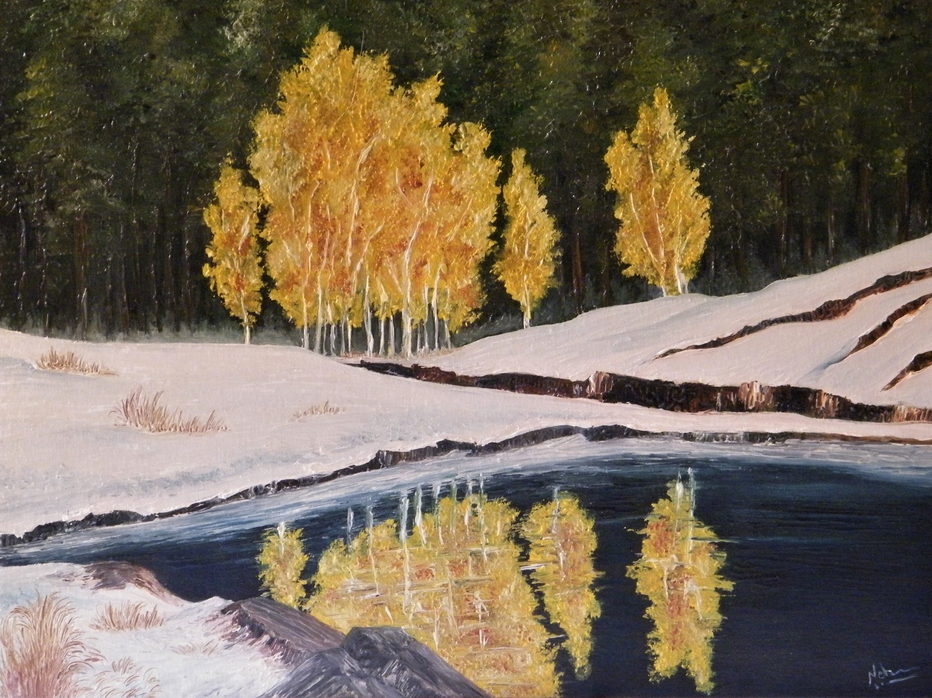***TWIN WALTZ ….***

*Oil on Canvas / year 2015*

*Medium / 20 x 24 inches*

*KASHMIR*

*Once, famous Persian poet, Amir Khusru wrote in Persian, these lines, describing Kashmir ….*

*"Agar firdaus bar roo-e zameenast,  
Hameenast-o, hameenast-o, hameenast.”*

*… If there is a paradise on earth,  
It is this, it is this, it is this….*

*Once a paradise, Kashmir bleeds helplessly today. But there was time when melody and laughter rang through the valley. Today bullets and fear whizzpast.Who is justified and who is unjust is not the question anymore.Whose blood will make the river red, this is the mood of the Valley! People suffer! Rivers bleed! Forests cannot breathe! But it was once a paradise.*

*Autumn of every place is unique in colour. Autumn of Kashmir Valley is saffron in colour. Chinar tree is embedded in the culture and topography of Kashmir. Vibrant and mellow saffron orange of the autumn leaves of Chinar tree create a magical saffron canopy and carpet. Also, the fragrant and aromatic Saffron Herb is native to Kashmir.*

*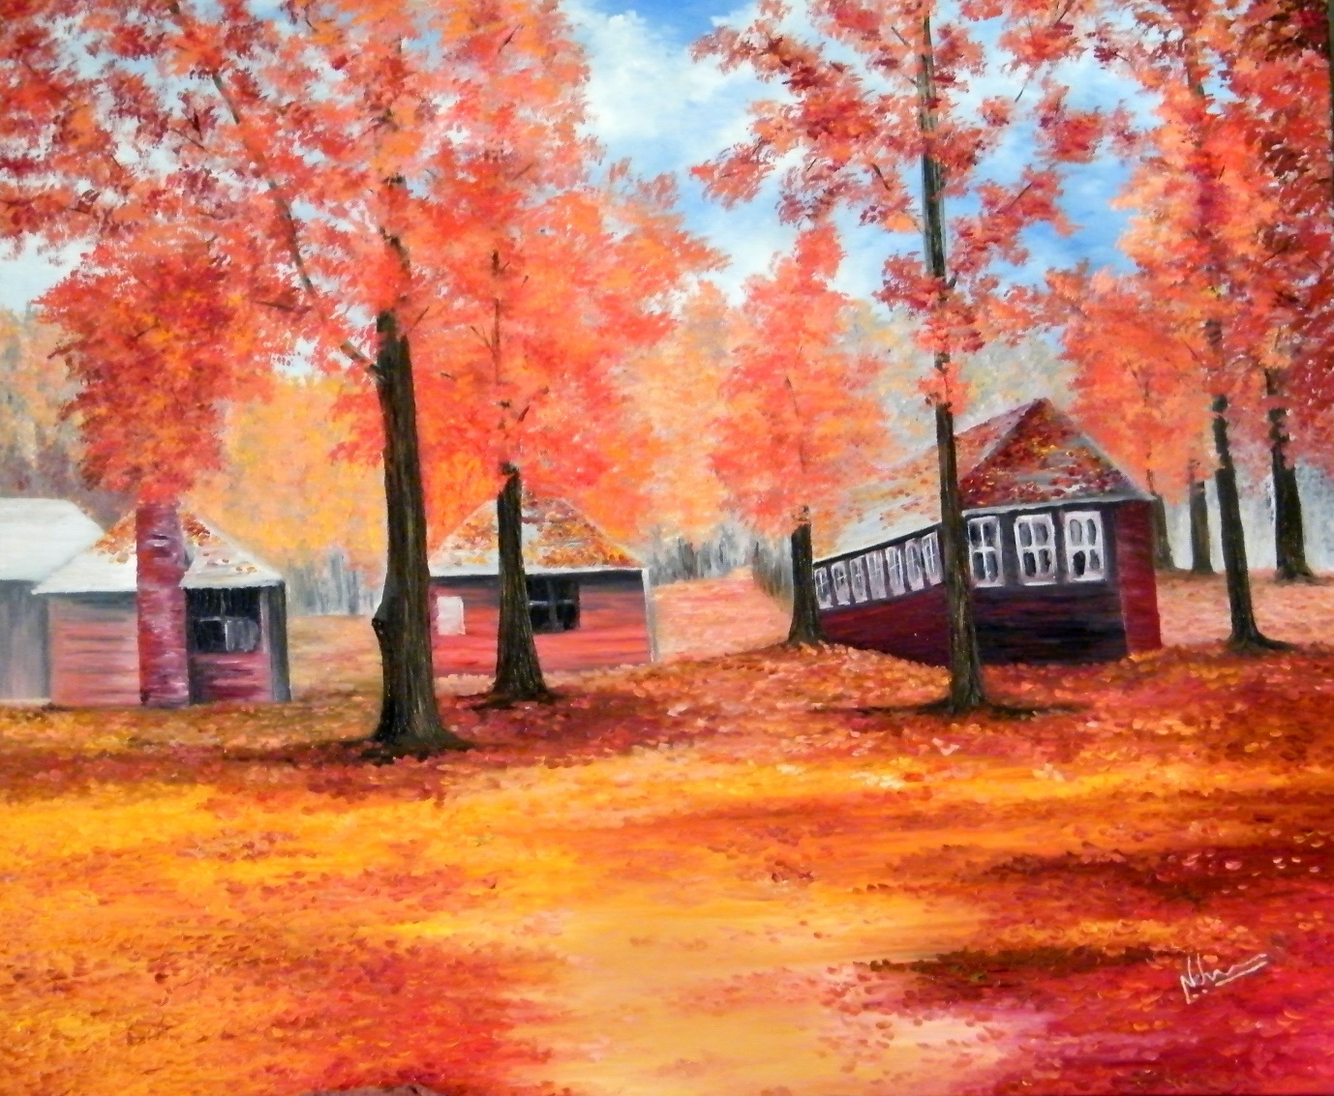KASHMIR …..*

*Oil on Canvas / year 2017*

*Large / 36 inches x 36 inches*

*The beauty of Kashmir, Amir Khusru’s Paradise, in the Saffron autumn of Chinar is unparalleled.*

*This painting was commissioned by a client whose ancestral home is in Kashmir.*

***WINTER'S ONSET AT THE EDGE OF A FOREST***

*Walking down a snowy road.  
At autumn’s end, winter’s onset.  
At the edge of the forest that allures and beckons.  
I stop and look.  
Should I enter?*

*And see its treasures?  
Or should I simply pass it by?*

*I can hear the birds chirping.  
But it looks so dark.  
I ponder…  
Should I enter?*

*And see its treasures?  
Or should I simply pass it by?*

*It will be nightfall soon! ......*

***WINTER'S ONSET AT THE EDGE OF A FOREST***

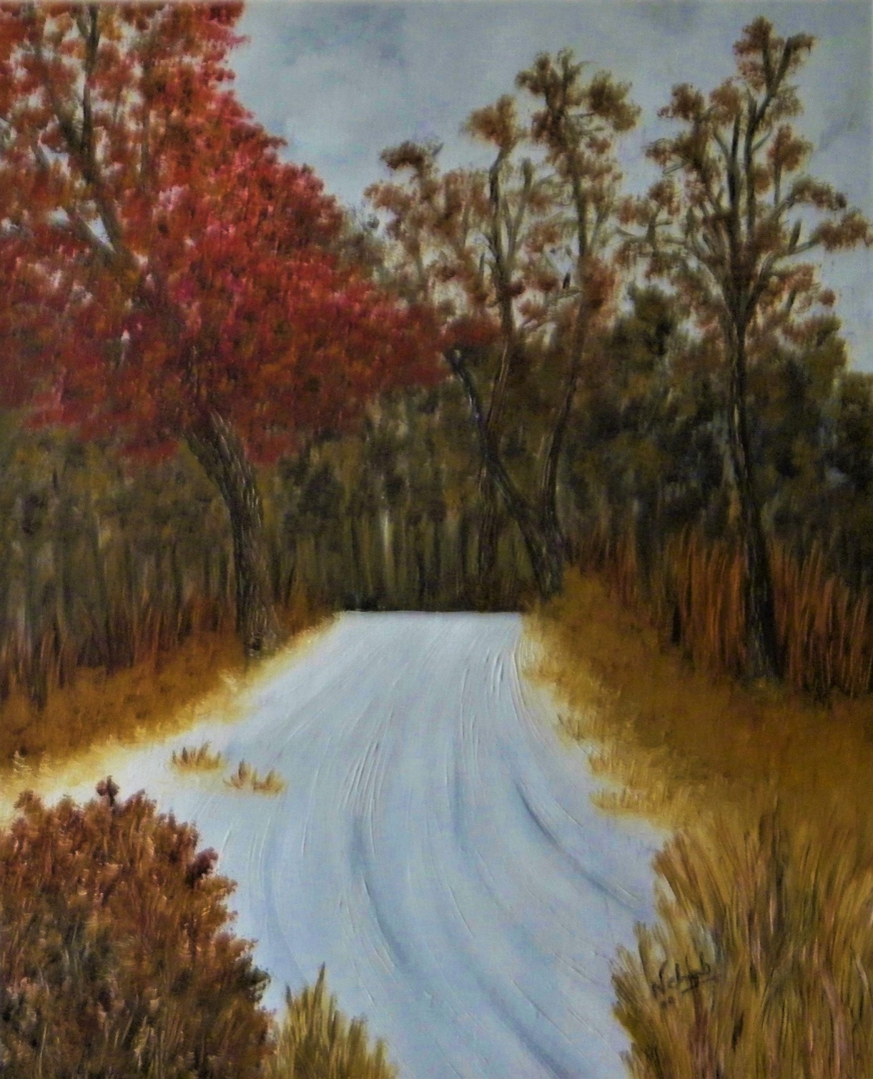

*Oil on canvas / year 2014*

*Medium / 20 X 24 inches*

***WINTER HUES***

*A TRIBUTE TO WINTER*

***SILENCE AND BLISS***

*The greys and whites.*

*Sunshine, blinding bright.*

*Blue tones hiding the many hues.*

*Speak of a journey vibrant and true.*

*Sometimes melancholic,*

*Sometimes warm,*

*The wisdom of the hermit*

*Lies in the wintry winds, full of frost.*

*A time of patience.*

*A time of waiting.*

*Winter is a pause you must respect.*

*A time to reflect*

*And slow the spinning.*

*If you can hear the cold winds and read the white snow.*

*If you can understand the stillness in the air*

*And the anxious turbulence in grey skies,*

*You will know what the Universe speaks,*

*About the cycle of life.*

***WINTER BLUES ….***

*In the stillness of white,*

*Beneath overcast skies,*

*Heart searches….*

*Searches in the cold north winds,*

*In the frozen grass.*

*The memory of a spring left behind.*

*Regrets, there are none.*

*It is just a winter mood.*

*The wine is passion red.*

*The sky is a stormy blue.*

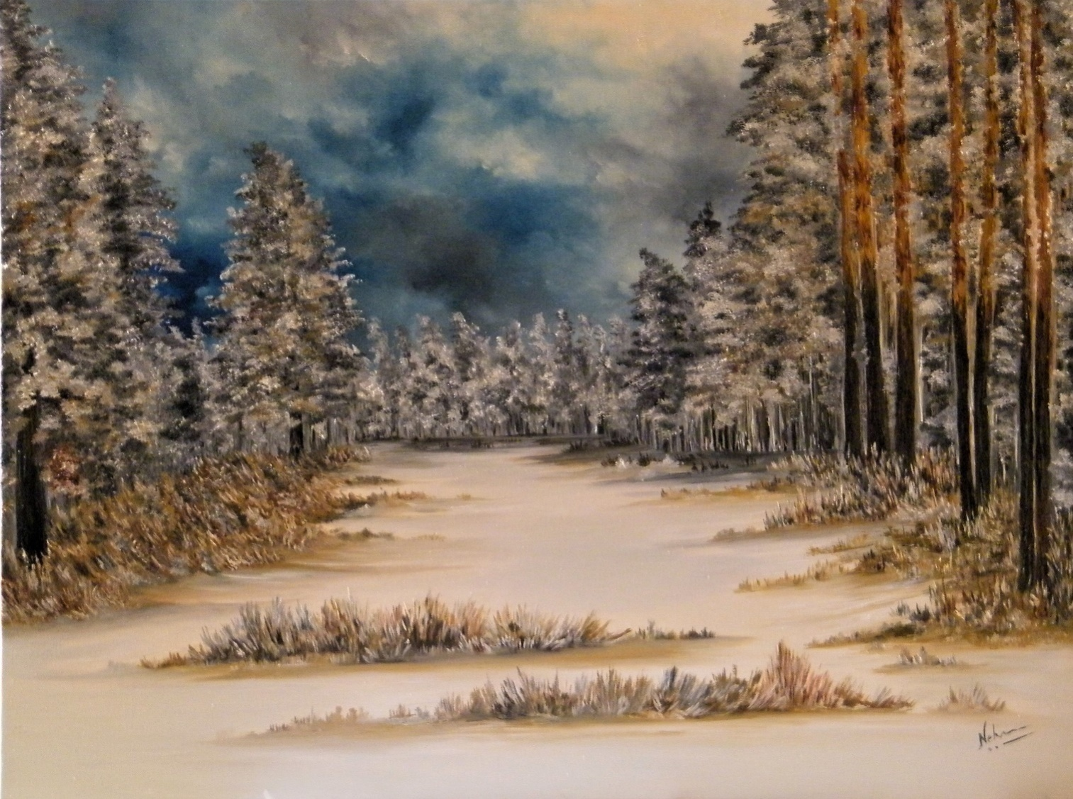***WINTER BLUES …..***

*Oil on Canvas / year 2017*

*Large / 26 inches x 36 inches*

***A WINTER SONG …***

*Like a white veil,*

*Snow covers earth.*

*Branches are like white lace,*

*And leaves like silver tassels.*

*Mist dances in and out.*

*Sunshine has its moods.*

*Snowbirds and cardinals take playful flights.*

*Cherries hang like ruby red necklace.*

*It is a winter song that nature hums,*

*To put a pause on the spinning wheel.*

*After all,*

*There is work to do,*

*In the tide of spring.*

***A WINTER SONG …***

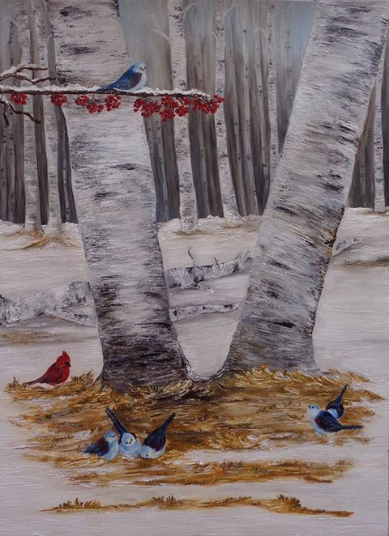

*Watercolour & Acrylic on paper/ year 2015*

*Medium / 20 inches X 18 inches*

***TRANQUIL TRANCE….***

*There is a difference between*

*Loneliness and Solitude.*

*Heart knows it well.*

*One is a struggle of pain.*

*The other is a gift of acceptance gained.*

*One is peace.*

*The other is tears.*

*It is a tranquil trance*

*That casts a spell*

*On a soul that has truly journeyed.*

*And*

*No longer desires to do the dance.*

*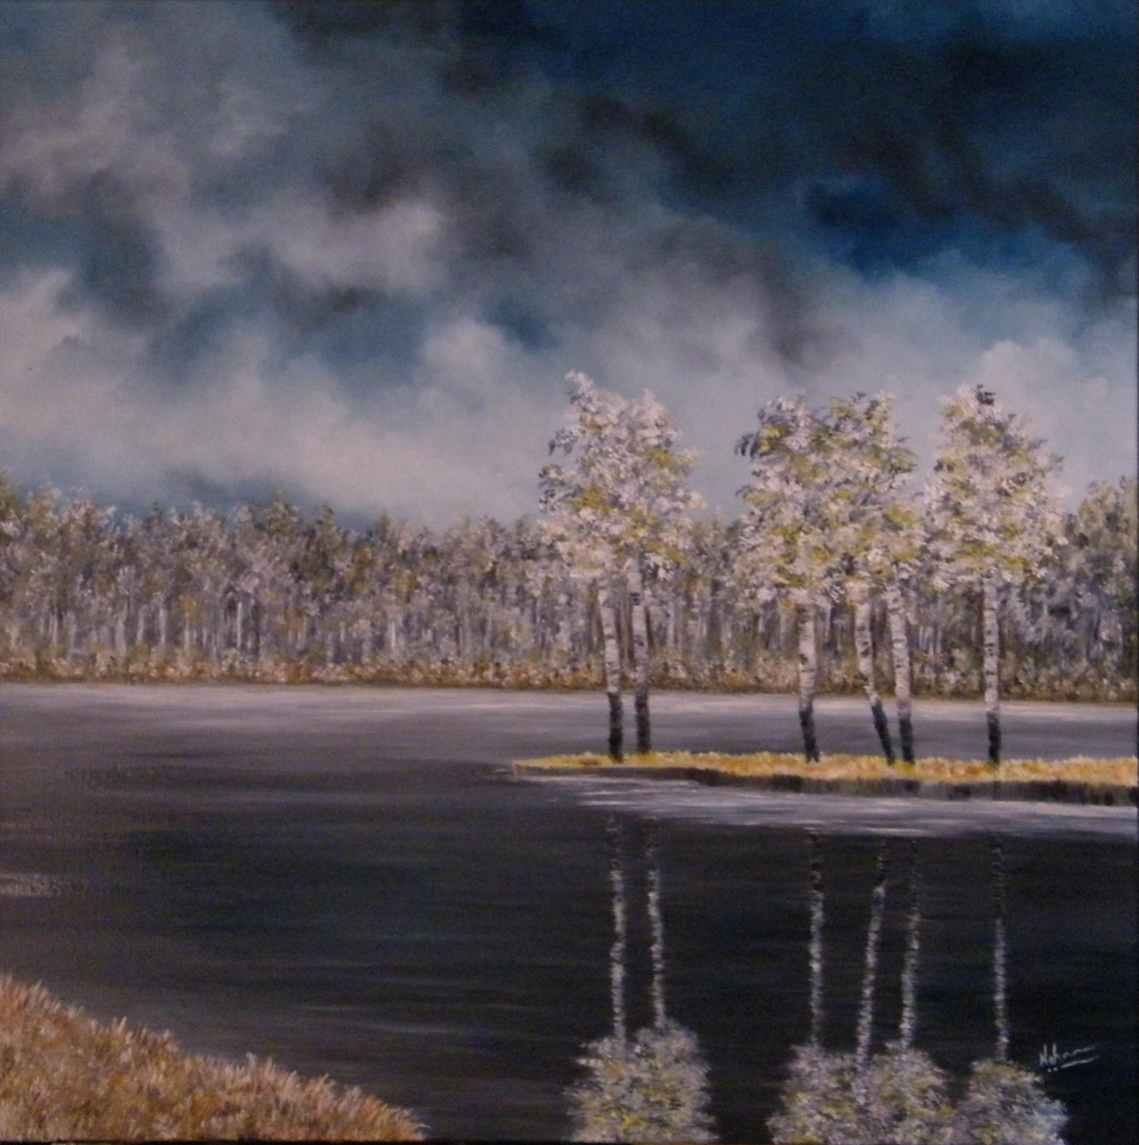****TRANQUIL TRANCE***

*Oil on Canvas / year 2018*

*Large / 36 inches x 40 inches*

***REQUIEM…***

*In beautiful forests, in sunlit snow,*

*Doves fly in freedom*

*Without boundaries.*

*To meet their beloved.*

*In faith and in hope.*

*A requiem of a dream*

This painting has been made in grisaille technique. Grissaille is a method of painting in grey monochrome, typically to imitate sculpture. It originated as an underpainting technique for an oil painting, and as a model for an engraver to work from. Paintings executed in brown are referred to as brunaille, and paintings executed in green are called verdaille.

*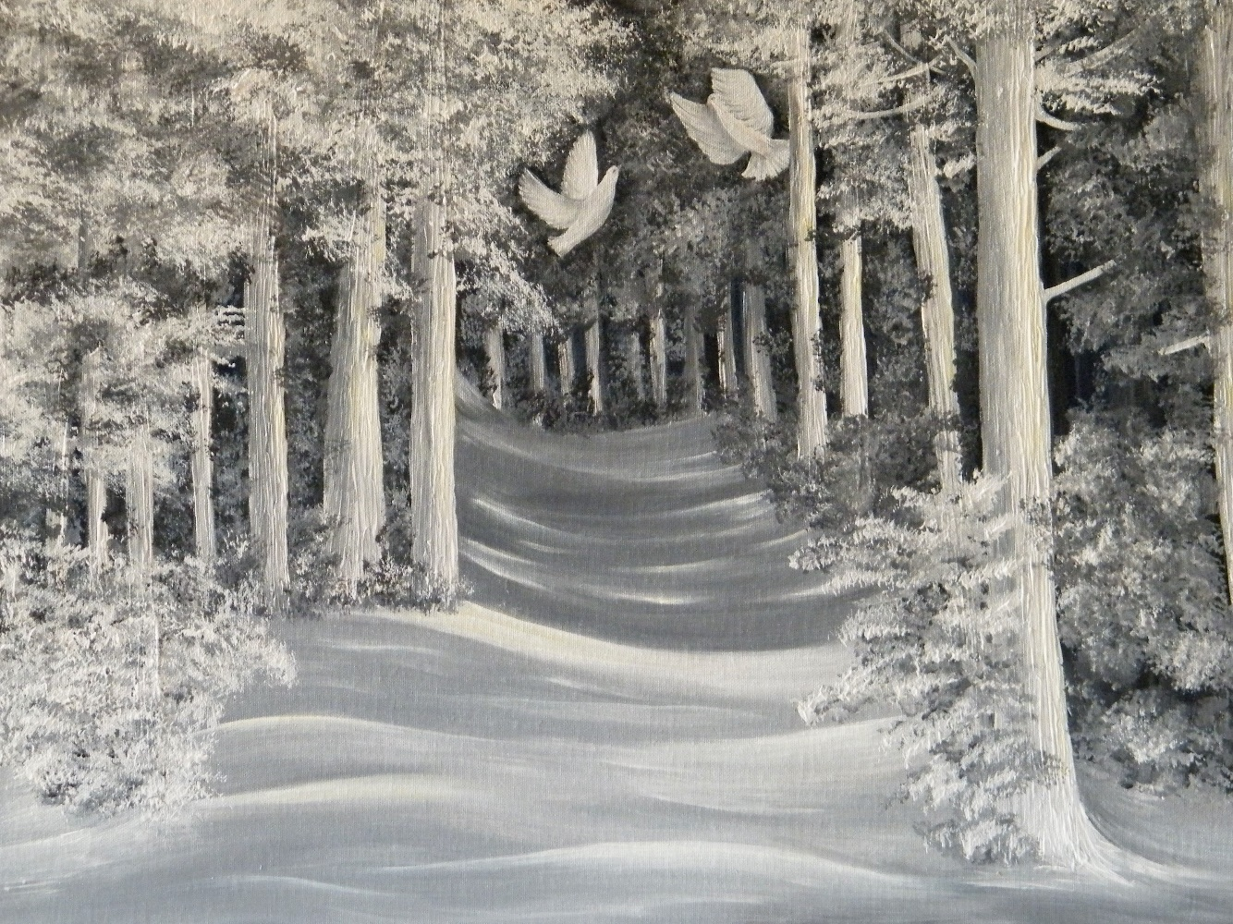****REQUIEM…***

*Acrylic on Canvas / year 2015*

*Medium / 20 inches x 24 inches*

***WINTER WOODS***

*Fog and mist float around.*

*Like fairies and spirits playing amongst trees.*

*Snow laden branches like a cloak cover the trees,*

*Mellow sunlight streams, filtered through the fog.*

*Soft snow blankets the ground like a quilt.*

*The fog, the sunshine and winter white,*

*All enact a scene like a dream.*

*The beauty hides the ruthless cold.*

*Winter woods are places of fantasies untold.*

*Here fairy tales are born in the mystery of the mist and told.*

***WINTER WOODS***

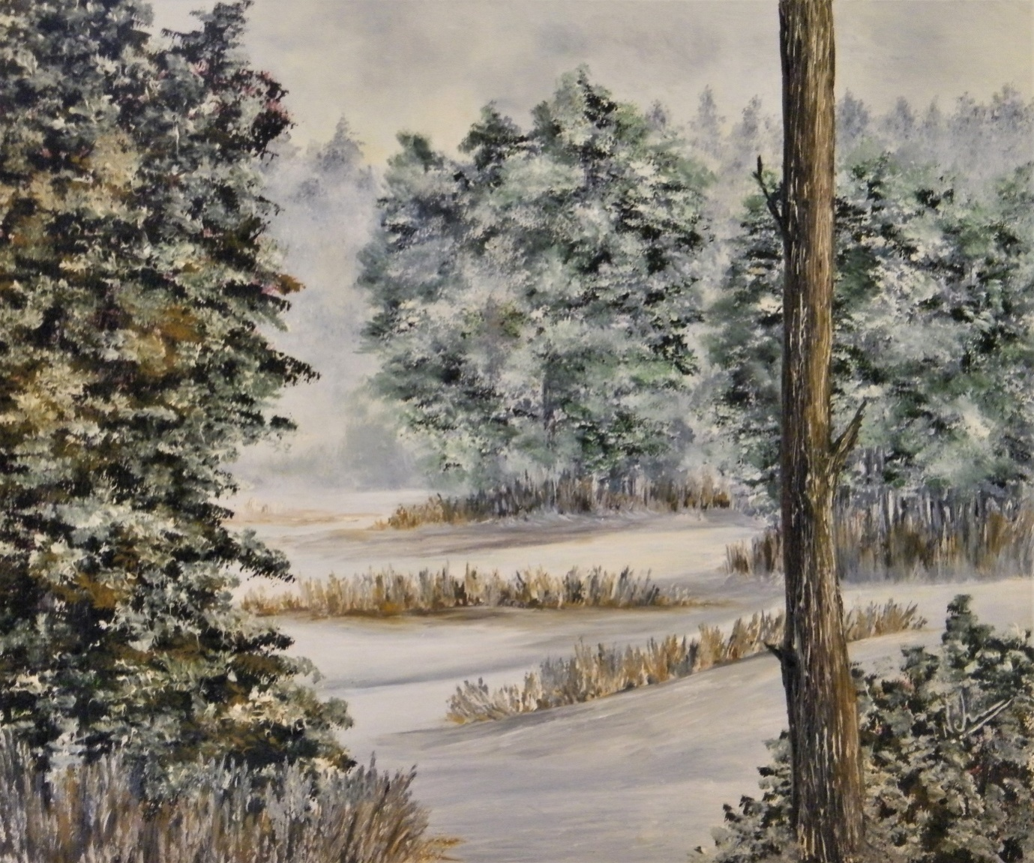

*Oil on Canvas / year 2016*

*Medium / 20 inches x 24 inches*

***SNOW ON SPRUCE***

*Snow on Spruce, like a veil glows.*

*Shining in the moonlight,*

*Glittering in the sun.*

*Paths and bridges lie pristine and untrodden.*

*It is time to sit by the fire, in the warmth of home*

*And reminisce the seasons gone by*

*When Snow on Spruce, like a veil glows…*

*Flowers will bloom sometime soon.*

*Birds will chirp the springtime tune.*

*But right now,*

*It is blissfully silent.*

*Snow on Spruce, like a veil glows…..*

***SNOW ON SPRUCE….***

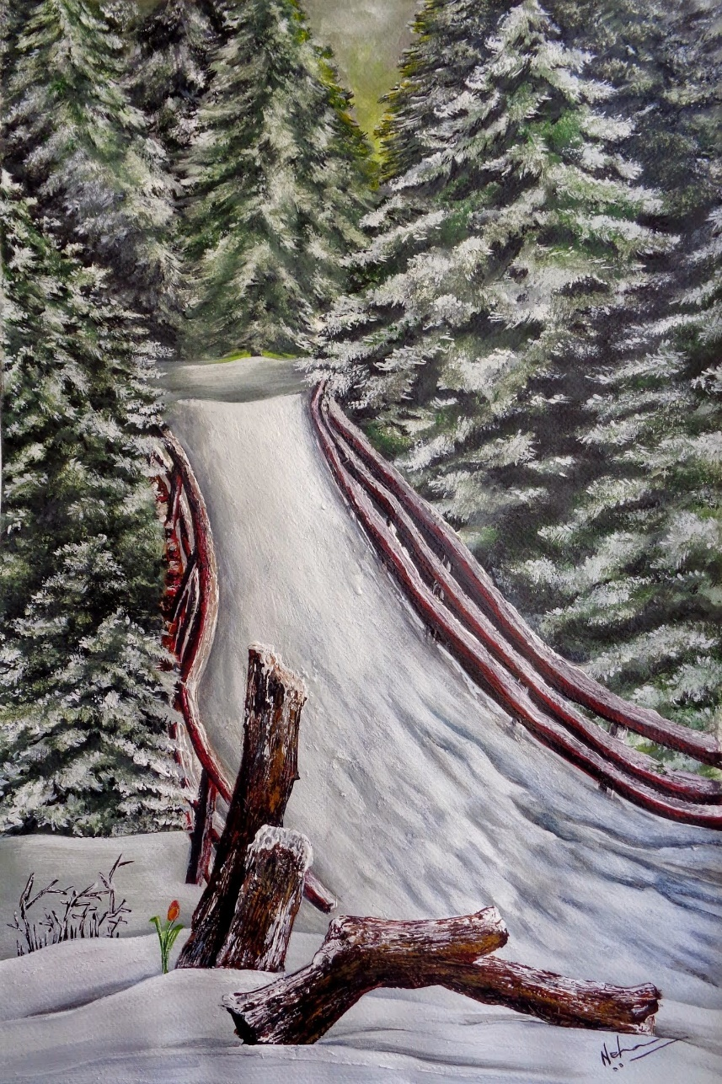

*Watercolour/ year 2014*

*11 inches X 16 inches*

***PRISTINE SILENCE***

*Not every thought is spoken,*

*Not every picture displayed.*

*The fragrance that touches the soul, is like a story untold.*

*Floating in the air, hiding in the fog.*

*Buried in the snow,*

*Crackling in the fire,*

*Smouldering in the embers….*

*Some stories lie frozen*

*In pristine silence.*

*Not every thought is spoken,*

*Not every picture displayed.*

*The embers glow bloody red,*

*The veil is frozen white,*

*In stories that lie frozen,*

*In pristine white.*

***PRISTINE SILENCE …***

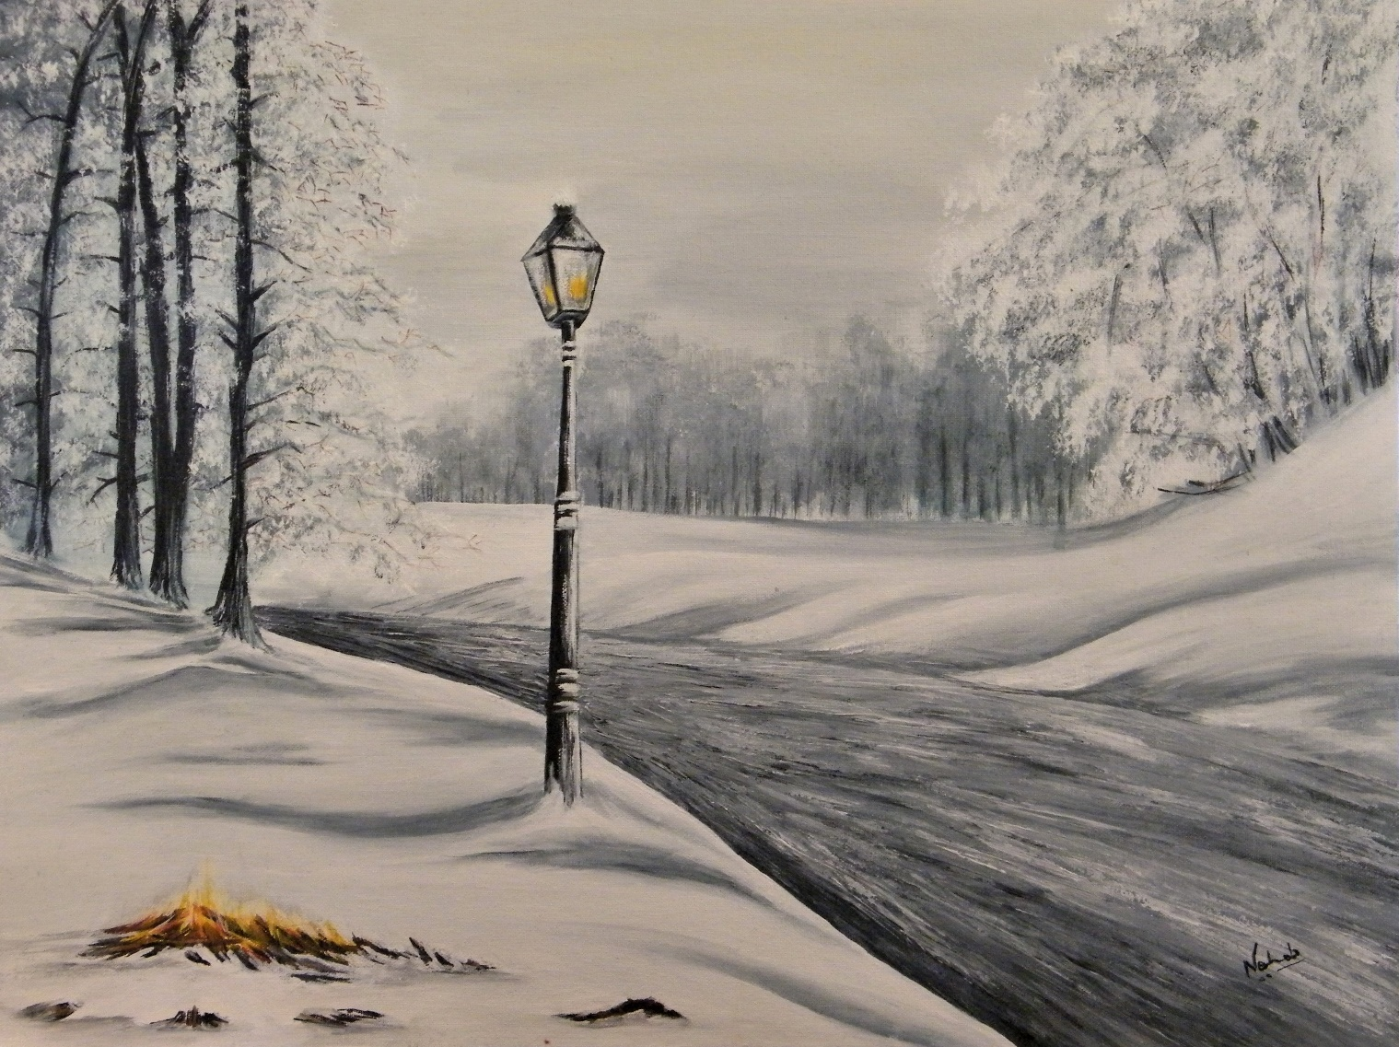

*Acrylic on Canvas / year 2015*

*Medium / 24 inches X 30 inches*

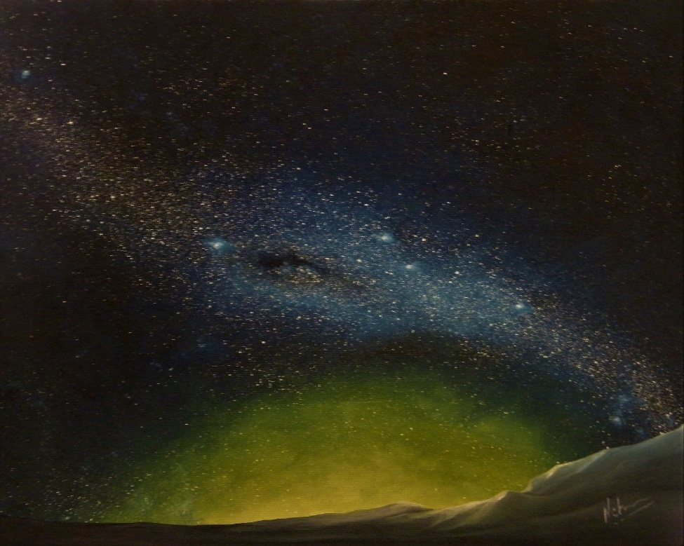

***Eye of the Universe….***

*(Oil on canvas / year 2014)*

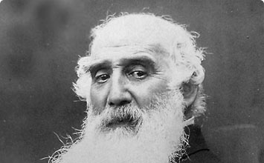***“The whole world is beautiful.***

***The art is in the seeing.”***

***Camille Pissaro***

CATALOGUE OF SMALL PAINTINGS AND VIGNETTES….

Some Vignette Pieces for cosy corners …

Every home has those tiny corners or spaces above pretty and small drawers or floating shelves that lie vacant, wanting something to give them definition and character.

That little vintage table, the counter in the lobby, that armchair near the window, the cosy coffee spot, the antique console table, they all need a companion on the wall to make them come alive.

These are a few of my small vignette painting collection that marry these cosy spaces and furniture, and create a beautiful artistic composition with the furniture and curios.

***RAIN ON THE HIGHWAY ….***

*Rain & wind, lashed hard.  
Raged like fire.  
Surreal was the light.  
Unlike day, unlike night.  
Music in the car echoed smooth.  
It was the red spot in front that caught my eye.  
It made me think.  
It made my mind wander -  
To lanes and alleys long forgotten.  
To all that had gone by.  
Raindrops ran down, mixing with tears.  
I was looking in front and seeing within.   
Hypnotised by the red spot in front.  
It refracted & reflected.  
Shone like a ruby.  
Blood red.  
Just like the red forest I had left behind.  
Yonder, in the horizon, twinkled a grey labyrinth of wilderness.  
Juxtaposed I was between two jungles.   
The weather invaded my eyes.   
It was the red spot on the road.   
That caught my eye.  
Journey was not over yet.  
Twist in the tale was just round the corner.*

***RAIN ON THE HIGHWAY ….***

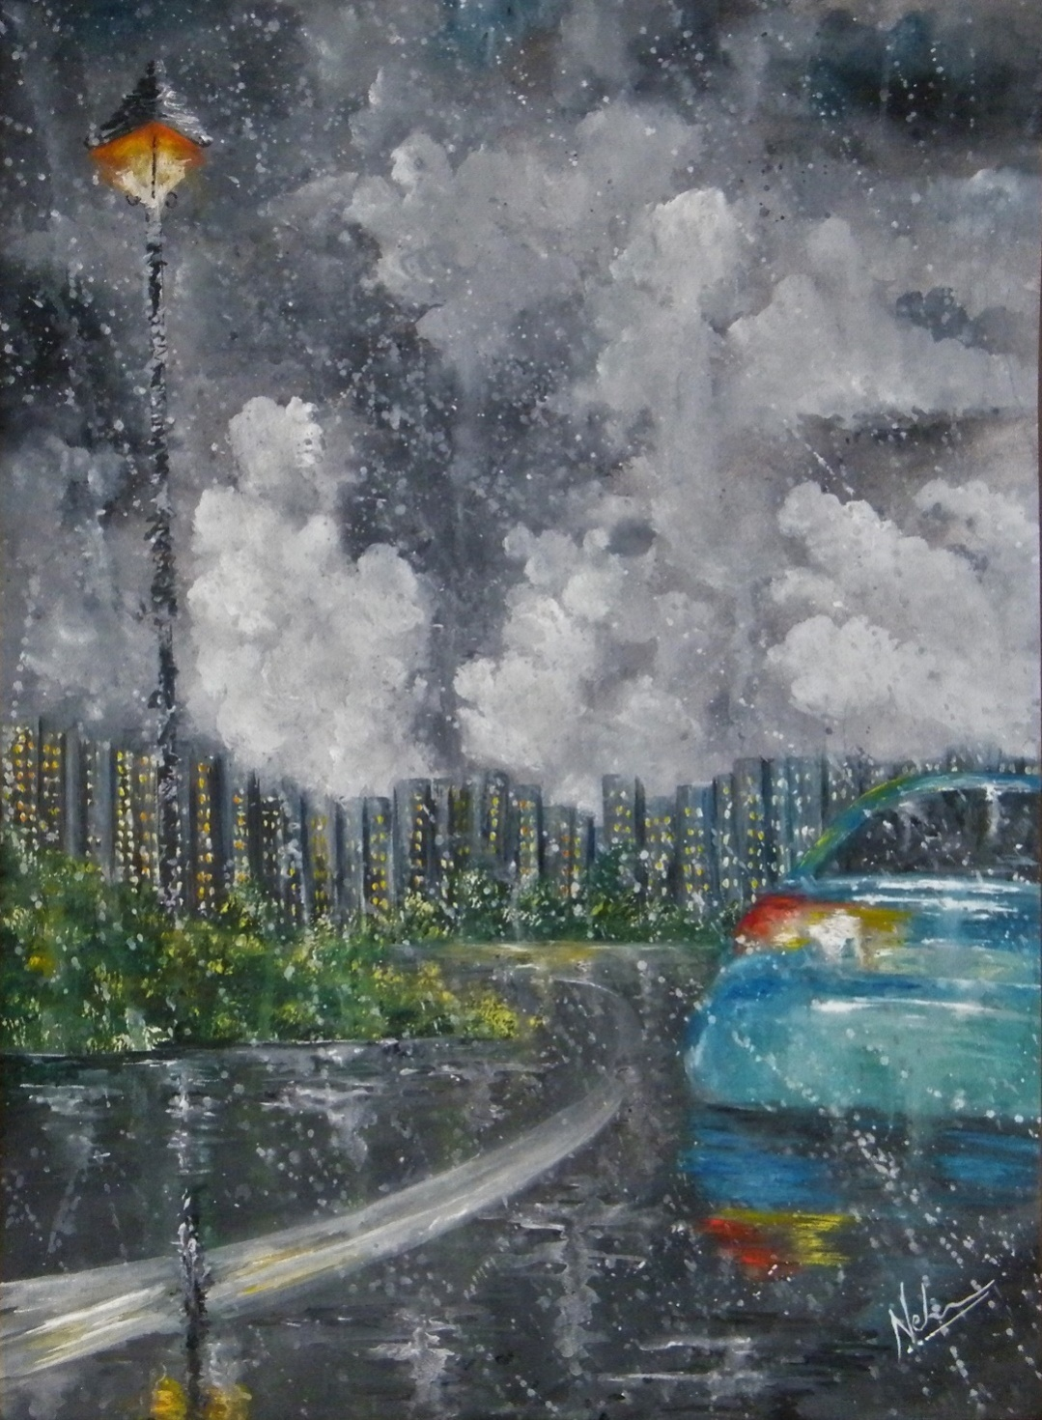

*Watercolour / year 2018*

*16.5 inches x 23.5 inches*

***MOON ON THE STREET*** *It was a strange night.   
When the moon fell on the street.  
Light was magical,   
Air was sweet,  
When the moon fell on the street.   
Creating illusions & deceptions.  
He stood there in the shadows.   
Like a figure out of a dream.  
It was an uncanny night.  
Full of deception.  
When the moon fell on the street.*

***MOON ON THE STREET…….***

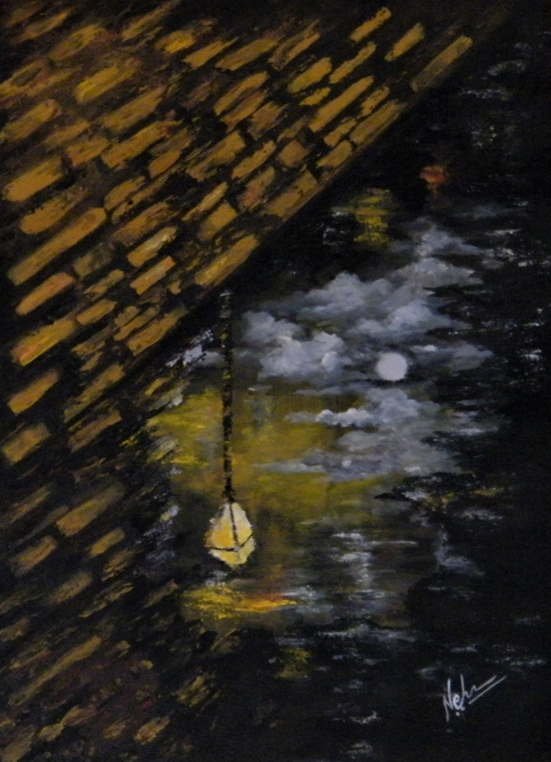

*Acrylic on Paper/ year 2018*

*16.5 inches x 23.5 inches*

***SILENCE…***

It's been a long journey.  
I don't know what to speak.  
What was right & what went wrong,  
It is of no consequence at all.   
Who betrayed and who walked the yard,  
Has long lost its relevance, all.  
Truth, lies, charades, all lie in the grey zone.   
Daisies bloom, poppies sway.   
Birds fly and oaks await.  
As they always do.  
Feeling is just a feeling.  
My heart seeks silence.  
A silence that drowns all sound.  
Love - do I seek it?   
Or happiness & hope?  
Ah! They don't exist, the way I see it.  
I seek freedom.  
Yes I do.  
Freedom to be silent.  
Freedom to be!

Whenever we travelled to Lansdowne, our road journey would start early, before the break of dawn. Somewhere along the way, dawn used to break, through the morning fog, over fields and trees wet with dew. The sun looked like the moon. It is a picture painted in my mind. And I finally put it on paper.

***SILENCE……***

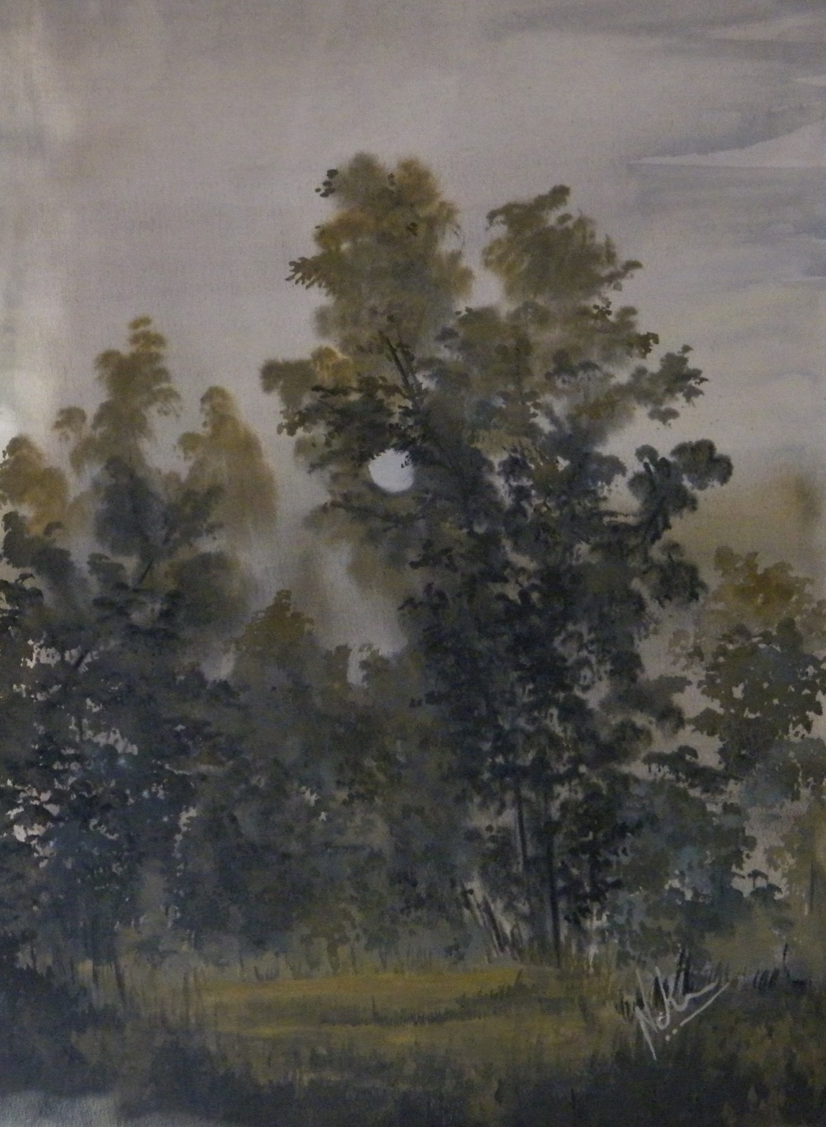

*Watercolour / year 2019*

*16.5 inches x 23.5 inches*

***ORANGES ON AN OLD WSINDOW SILL***

*The table was old,*

*Scratched with tales of a hundred years.*

*Walls hid so many stories in their bosom.*

*So many tales of years gone by….*

*Some beautiful and some too dark to be told.*

*A musty smell clung to everything.*

*But the oranges on the window sill…*

*They were so juicy, vibrant and fresh.*

*The trees outside the window were donned with new leaf.*

*The decay of age all around*

*Couldn’t hide the colour of new life around.*

*I thought I had walked into a novel.*

*The table was old, the oranges just plucked.*

*I find old country homes very fascinating.*

*The houses are old, full of stories but the food on the table is fresh from the garden.*

*A beautiful contrast and paradox of the decay of the old and freshness and hope of the new, I have seen in many old country homes.*

*The coexistence of the ageing structures and fresh and vibrant natureis most fascinating.  
And the glassy view from the window, in a country home, invariably creates a reflective mood.*

***ORANGES ON AN OLD WSINDOW SILL***

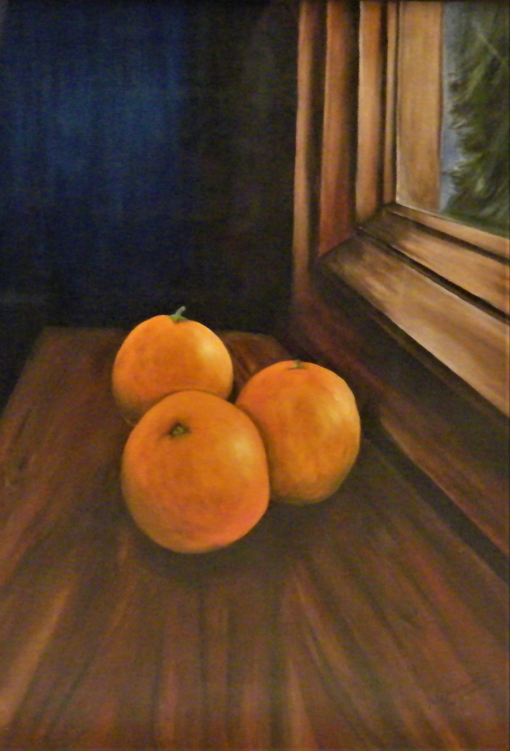

*Watercolour / year 2014*

*11 inches X 16 inches*

***TWO WORLDS ON A WINDOW SILL…***

*The window sill has been my silent companion for long.*

*I remember the first bloom of spring and the bird that always came by.*

*I remember the toy seller in his cycle in my Grandma's town.*

*He always passed by my window sill, singing a funny song.  
I remember the distant lights from my hostel window that always took me home.  
I remember the views and sounds that called me to the window*

*And made my mind roam.  
I remember the excitement that always bubbled,*

*On the window sills of my childhood.  
Today my window sills are quiet as I see the world passing by.*

*My companion has fallen silent.*

***TWO WORLDS ON A WINDOW SILL…***

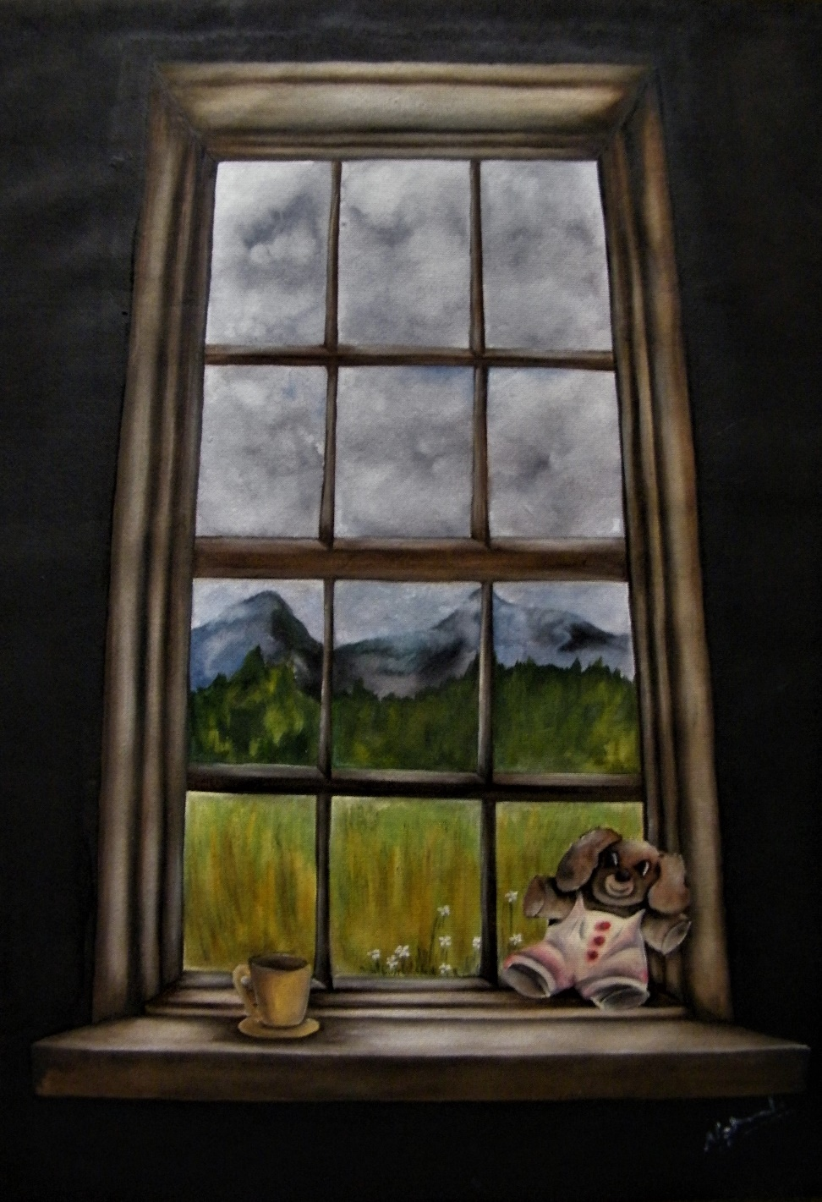

*Watercolour / year 2014*

*11 inches X 16 inches*

***FALLEN LEAVES ON PATHS TRAVERSED…***

*Oftentimes I look back,  
at the years gone by, and ponder.*

*There were roads I took, which I should not have taken.  
And roads I ignored, which I should have taken.  
There were paths I took in haste, without thinking.  
And there were paths, which I never valued.  
There were lanes I missed.  
And there were turns I took, with my eyes closed.  
There were doors I knocked on, which never opened.  
And, there were open doors, which I did not see.*

*Some paths led me to dead ends.  
Some paths led me to desolate gardens.  
And yet, some paths led me to beautiful horizons.*

*I ponder oftentimes....*

*Should I have taken this road or knocked on that door?  
Should I have waited, and rationalised calmly?*

*And then, slicing through the wet fog,  
Like a lostvagabond leaf, in the winter breeze.  
A voice comes haunting and I realise….*

*Every turn I took, every turn I missed.  
Every road I walked on & every path I ignored.  
Every lane I rushed into, every dead end.  
Every desolate garden & every locked door.  
It brought me here…*

*Destiny has its own designs.  
Decisions were mine.  
This must be the greatest illusion of mine!*

***FALLEN LEAVES ON PATHS TRAVERSED…***

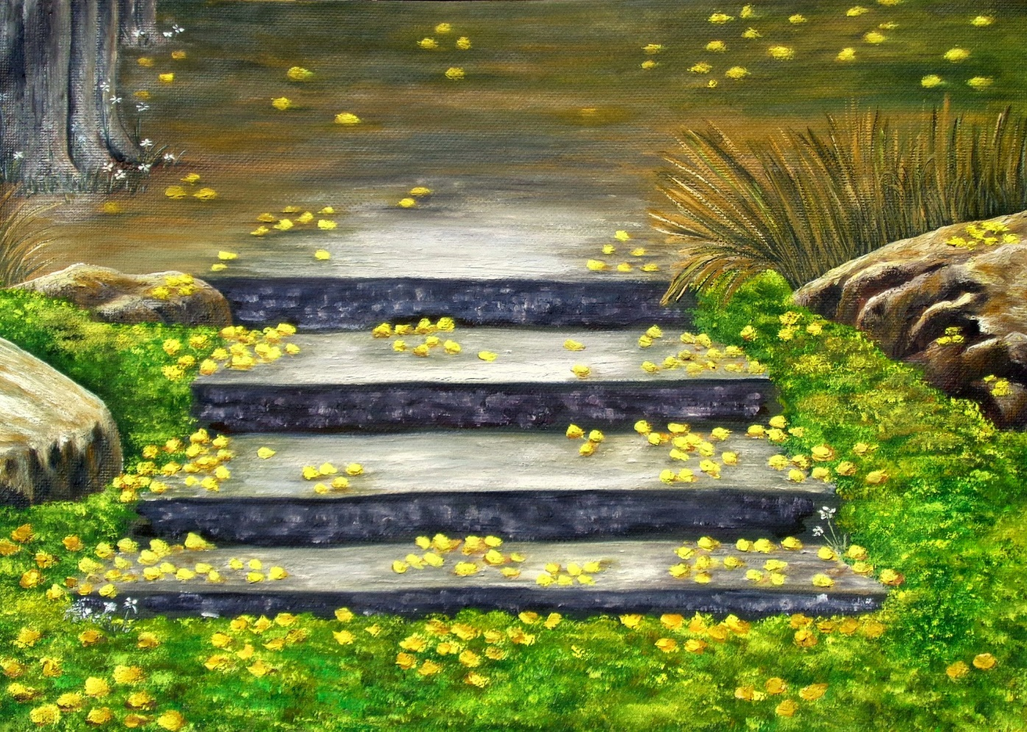

*Watercolour / year 2015*

*11 inches X 16 inches*

TWO STORIES

Art always tells two stories.

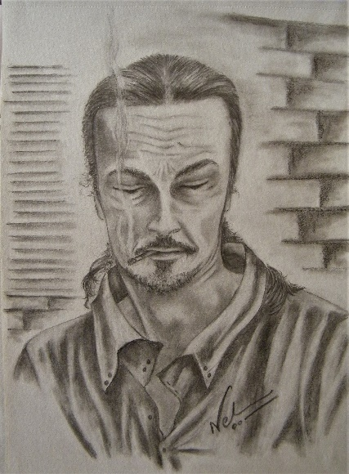 The Glance (pencil)

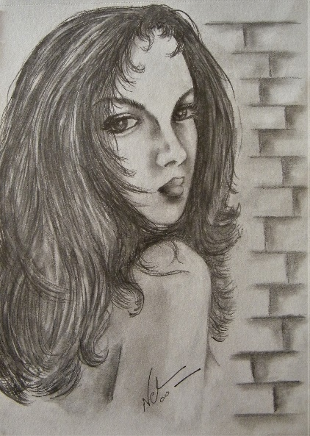

Veiled Thoughts (pencil)

Art is a creation that speaks!

It is a dialogue. It interacts. Evokes thoughts and feelings. Only then it is art.Simply a technically beautiful picture is not art.

Beautiful? Yes. But art? No.

When you see an artist’s creation, what you see in it, is not just an image. Art is what you see beyond the image.

What you see in art are two stories….

Perhaps, the painting takes you on a personal journey of your life.Perhaps you see your emotions and memories, dreams and desires and realisations there. Perhaps it reflects your mood or an emotional moment in your life.

When you see a part of yourself in a creation, then it becomes alive and breathes. And then it becomes art.

And what about the artist?

For the artist, his art is his relationship with his life, experiences and feelings. His journey.

For the viewer, art is something that triggers an emotion and embodies his relationship with his life & experiences. And, for the artist, it is his love and his soul experience.Hence, art is a tale of a relationship between two elements. The artist and his emotions. And the viewer and his emotions.

So, Art always tells to stories –

The artist’s story and the viewer’s story.

My story and your story.

I believe art is an offspring of emotion. It should never be intellectualised. It must only be felt and experienced. It is a personal experience for the artist and for the viewer.

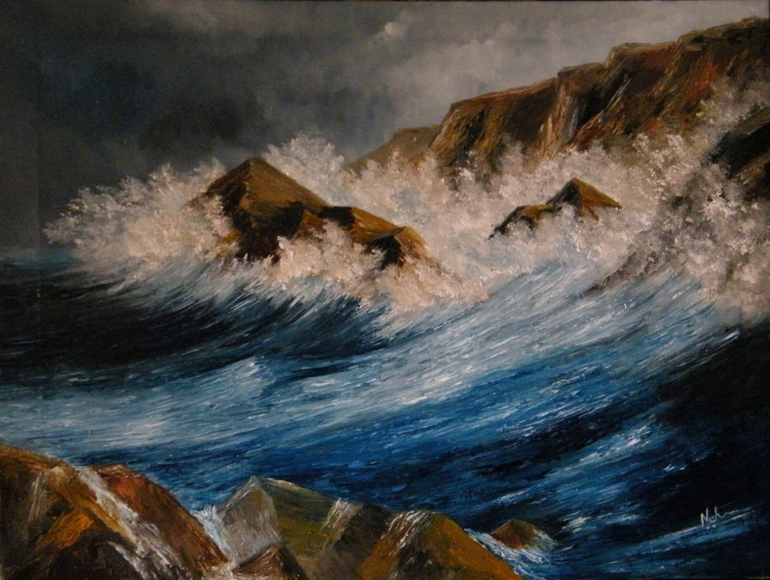You can never know or understand what the artist felt while painting.  
You only understand what you feel when you see the painting.

My painting belongs to you and is your part as much as it is mine.

*(The Rage / oil on canvas/ year 2006)*

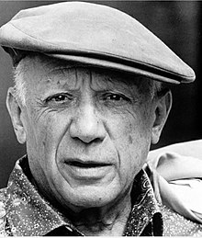***Every child is an artist. The problem is how to remain an artist once we grow up.”***

***Pablo Picasso***

THE FEMININE ENERGY - MOOD & EMOTION

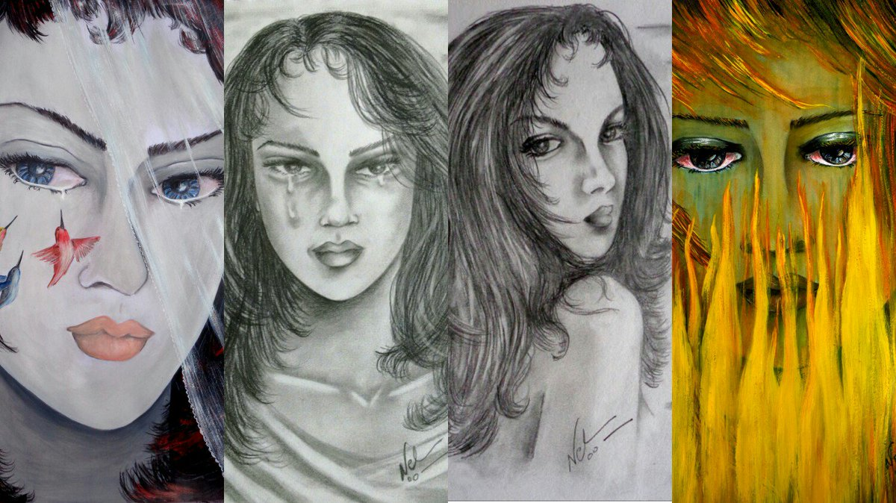

The essence of the feminine energy lies in her power to feel. Her emotional charge. True “*Shakti*” (feminine power) lies in unlocking the emotion, understanding it and channelizing it.

I like to paint theunspoken fire and emotion that lies deep within the soul of femininity that has survived every storm. Her longings, her pain, her love, her vulnerabilities, her strengths, her fire, smoulders in her eyes in my meandering brush.

My portrait art is a mix of Expressionism, Fauvism& Surrealism. The subject is the most intriguing element in the Universe, - The Feminine Energy! Her love, her passion, anger, strength, vulnerabilities. Her falling, her rising.

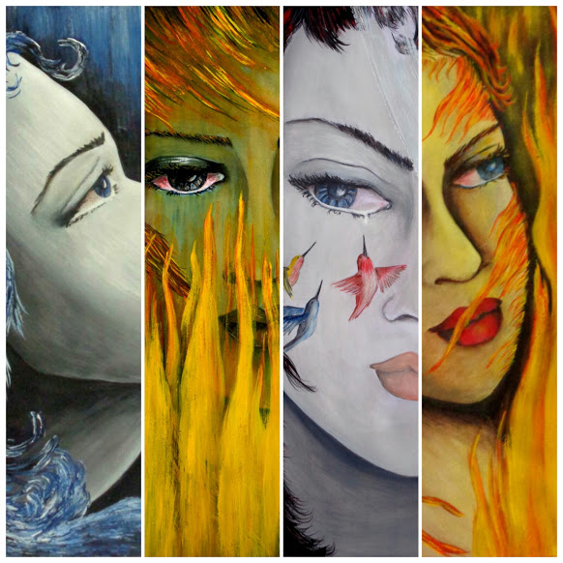

***I create her as I feel her flow inside me ….***

***BLUE EYES***

***The End of a fairy tale……***

*Memory of hurt floods the eyes.  
Burning tears scald and roll.  
Why things happen, heart doesn’t know.  
The most beautiful flower withered and fell.  
Its fragrance disappeared.*

*Memory of hurt floods the eyes.*

*Questions float unanswered*

*Blood in watery letters runs down.*

***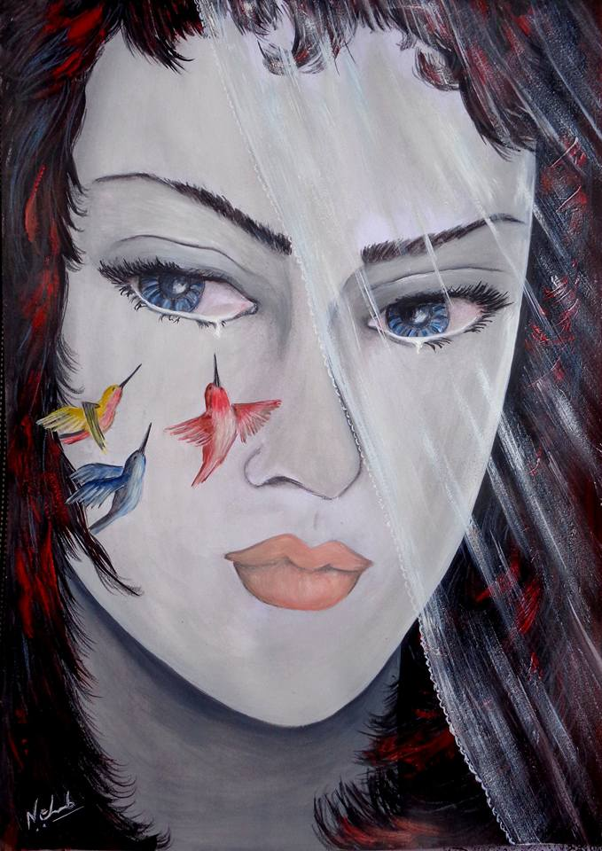****The tale was sweet.*

*But the story stopped.*

*Blank pages flutter in the wind.  
Waiting for a word still.*

*Beautiful birds quench their thirst.*

*It’s just a memory of hurt that floods the eyes*

*Blue Eyes breathe.*

*The story ends.*

*watercolour/ year 2015*

***BLUE MOON***

***The Illusion she loved…***

*He came from distant lands.  
Shores she had never seen  
He came like a dream…  
A dream she had always seen.*

*He crossed her path,  
Like a twist in the tale.  
Caught her off guard.  
Ruthlessly ensnared.*

*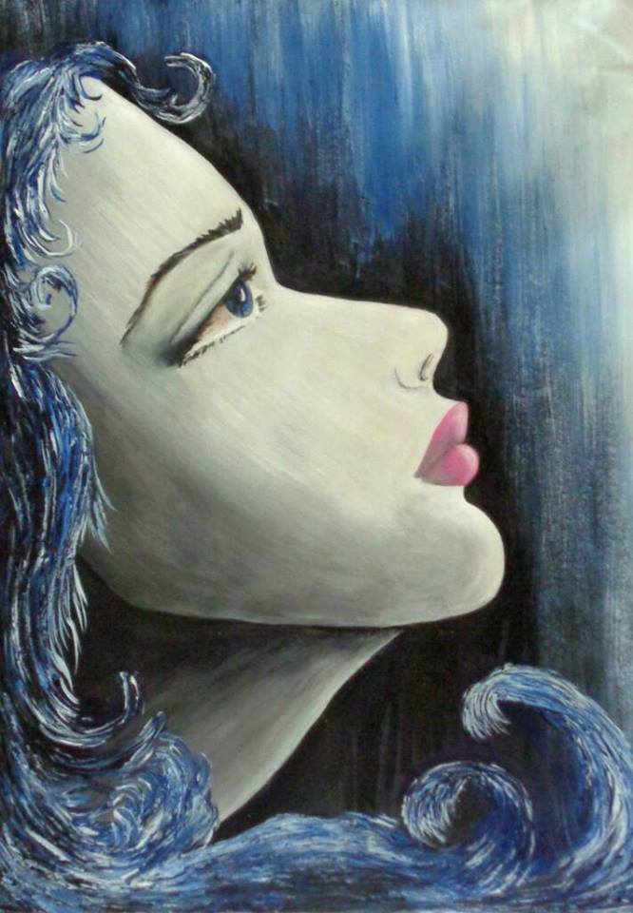A quirk of destiny,  
She couldn’t foretell.  
She couldn’t see it coming.  
The potent love spell.  
She saw her Prince, the light was behind.  
She couldn’t see, brightness blinded her eyes.  
She wrapped him in the silvery cloak of her dream.  
The cloak was not his at all,this she couldn’t see.  
She couldn’t see his cloak was dark,*

*Hiding secrets within.  
She created an illusion and loved her dream.   
She covered him in the silver dust of her desires.  
The moon cast a magical light.*

*The stars shone so bright.  
She loved the illusion she had created.  
She loved her blue moon dream.*

*watercolour/ year 2015*

***CATCHING FIRE…***

*Some run after mammon, some seek love.  
Some burn in sorrow and for others it is desire.*

*For few, the flames dance with joy.  
Others dance in flames of romance.  
Some glow in fires of inner peace.  
Yet, restless wars of survival scald many dreams.*

*******I have burnt my fingers in flames of many hues.  
My anger burned me and so did my dreams.  
I burnt to ashes and rose again.  
Only to be burnt once again.*

*The fumes and flames blinded my eyes.  
The fog was smoke or mist, I could never decide.  
Many wanderings, longings and dreams,*

*In time told me,*

*I really have no choice.*

*To burn, is Destiny, there is no other way.  
Yet, I have one power.*

*I can choose my flame and my fire.*

*To burn is Destiny, we are forever catching fire.*

*So, choose wisely your heat,  
Your Flame and your Fire.*

*(watercolour/ year 2015)*

***CATCHING FIRE…***

*With wisdom I had chosen my fire.  
I thought I was right, without confusion, Sire!  
Till that fateful day.  
When the fire burned me, without my choosing.*

*Scalding pain, smoke in my eyes.  
Tears of sorrow and of burning heat.  
The suffocation, the laboured breathing.  
I remember too well.  
I had not chosen those flames.*

***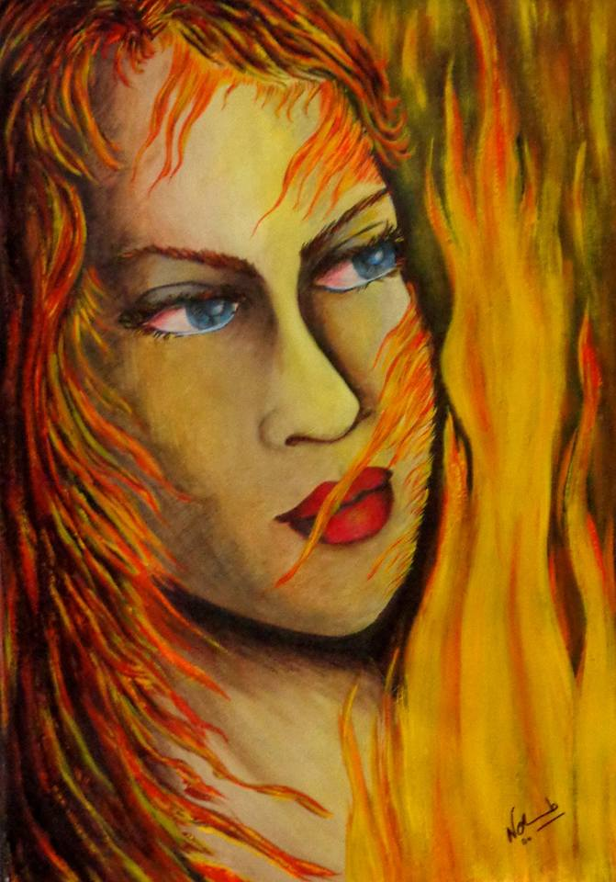****It takes many scars, many twists and turns,  
To finally have the wisdom to choose,*

*The blessed Fire in which to burn.  
But the Irony of Fate plays its music.  
Flames blaze high, but not of your choosing.  
Just when you put a full-stop, close the door,  
Destiny comes by, erases it.*

*Puts a comma, opens the door.*

*It makes me wonder…  
And question my wisdom,  
Is it really possible to choose the fire to burn in?  
Perhaps it is an illusion and a foolish desire.*

*To choose my flame and my fire.  
How could Iforget,*

*Neither is in my power.*

*(watercolour / year 2015)*

***THE MUTANT***

*At every turn, every twist, at every step & breath,  
She knew something was amiss, it didn't feel right.  
Even when things were perfect, it wasn’t right.   
Hell! One day she realised.*

*It was she who was not right.  
She just did not fit into any cage.*

*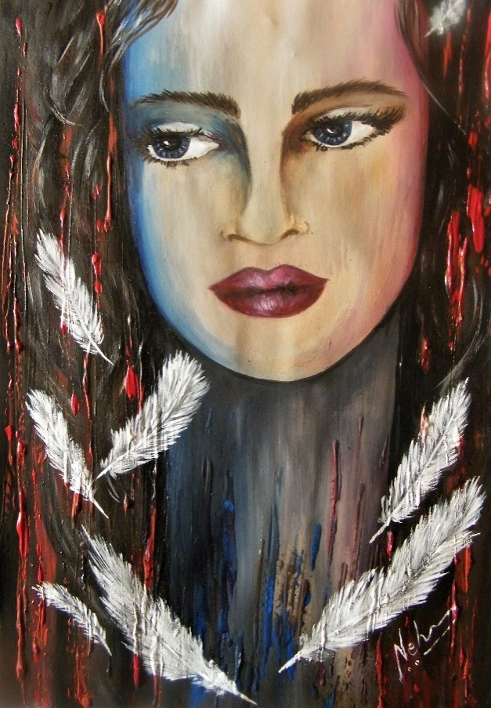Her soul was free, full of love.  
Her thoughts were from far beyond.  
World accused her of being a rebel.  
Too strong and too independent.  
Not good for her to be so, they said.  
They accused her of being too "off the track".  
Was she?*

*Or her accusers were off?   
Mutant she was, she finally realised.  
To fit into the cage she stopped trying.  
She allowed herself to breathe free.  
In her own passion and her peace.  
Her eyes smiled.  
Her beauty shone through.  
And people thought she was a goddess.  
But just a mutant she was.*

*A mutant who embraced her different hue.  
Just a mutant not meant for any cage.*

*(Watercolour/ year 2018)*

***PRODIGAL DAUGHTERS***

***&***

***COFFEE STAINS***

***“Did I not want a cosy family, home and hearth with children and a beautiful garden and a loving man?Of course I did. Who doesn’t? I dreamt of it all the time. Yes I did want all that.***

*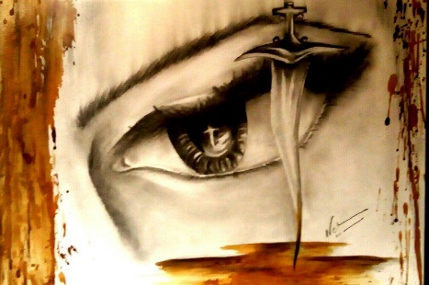****But my dear, my self-respect got in the way.” she said, with a tear and a smile.***

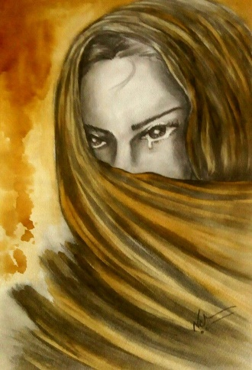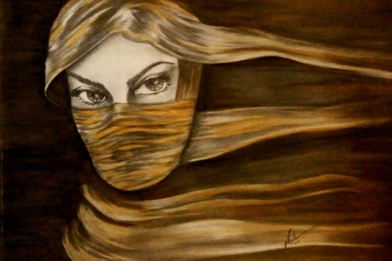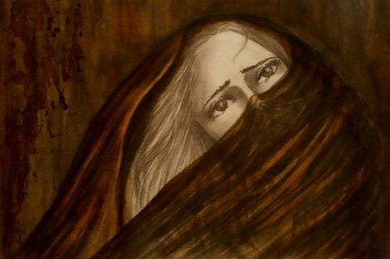

***This is a series 0f four concept portraits I did with pencil and coffee powder.***

***The bittersweet coffee stains on paper….***

***I call it “Prodigal Daughters and Coffee Stains”.***

This series is for every woman who dared to live by her own parameters and battled her demons and faced her nightmares all alone.

Her life redefined the meaning of trust and love as she found people trickling away like sand through fingers.

The stains of errors made her stronger and more beautiful and also “untouchable”.

With blood she erased her path to all illusions & etched her path to her own truth. And so was born the prodigal daughter.

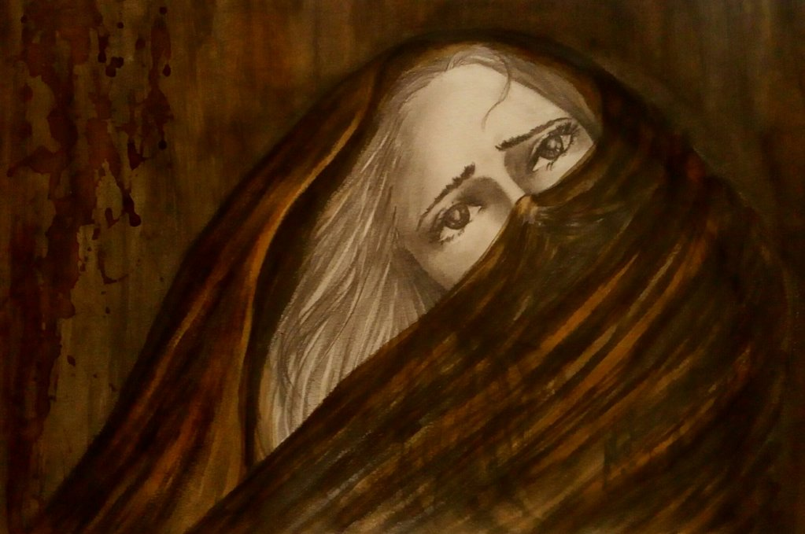

*(year 2018)*

***SILENCE OF THE VEILS***

*I am not a pessimist, not an optimist either.  
Perhaps a realist.  
I cannot be blind to the degradation around.  
To the crime and terror lurking all around.  
It is impossible for me to not see, innocence lie bloodied.  
Life was simple when I was not aware.  
It was happy and rosy when I didn’t know!  
Awareness brings sorrow, unveils the truth.  
Like an agonising peeling of the skin.*

*Soon a new skin grows, a new light dawns.  
But the transition is agonising and confusing.  
Why? The answer hides and forever eludes.  
Soul becomes weary in search for answers.  
Perhaps, old order changes, giving place to new.  
But right now the mind swirls in terrible dark hues.*

*I am not a pessimist, not an optimist either.*

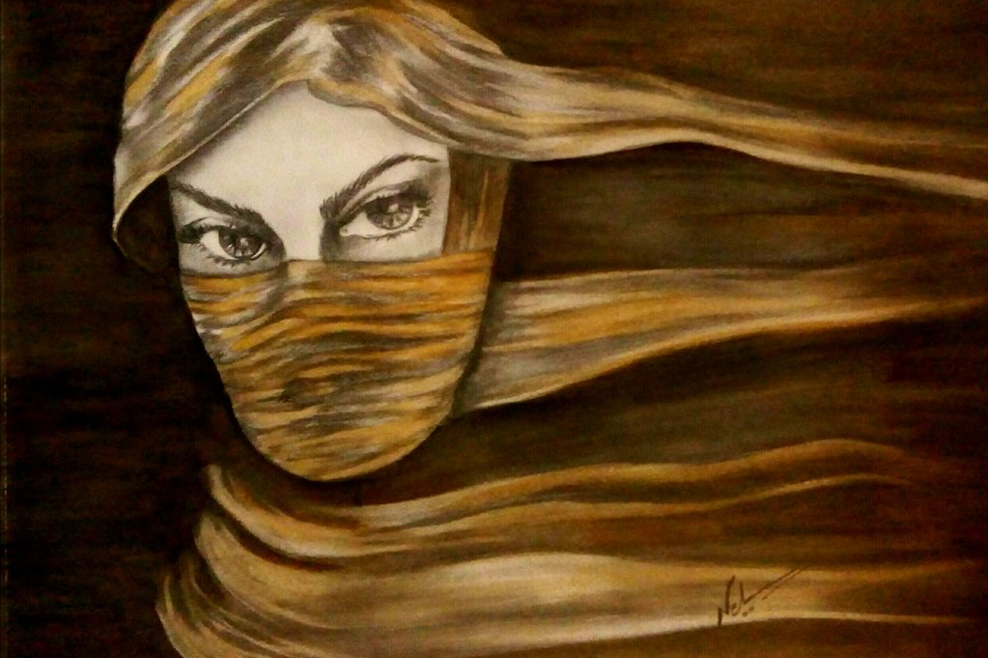

*(year 2018)*

***AWARENESS OF CAPTIVE DREAMS*** *You don’t see me, you don’t hear me.  
I am Just a number in some census.  
My songs echo in dark rooms.  
Where no light ushers in, where no breeze blows.*

*The key lies lost, somewhere in the blackness.*

*When I close my eyes, I see a beautiful world.  
Where sunlight shines like diamond.  
I see golden fields swaying beneath azure skies.  
I see frost paint patterns in white.*

*I hear the waves crashing against cliffs and shores.  
But you don’t see me, you don’t hear me.*

*The key lies lost, somewhere in the blackness.*

*To find the key, is the journey.*

*A day will come when my songs will find wings.*

*And you will see the soul you never valued.*

*Darkness is not forever.*

*Light always breaks through….*

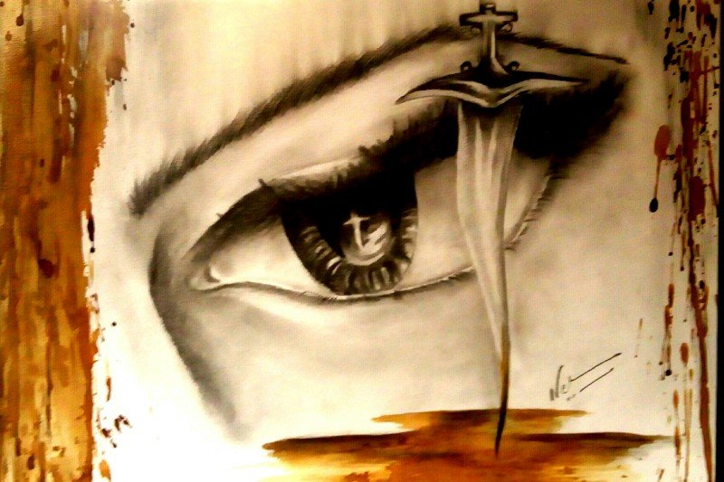

*(year 2018)*

***A SHADE DARKER***

*You committed no crime.  
But the crime was committed.  
The Dagger was pierced.  
The Blood was splattered.*

*Atmosphere of hurt,*

*Imbalance &injustice prevails.  
A pain throbs deep,  
Breathes toxins into the air.*

*Eyes have run dry.  
Blood stains are dry too.  
There are pages that are sealed.  
And some are missing too.  
The end was written.  
The story unfolds too.*

*You committed no crime.  
But the crime was committed.  
The Dagger was pierced.  
The Blood was splattered.*

*It is all gotten darker.  
Just shade darker.*

***PHOENIX***

*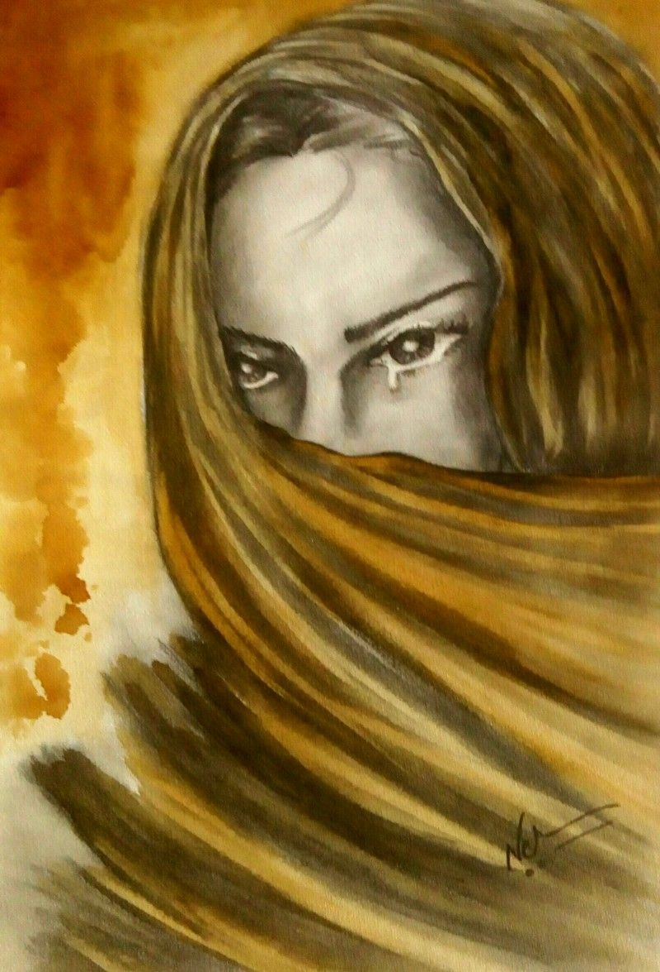The abyss was dark.  
A bottomless pit.  
I was hurtling down.  
Spiralling into oblivion.  
I was looking for a hand to pull me out.  
To stop the fall and lift me up.  
But the hands that came pushed me deeper.  
Into an abyss that only grew darker.  
Ah! My broken wings had no will.  
Yet, a red ember blazoned in the eye.  
Somehow,  
The tears did not douse it’s heat.  
The warmth of the ember, healed the wings,*

*Heart made a resolve.  
The Phoenix fluttered.  
Felt the heat of the smouldering ember.  
Steadily ...  
Despite the memories,  
Despite the sorrow,  
Began to rise towards the light.*

*Like the phoenix that it was…*

*(year 2018)*

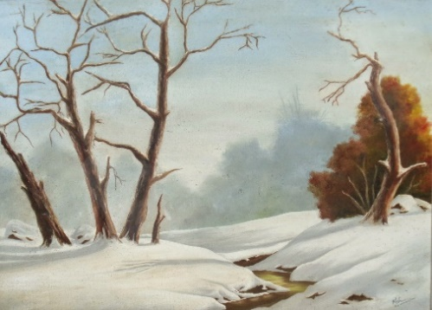**Many came. Some stayed. Some left. But the coffee kept brewing…..**My gratitude to all who came into my life as blessings and lessons and became part of my journey.

The support, appreciation and encouragement of all is invaluable….

**(Brook In Snow, oil, 1995)**

**I am indebted to ….**

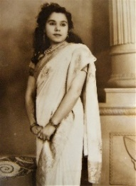**Rani ArunKumari Singh (RajmataHaraha Principality, India & late Princess of Nepal), my maternal grandmother.** A lot of my childhood was spent with my grandmother. Her words and life lessons have always given me strength to follow my dream and stand my ground. I once asked her as to why did she choose to marry someone from another country. She said, “I wanted to see the world and India was closest and a most acceptable proposition. And then I liked your grandfather the moment I saw his photo.” A very well read and well informed lady, I admire her for her progressiveness and her desire to keep learning and exploring. Her soul travelled the whole world through books & observation.

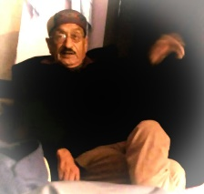**Devraj Singh Bisht (Advocate), my father.** I have always been close to my father. He always treated me like a princess. My debates and discussions with my father opened a whole new world in front of me. It took me to distant lands and cultures. One of the most well read, well informed and compassionate humans, he gave me the understanding that nobody is perfect, but everyone is beautiful.

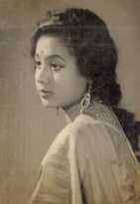**Rani SwarnaKumari Bisht, my mother.** A mother is a mother. I owe my life and skills to her. I learned from her that you have to make your choices and live them. No excuses. An artist herself, she opened the door to art and aesthetics for me. Once the door opened, the journey never stopped. She always said to me, *“If you cannot complete it, don’t start it. And what you begin, you must complete.”* And so it is. I intend to complete the journey.

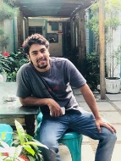**Swaritt Singh (Swimmer, Aspiring Writer, Fitness Guru).** My son, the little pebble that rolled with the meandering river. I call him a healer. Wise beyond years, he takes your pain away with his energy. He has always stood by me and supported all my endeavours and lived the journey with me. He is the blessing to whom I owe everything. In his words, ***“Your paintings tell a story. They have a sense of mystery in them.”***

**AnirudhTripathi (Installation Artist, Fitness Guru, BCCI coach, Philanthropist).** A philosopher, thinker and philanthropist, Anirudh has always supported my endeavours. Always a learner at heart, an observer of life, He says, ***“there is a very soothing, serene & solitary energy in your art. It brings out thought”****.* I am indebted to him for the unconditional support he has always given me.

**It is always a pleasure and an encouragement for an artist to hear such beautiful words about their art….**

**For all the support and appreciation, my heartfelt gratitude to …..**

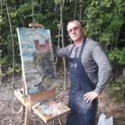**Sergei Sonera, (Fine Art Teacher & Reputed Estonian-Russian Artist.).** Sergei is an amazing artist, greatly revered in Estonia. I am honoured to be a member of his esteemed online art group, “Fine Art, Practice & Secrets”. Sergei has always guided me and solved my art queries and problems. He honours me with these beautiful words-**"*I am delighted with the air the colours breathe in Neha's paintings. She really feels the atmosphere of different places in her landscapes. I marked their status as paintings of North-West Europe. Neha is from South-East part of the world. India. It is amazing how she captures the aura of a place so different from hers. When I see her paintings, I feel as if she is living closer to me. Of course she directs her art onto many other styles and techniques. But I personally see in them the special emotion of our European Artists of Classical school. Good luck, Neha. Your talent is growing with every work. Work and study! Study and work! And your level and professionalism will be grow. I would like to show your example to my students in the group of Art School in Estonia."***I am honoured that Sergei feels my landscapes.

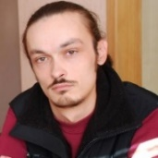**YuriiChernenko, (Finance Analyst, Art Connoisseur, Ukraine).** Yurii’s knowledge of art and literature is immense. He has guided me and greatly helped my art evolve with his honest appraisal. His inputs always helped me work on my vulnerabilities in art. He always told me *“Work on your foreground. Foreground is your Karma. Background are your dreams. And the devil is in the details”.* A man of few words, he honours my art by saying, ***“Neha, I see passion, love and warmth in your art! I see your soul.”***

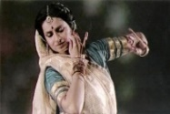**Nalini Ravi Jain, exponent of Kathakali, Lucknow Gharana. India. A** beautiful soul, she honours my art with her soulful insight. She once said, ***“Neha you are one of the finest artists I have met. Your aintings are an amalgamation of various colours and inner beauty which touches the soul”*.** Her appreciation is an honour for me.

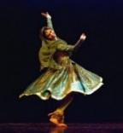**Richa Jain, a star of Kathakali dance, Lucknow Gharana, India. She** has done India proud by expanding the horizon of Indian dance form and culture to many countries. I am honoured by her undying support. She says, **“*Neha, your paintings are an ocean of emotions. You speak through your canvas. Your art is full of devotion and divinity. Undoubtedly, an artist par excellence!”***I am so touched by her appreciation.

*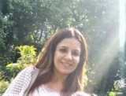***Neha Talwar (Artist, Contemporary Art, Torchbearer of GAG Moderne Art Gallery, Delhi).** It is a pleasure to have known Neha, A genuine and beautiful soul, I am grateful to Neha for all the support and resource that she has extended to me whenever I needed. Always a pleasure to work and share coffee with her.

****Dr Risheendra Singh Bisht (Civil engineer & Hotelier).** I am very grateful to my brother for always being there whenever I needed his guidance. He has always believed in my potential and pushed me to stand in my power and be my own person.

**Last but not the least….**

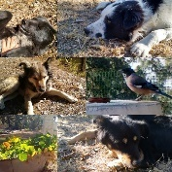**My canine babies.** I am indebted to Tippy, Coco, Wally, Bella, Touchwood and Phoenix for the love they filled my life with. My art is born of love. And my babies are the embodiment of love…

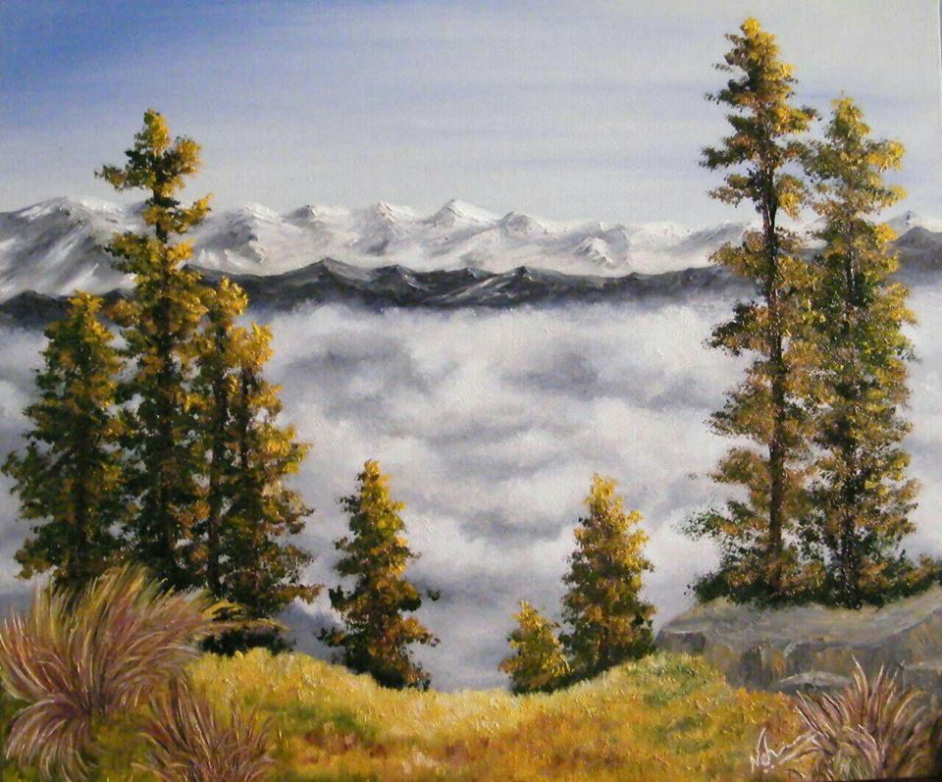

***“Nothing is forgotten.***

***Nothing is forgiven.***

***Thoughts and deeds are energies, that once created,***

***Always float in aether.***

***…. So create with care.”***

***neha b***

*“The Precipice”(watercolour/ year 2014)*

*Lansdowne, Uttarakhand. A view from Tip-in- Top,*

*In the end, I only want to say this. …..*

*There are two purposes of art.*

*One is to spread beauty and good aura.*

*The other is to tell a story and express a journey.*

*And it feels good to know that …*

***”God takes care of imbeciles, little children and artists.”***

***Camille Pissarro***

**MEANDERING BRUSH …**

**ARTWORKS BY NEHAB**

**(NEHA BISHT)**

I offer you my artwork and the aura of healing it embodies.

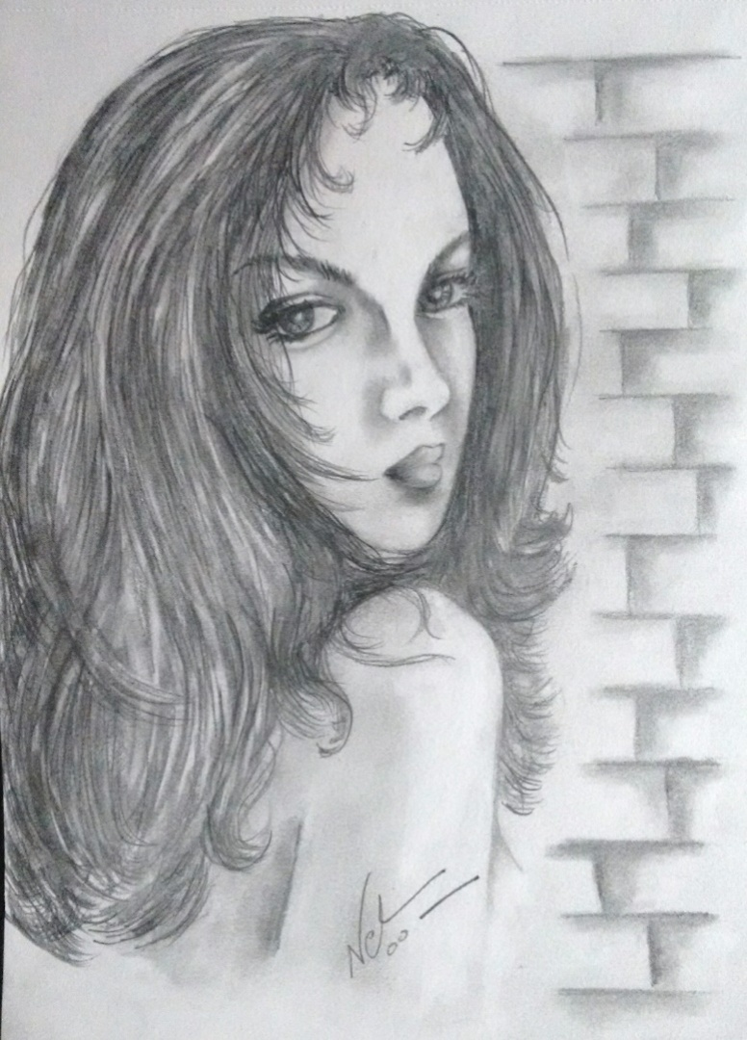I do not make copies of my work. Each painting is unique and exclusive. As the owner of any of my paintings, you are the sole and exclusive owner of that piece.

For details regarding purchase, price, framing, viewing of original painting, contact me ….

Contact number 9555334699

Email id – [claret.peony@gmail.com](mailto:claret.peony@gmail.com)

DM on Whatsapp / FB messenger (Neha Bisht) / Twitter (@nehab16)

**All the content, - Paintings, Images, Writing, Concept, Thought, Poetry, displayed in this book, “MEANDERING BRUSH … artworks & verses by Nehab, Neha Bisht” are the sole copyright of Neha Bisht. Copying or commercialising of the said material, without permission is prohibited**

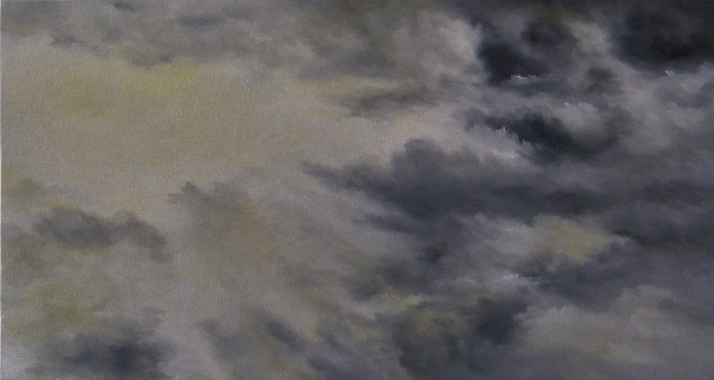

***“Every turn I took, every turn I missed.  
Every road I walked on & every path I ignored.  
Every lane I rushed into, every dead end.  
Every desolate garden & every locked door.  
It brought me here…***

***Destiny has its own designs.  
Decisions were mine.  
This must be the greatest illusion of mine!”***

***Neha b***